 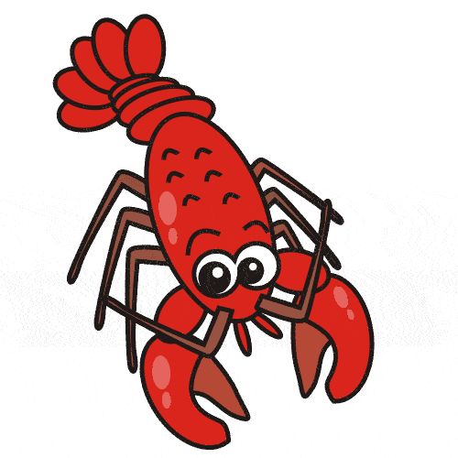

Take One Song

Throughout the school we are currently linking our learning to The Beatles’ Yellow Submarine:

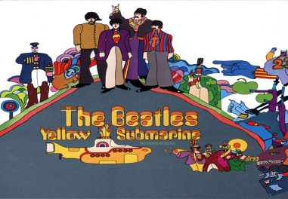

Lobster Class Code of Conduct

We agreed to:

* Put your hand up when you want to share and listen to each other.
* Take care of each other.
* Share nicely.
* Be quiet in the classroom so that everyone can concentrate.
* Look after the classroom.

If you have concerns or questions please let me know.

I will be in the playground before school where you can make an appointment to see me.

Thank you,Miss Wheelhouse

Dates for your diary:

Half Term: Monday 26th October – Friday 30th October

Term 2 starts for pupils: Tuesday 3rd November

End of Term 2 for pupils: Friday 18th December

Term 3 starts for pupils: Tuesday 5th January

Lobster Class Assembly: Thursday, 26th November (9:10am)

Parent’s Evening: 13.10.15, 15.10.15, 22.10.15

Our school website address is:

<http://www.denton.e-sussex.sch.uk/> and our class page is there for you to find out information about the class, upcoming events and links to useful websites:





Lobster Class

Curriculum Information

Term 1 & Term 2

Learning Journey:



Things to Remember:

* P.E. kit for Tuesdays and Thursdays.
* Reading book and home-school link book to be in school every day
* Homework is given out on a Friday and due in by the following Friday
* School starts at 8:50am with gates open at 8:40am
* Book Look is on Thursdays 8:40am-9:00am

**Geography**

Linked to both the new curriculum and our over-arching learning journey, Year 1 will learn about the names and locations of the continents and oceans. We will explore these using various materials, such as the interactive whiteboard and large maps and present information learnt through the use of paintings and Playdough models.

**R.E.**

In R.E. the class will be answering questions such as, ‘What does it mean to belong?’, ‘Where do we belong?’, ‘Why are babies special?’ and ‘Why are babies often welcomed in a special ceremony?’

**Art and Design**

Year 1 will use different materials to create submarines, including papier-mâché and mosaic. They will look at the flags of different countries and design their own.

They will plan, make and evaluate a fruit kebab in D&T!

**Computing**

Computing within Term 1 looks at children as collectors. The class will be finding images of underwater animals then learn how to group and resize images. They will also be introduced to the term algorithm. In Term 2 Year 1 will become TV chefs and film the steps of a recipe.

**Science**

Throughout the term Year 1 will investigate the properties of various materials and linking to our learning journey, whether these materials float or sink. This will involve predicting as well as investigating independently. Later into the term children will design a raincoat for a teddy bear based on what they have learnt about the various properties of everyday materials. What material will keep the teddy bear dry and comfortable?

**P.E.**

Our PE days are Monday and Wednesday. Children need to bring their shorts, a

t-shirt, trainers and plimsolls on these days as we may be inside or outside.

Children need to remove earrings on these days as they cannot do PE with them in.

**Long hair needs to be tied back every day please**.

We are currently looking at dance but may conduct some lessons outside so it is advisable that trainers are also packed.

**Music**

Lobsters will be focussing on the song ‘Yellow Submarine’ and making up their own actions. They will be using percussion instruments to play along to beats and rhythms.

**P.H.S.E.**

This term in P.S.H.E. we focus on developing children’s knowledge, understanding and skills in four aspects of social and emotional learning: empathy, self-awareness, social skills and motivation.

**Homework**

Homework is set on a Friday for children to return by the following Friday and will relate to previous or future work in class. Later in the term spellings will be stuck into reading records to be practised and learnt for a test the following week.

**Numeracy**

In Year 1 we have carefully planned our Numeracy to link to our Literacy lessons and our learning journey.

Over the course of Term One we will look at number recognition, 1 more / 1 less, capacity, shape, subtraction, time and addition.

In Term Two we continue looking at these same areas but in a greater depth, becoming masters of each mathematical skill.

Every day we do counting activities to help speed up their mental calculations and pattern recognition. A counting stick is used during these activities. In school we strongly promote the use of apparatus and have a whole range of tools to support your child. These include number lines and Numicon.

**Literacy**

It is vital that children are exposed to quality texts and in Year 1 we have linked all our texts to an underwater theme.

The texts we have chosen are ‘Tiddler’, ‘Yellow Submarine’, ‘Shark in the Dark’, ‘Dougal’s Deep Sea Diary’, ‘Rainbow Fish’ and ‘Commotion in the Ocean’. While enjoying these stories the children will learn about speech bubbles, story mapping, lists, diary writing, letter writing and poetry.

We encourage all children to read to someone at home every day for about 5-10 minutes and we still have a storyteller coming in for workshops!

Every day the class have a 30-minute phonics lesson where they learn new sounds and spelling patterns to help them read and spell.