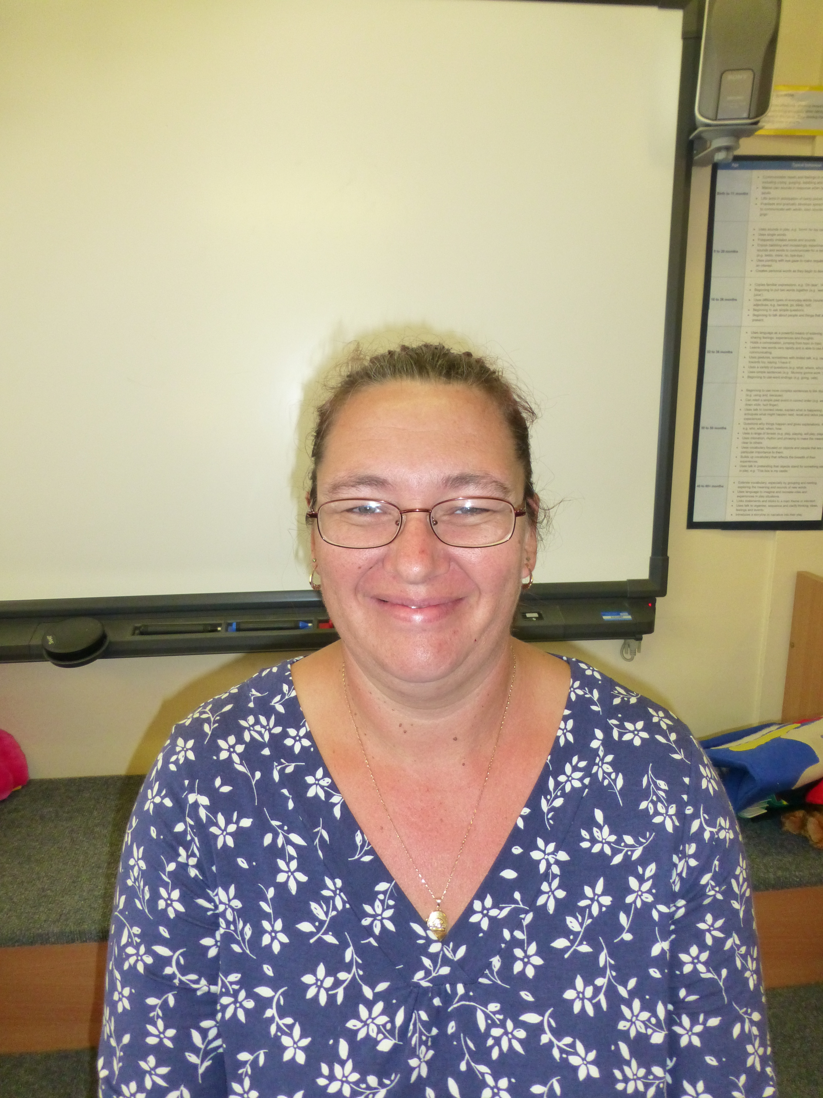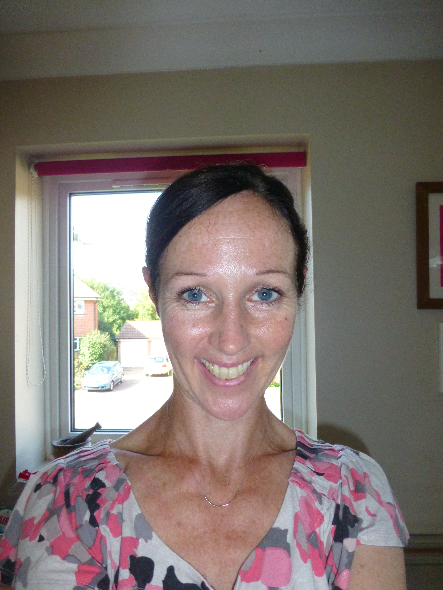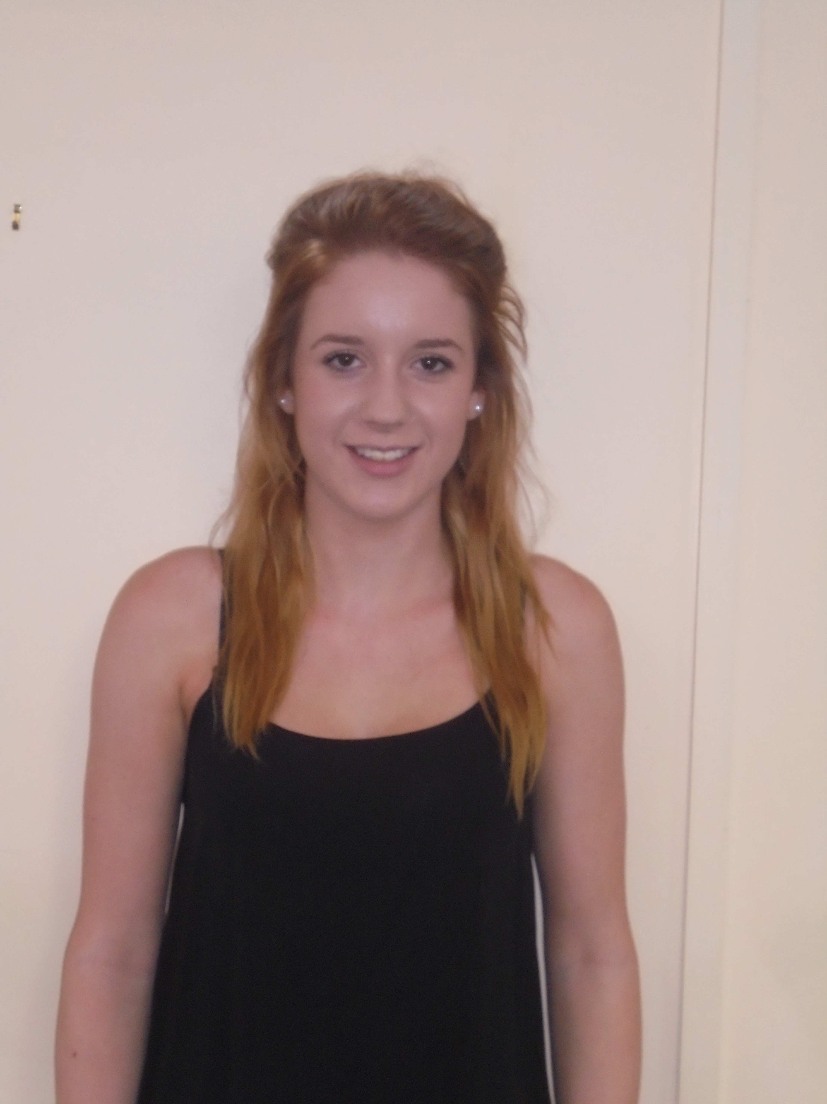
Things to remember for school:
Please remember to send your child into school wearing appropriate clothing for our P.E session on a Thursday. Long hair should be tied back and leggings or joggers are preferable to school trousers and skirts.

Please remember to replenish your child’s change of clothes bag. We are running out of spare clothes and underwear at Nursery. If we aren’t able to change your child, we will have no alternative but to call you to come in with replacements. If you have any school clothes at home, we would really appreciate it if you could return these as soon as possible. Thank you.
 Sea-lions Nursery Class
Term 4

Mrs Ashdown Mrs Dicksee Miss Gilburt
Working together to maximise learning:

We recognise the importance of working together to help your child achieve their very best. We love to hear about their successes at home and encourage you to pick up a WOW leaf from the envelope by the door. We always celebrate the children’s achievements as a class before adding the WOW leaf to our tree.

Please join us on a Friday morning from 8:45- 9:05 for a stay and play session. We will be showing you how we enhance children’s learning in different curriculum areas. This term we will focus on:

Friday 28th February- Maths activities
Friday 6th March- Fine motor activities
Friday 13th March-Sport Relief- physical activities including yoga
Friday 20th March- Phonics activities
Friday 27th March-Learning Journey Look
Friday 3rd April- Easter Egg hunt in the garden

Key dates this term:
Nursery Parents’ Evenings:
A range of appointments will be available throughout the week commencing 23/3/20
Late appointments are available on:
Tuesday 24th March 3:30-5:30pm
Thursday 26th March appointments available from 11:45am- 6pm
Friday 3rd April Easter Egg hunt


Prime Area: Personal, Social and Emotional Development
Self-confidence and self-awareness: We are learning to express our preferences and to give reasons for these. We are developing our self-help skills in terms of putting on our shoes, socks and coats.
Managing feelings and behaviour: We will be talking about what makes a good friend and we will be helping the children to develop strategies to share, take turns and negotiate with their peers.
Making relationships: We will be building relationships through collaborative play. We will have a weekly circle time which will encourage us to learn more about our friends. We will have lots of critical thinking problems to solve so we will have to engage in some great teamwork.

Prime Area: Communication and Language
Listening and attention: We will be listening to stories linked to our topic of Growing. We will be learning texts and we will be using signs and actions to help us remember them. We will be playing lots of memory games in small groups and in our circle time sessions.
Understanding: We will be looking at changes in the garden and we will be thinking about why these occur. We will be following instructions to plant seeds and we will be learning about the use of objects such as trowels, rakes and wheelbarrows.
Speaking: We will be using language to sequence and organise when we retell stories such as Jack and the Beanstalk. We will be looking closely at flowers through magnifying glasses and developing our use of technical terms. We will be focusing on vocabulary development as we try to learn 25 target words every single week!
Specific Area: Expressive Arts and Design
Exploring and using media/materials: This term we will be busy making flower collages and decorating our own plant pots. We will be making observational drawings of plants and flowers. In our mixed media work we will be using seeds, beans and pulses to create patterns. We will make gardening machinery with our construction toys. We will use beans and pulses to create sound makers.
Being imaginative: We will be busy buying and selling in our indoor role play Garden Centre. Outside we will be working in our own garden as we dig, plant, rake and harvest our imaginary plots. We will make our own garden camps with den building equipment.

Shape, Space, Measures: He
Prime Area: Physical Development
Moving and handling: In our fine motor work we will be learning to form recognisable letters. In our Finger-Gym we are developing our tripod grip with lots of creative activities such as extracting water melon seeds with tweezers. Our Gross motor activities will include tree climbing, completing apparatus circuits and controlling small equipment such as balls and bats.
Health and self-care: We will be looking at healthy eating and we will be planting things we can harvest and eat later in the year. We will be talking about where our food comes from and how to eat a balanced diet. We will be learning to use gardening tools safely.

Specific Area: Literacy
Reading: Every week we have a focus text and much of our work is based around this. This term we will be looking at stories with a growing theme. We will study “Mabel’s Magical Garden”, “Jasper’s Beanstalk”, “Jack and the Beanstalk” and “The Tiny Seed”. We will continue with our daily phonics sessions so that we can discriminate between sounds and start to link phonemes to graphemes. Our book corner is having some new furniture and we will be spending lots of time in there enjoying stories with our friends.
Writing opportunities: We will have continuous access to our writing area and we will have writing opportunities outside and in our role play areas. We will be writing shopping lists, instructions for planting seeds and labelling plants. We will also be focussing on writing our names.

Specific Area: Mathematics
Number: This term we will be having a big focus on numeral recognition. We will be learning how to add two groups and we will be refining our counting skills. We will learn about number order and we will learn the terms ‘First, second and third”. We will play number games that involve us in calculating how many more.
Shape, Space, Measures. We will be looking at time and learning about the days of the week and O-clock times. We will be sorting seeds and beans and we will be making real block graphs about our favourite fruits and vegetables. We will make repeating patterns when we print with fruit and vegetables.

Specific Area: Understanding the World

The world: We will be learning about the conditions plants need to grow. We will label and discuss the parts of a flowering plant. We will discuss similarities and differences in flowers and plants. We will also find out which everyday products are derived from plants.

People and Communities: We will be thinking about farmers and the jobs they do. We will begin work on our class flowerbed, planting summer flowering bulbs.

Technology: We will use tablets to photograph weekly changes in our garden. We will retell the story of Jasper’s Beanstalk into a USB microphone. We will investigate pulleys as we try to move heavy objects in the garden.

