Things to Remember:

* SATs Week: Monday 9th May – Thursday 12th May
* Seahaven Academy Transition Week: Monday 4th July – Friday 8th July
* Seaford Head Transition Week: Monday 11th July – Friday 15th July
* P.E. kit for Wednesdays and Thursdays
* School starts at 8.50am – it is really important that your child is on time.
* Please ensure your child is in correct school uniform everyday
* If your child brings a mobile phone to school it must be left at the School Office
* Toast & Talk, run by Mrs Buss, is open each morning to Year 6 from 8.15

Homework

Homework is set on Tuesdays and due in on Mondays. It is important that you support your child with their homework. Any problems, please don’t hesitate to come and speak to me.

Whales’ Class Rules

Be Kind

Be Polite

Be Honest

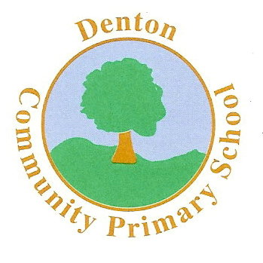 Whales Class

Terms 5 and 6

R.E.

The focus for RE this term is Judaism. We will be looking at the beliefs of the Jewish religion and how these impact on their lifestyle and choices.

SCIENCE

We will be carrying out science investigations and experiments this term which will be linked to our Natural Disasters topic. These investigations will include ‘making’ a volcano and investigating the water cycle.

P.E.

The children will enjoy a range of summer sports. This will include sessions in cricket, rounders and stool ball. Wednesday sessions will continue with Coach (Mr Hymers), who will focus on athletics, football and tag-rugby.

Modern Foreign Languages

We will develop our Spanish by advancing our conversational skills and sharing basic information with new friends.

Art and D.T.

We begin by looking at the painting ‘Great Wave off Kanagawa’ by Hokusai, as part of our Natural Disasters topic. We will be using the painting to inspire our own artwork for the term, using a variety of media in the process.

ENGLISH

This term begins with some work on letters – to the Queen no less! - and instructions, for which I will be sharing an ancient Walsh family sandwich recipe! Later in the term we will be covering a range of genres, including: short stories, persuasive writing, non-chronological reports, poetry and imagery. We will also be working hard on our spelling, punctuation and grammar in preparation for the much awaited SATs whilst perfecting our reading comprehension skills.

.

HISTORY & GEOGRAPHY

This term will have a geography focus and we will be studying natural disasters. This topic will cover physical geography such as rivers and mountains and will then go on to look at earthquakes, volcanoes, tsunamis, tornadoes and storms. We will be using cross curricular resources to maximise learning.

P.H.S.E.

In PSHE we will be learning from the SEAL materials and covering topics such as ‘Moving On’, with a focus on transition to secondary school. We will also be working on emotions and relationships.

MC900358181[1]

MUSIC

The children will take part in a range of singing in assemblies. They will also be learning composition and performance and preparing for another fine Key Stage 2 performance later in the term!

Computing

The children will continue to investigate e-safety issues, before exploring work on mobile phone apps. This will include research and development opportunities before pitching the final product to the class!

MATHS

In Maths the children will cover a range of topics. This term we will begin our SATs revision for which the children will be looking at and completing past papers as well as improving their arithmetic skills. There will be plenty of things for them to practise at home as well! In Term 6 we will begin to look at calculations and prepare the children for the topics they will encounter at secondary school.