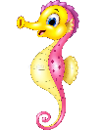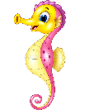

Year 2 Class

Code of Conduct

We will:

* Look after classrooms, make sure rubbish goes in the bin
* Show good listening and good learning
* Listen to all adults
* Put our hand up to speak
* Be kind to all
* Never give up!

Dates for your diary:

Inset Days – Thursday 3rd and Friday 4th September 2020

Term 1: Monday 7th September 2020 – Friday 23rd October 2020

Half Term: Monday 26th October – Friday 30th October 2020

Term 2: Monday 2nd November – Friday 18th December 2020

Christmas Holidays: Monday 21st December – Friday 1st January 2021

Our school website address is:

<http://www.dentonprimaryschool.co.uk/website/sea_horses_year_2__/501477>

and our online blog is there for you to find out information about the class, upcoming events and links to useful websites.

Things to Remember:

* P.E. kit for Monday and Thursday
* Reading book and home-school link book to be in school every day
* Homework projects set each long term
* Spelling test on Fridays
* Our school start time is 8:40 – 8:50am and finish time is 2:50pm

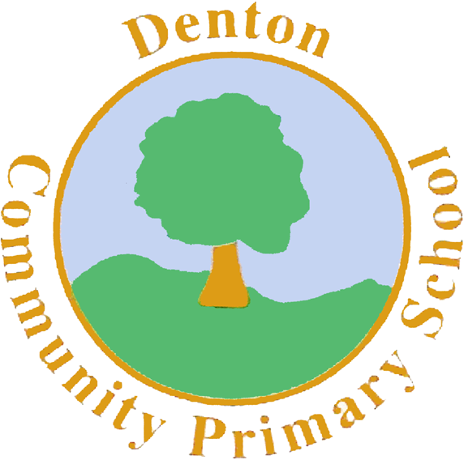

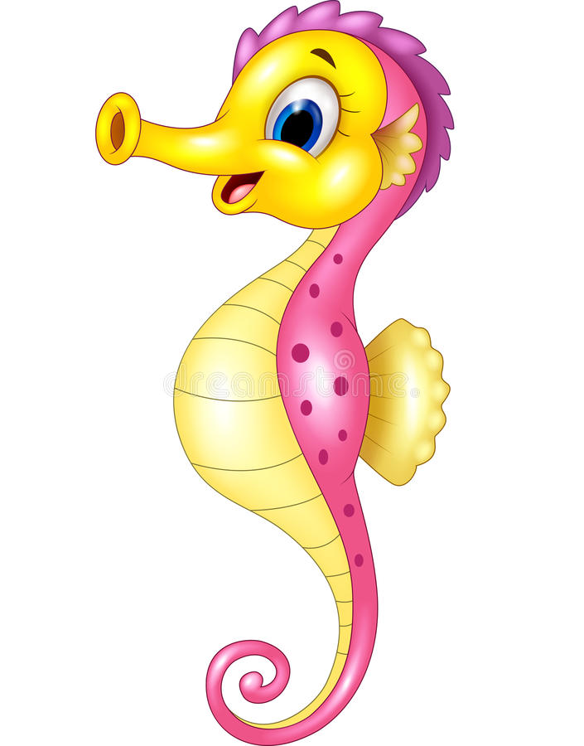

Sea Horse Class

Curriculum Information

Term 1 and 2

2020

If you have concerns or questions please let us know via Dojo or through the office to make an appointment to meet at a mutually convenient time.

Thank you,

Miss Blotz and Miss Ford

Topic

We begin the year with a whole school learning journey called ‘Magical Marvellous Me’. Our focus will be on mindfulness, self esteem and friendship. After this, we move onto our topic ‘Houses and Homes’. We will be exploring different types of houses; those in the past and around the world, materials houses are made out of and how we use our homes to stay safe.

P.H.S.E.

Throughout Term 1 our focus during circle time is mindfulness. Ensuring we can talk about our feelings and identify when we’re feeling certain emotions. We will be introducing the ‘Zones of Regulation’ to support children in recognising when they are finding dealing with their emotions tricky and helping to find ways to manage that emotion. During Term 2 we look at staying safe online and the importance of getting a good night’s sleep.

Music

In Music children will explore a range of songs and rhymes all about houses to the tunes of well-known nursery rhymes. We will learn and sing the songs, exploring the tempo and rhythm of each tune. Then, using a range of musical instruments we will perform the songs, keeping to the beat.

Geography/History

In Term 1, we will focus on History and how houses have changed over the years. We will look at how different materials have been used and why and how the inside of our houses have adapted over time.

In Term 2, we will focus on Geography and where and how different materials are made and produced. We will look at houses around the world, exploring how different countries use different materials.

Art and Design and Technology

We begin Term 1 focusing on Art. Our topic will focus on various artists who paint landscapes and cityscapes including Vincent Van Gogh, Claude Monet and Jean Mertzinger. We will compare and contrast each picture and practise various techniques the artists have implemented.

In Term 2, we move onto Design and Technology where children will design and build their own houses out of junk modelling materials.

Computing

Our first Computing topic is Coding. Children will explore basic algorithms and use them to give commands on their PurpleMash programs to various characters.

After this, we move onto Spreadsheets. Children will use the 2simple program on PurpleMash to collect data and then represent their data onto graphs using copying and pasting techniques.

Literacy

We start our year looking at books to support our self-esteem including ‘The Dot’ by Peter Reynolds and ‘A Huge Bag of Worries’ by Virginia Ironside. Our focus will be on key vocabulary and story sequencing. Then, we move on to various versions of the ‘Three Little Pigs’. We will use the ‘Talk for Writing’ sequence by Pie Corbett to re-create our own versions of the story, write letters to the big bad wolf and create presentations for a house we have designed for the little pigs. Finally, we will use the story ‘A Squash and a Squeeze’ by Julia Donaldson to write newspaper reports. As we head into Christmas, we will focus on writing our own poems using ‘Twas the Night Before Christmas’ and ‘The More it Snows’ for key vocabulary.

Numeracy

Throughout Term 1, we will be recapping basic place value skills with the children; ensuring they are confident counting forwards and backwards, reading and writing numbers and understanding how many tens and units each number contains. We will compare and order numbers and practise counting in 2’s, 5’s and 10’s. In Term 2, addition and subtraction methods are our main focus; ensuring children can confidently use a range of methods including the part/whole model and the number line method to add and subtract independently.

P.E.

Our PE days are a Monday, with our sports coach, and a Thursday with me. Children need to bring their shorts, a t-shirt, trainers and plimsolls on these days. Children need to remove earrings as they cannot do PE with them in.

**Long hair needs to be tied back every day please**.

During Term 1 children will focus on Dance (with me), creating a dance sequence to the story of the Three Little Pigs and Football with coach. During Term 2, we move onto Gymnastics, looking at balance and travelling and Basketball with coach.

Science

We will focus on materials, thinking about different types, their properties and sustainability. We will explore the life of Scottish inventor, Charles Macintosh, who invented the waterproof raincoat, and plan a range of experiments that include testing various materials, making predictions and explaining our results.

Homework

Homework Projects will be set in the first few weeks of each long term. Each project will be tailored towards our current topic and will contain a range of different activities for children to complete. Spellings will be set weekly, then tested on a Friday. Please also ensure nightly reading is completed with your child and noted in their reading logs.

R.E.

In Term 1, we are focusing on bible stories and the morals of each story. We will explore how we can take these morals and use them in real life experiences.

In Term 2, we will look at the Christmas Story, focusing on the journey Mary and Joseph take.