Starfish Learning Week beginning 30th March 2020
Maths | Warm-up: times tables. Play a times-table game every day. (The most useful times tables are 6x, 7x, 8x, and 9x).  We don’t get much time at school to solve lots of number puzzles and investigations. So, we’re going to put that right this week!  Open up the ‘Puzzles, Challenges and Investigations’ document. In here you will find a huge range of challenging activities aimed at years 1-6. Have a go at 1 or more of these investigations in each session. They are designed to be at a ‘challenge’ level for each year group, so don’t be put off trying year 3 and 4 puzzles (or even a year 2 problem as a warm-up!).  The answers are all at the end of the document so you can check if you are right or not. Please feel free to work with each other to solve these; talking your way through a problem if you are really stuck is a very effective strategy!  There is also no right or wrong about written strategies to solve these problems; the ‘find all possibilities’ problems may require a grid to organise your thinking, or drawing pictures could be a useful way of understanding the problem. Remember – each problem may require a different approach!  If you find any creative ways of representing any of these problems using apparatus you have at home, do send them to me and I will do my best to share them with the rest of the class.
Literacy | SPaG: Synonyms and Antonyms  A synonym is a word that means the same as another (e.g. ‘large’ is a synonym of ‘big’) and an antonym is simply the opposite (e.g. ‘small’ is an antonym of ‘big’). Complete the ‘Synonyms and Antonyms’ grid on the website, and use these as your handwriting words and spellings this week.  Once you have filled out the grid, try to think of your own ‘root’ words and find synonyms and antonyms of your words. Who can find the best one? Dojos for the winner!  Writing – ‘Fantasy Story’  Time Travel  One evening you go to your computer and accidentally press one of the keys you have never pressed before. Suddenly you are transported into a different time! Your task is to write about where you travel to, what the place is like, who you meet and how you manage to get home again. Will you travel to the past (e.g. the Jurassic Era of dinosaurs, or Vikings) or the future (space travel and amazing inventions and gadgets)?  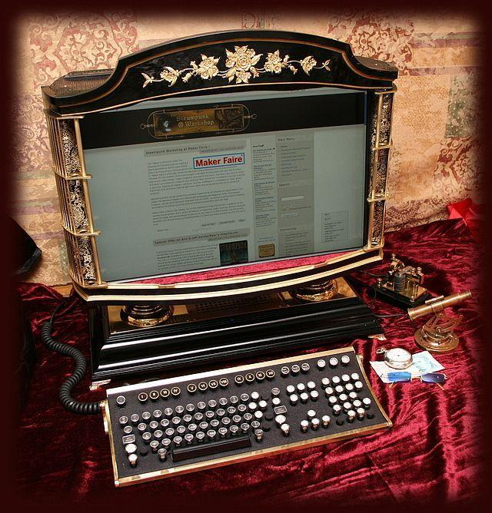  Planning Questions  Where did you travel to and what form did your transport/journey take? (Remember: You can travel back or forwards in time.) What is the place you visit like? Who do you meet? What are they like? How do you manage to get back home?  You might want to create a story map on the first session. Then write the story a chapter a day. Up to you! If you do any on the computer, I will do my best to upload them to our class page.
Science | Go to the Science Sparks website at www.science-sparks.com and try one of the experiments. You can upload any photos to the class page on Class Dojo.
Geography | For the final session of our ‘Natural Disasters’ topic, we are in the middle of a global natural disaster right now. Create an information page on the Coronavirus Pandemic (what is a ‘pandemic?!) for children in the future to read about. Include details of how it has affected you and your family. What is it like being under lockdown?
Art | Go to https://www.bbc.co.uk/programmes/p07kdz8k. Choose one of the ‘ten pieces’ of music to listen to and create a picture that could go with the music. Use whatever you want to make your piece of art and send me a picture of it on dojo if you can.
PE | Joe Wicks is running free daily PE lessons from his Youtube website. Try going out for a walk every day if you are able to.

