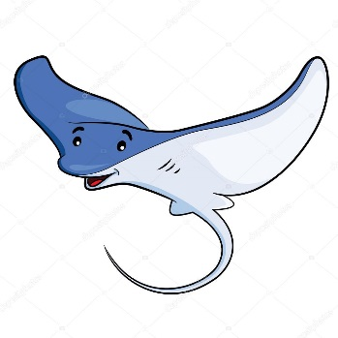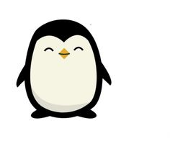 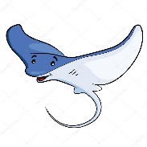

Dates for your diary:

Term 1 starts for children: Tuesday 5th September 2017

Half Term: Monday 23rd October – Friday 27th October 2017

Term 2 starts for children: Monday 30th October 2017

Stingray Class Assembly: Thursday 9th November 2017 at 9:10am

Penguin Class Assembly: Thursday 16th November 2017 at 9:10am

Term 2 finishes: Wednesday 20th December 2017

Year 3 Class

Code of Conduct

We will:

* Look after classrooms, make sure rubbish goes in the bin
* Sit quietly
* Listen to all adults
* Put our hand up to speak
* Be kind to everyone
* Do our best work in every lesson

Our school website address is:

<http://www.denton.e-sussex.sch.uk/> and our online blog is there for you to find out information about the class, upcoming events and links to useful websites

Things to Remember:

* P.E. kit for Monday (Stingrays), Thursday (Penguins) and Friday
* Reading book and home-school link book to be in school every day
* Homework in on Fridays
* Spelling test on Fridays
* School starts at 8:50am with gates open at 8:40am

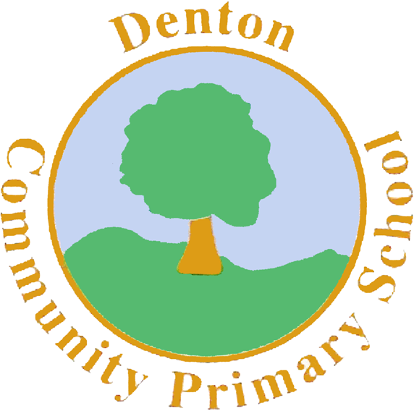

Penguin and Stingray Class

Curriculum Information

Term 1 and 2

2017

If you have concerns or questions please let us know.

We will be in the Key Stage Two playground before school where you can make an appointment to meet at a mutually convenient time.

Thank you,

Miss Blotz and Miss Morgan

P.E.

Our PE days are Monday, Thursday and Friday. Children need to bring their shorts, a t-shirt, trainers and plimsolls on these days. Children need to remove earrings on these days as they cannot do PE with them in.

**Long hair needs to be tied back every day please**.

Our focus in PE is Gymnastics. Children will use the hall equipment to experiment travelling and moving across the beams, apparatus and horses. Children will also take part in a PE session each week with our sports coach.

Spanish

Year 3 sees the introduction of Spanish to our curriculum. We begin the year learning body parts and will learn the song ‘Head, shoulders, knees and toes’. After this we will focus on basic greetings and colours.

Computing

In Computing we are going to focus on basic computer programming. Children will continue to build their knowledge of ‘Scratch’ to create simple algorithms to move characters in the program.

Science

During Term 1 our focus is on ‘The Senses’. Children will be conducting experiments to investigate each of the senses, whilst also learning about the anatomy of the eye, nose, ear, tongue and hand.

In Term 2 our topic is ‘Rocks’. We will be investigating the layers of the Earth’s crust, looking at volcanoes and exploring different types of rocks and minerals.

Topic

We begin our year with a whole school topic on poet, Michael Rosen. Our focus is on his poem ‘Hand on the Bridge’. We will learn the poem alongside a range of activities, whilst also exploring his life. After this we move on to thinking about the ‘Vikings’. We will investigate life and experiences throughout the Viking era, linking a range of stories and legends to our work.

Music

We will be thinking about rhythm and tempo during our music lessons during Term 1 and 2. We will learn a range of Viking camp songs and also make our own instruments such as drums and shakers to play alongside.

P.H.S.E.

We begin the year with our topic ‘New Beginnings’. We focus on feeling settled in our new classroom environments and feeling confident to express our feelings with our class mates.

Homework

Homework is set on a Friday for children to return by the following Friday and will relate to previous or future work in class. Later in the term spellings will be stuck into reading records to be practised and learnt for a test the following week.

Literacy

We begin Term 1 learning the poem ‘Hand on the Bridge’ by Michael Rosen. We will use the ‘Talk for Writing’ approach to learn and create our own poetry with a similar format.

After this we move on to writing instructions on ‘How to train a dragon’ and learning various Viking legends and stories. Once again we will use the ‘Talk for Writing’ format so children will have the opportunity to re-create their own Viking legends.

Art and Design and Technology

During our ‘Hand on the Bridge’ topic we will be creating some hand printing pictures, our aim to create a printed mural to go alongside our poetry. After this we will be researching Viking longboats. Children will design, create and evaluate their longboats.

Numeracy

Our focus throughout Term 1 and 2 in Numeracy will be on place value. We will be recapping our work on units, tens and hundreds, plotting numbers on number lines and counting in steps of 2, 3, 5, 10 and 100. For some, we will begin thinking about counting down to negative numbers and becoming confident plotting them on a number line. We will introduce recognising basic Roman numerals, whilst also focusing on counting and adding money. We will end Term 2 by recapping written methods for addition and subtraction.

R.E.

We begin our RE sessions focusing on Judaism looking at the significance of the Sukkot and the Torah.

In Term 2 we focus on Christianity and in particular the Christmas Story. Children will have the opportunity to visit out local church during Term 2.

Geography/History

Our focus this term will be History. Children will explore what life was like during the Viking era. We will learn about Viking rules, jobs and food. We will explore the countries that the Vikings both lived and those they invaded. All our information will go towards creating a survival guide on being a Viking.