Dear Parents/ Carers,
As I am sure you are aware, as well as being an enjoyable pastime, reading impacts hugely on children’s writing ability and general learning. We encourage children to read as much as possible, both at home and in school. To assist with the difficult task of choosing a new book, we have put together a recommended reading list. Whilst the children have access to a variety of books within each classroom, we are aware of the fact that not all of the below titles are available to the children in school. We are currently working on increasing the range of fiction books available to the children both in class and in the library.
In the meantime, we also encourage them to bring in their own books from home. The list below represents a cross-section of books suitable for your child’s year group. Happy reading!

Regards,
Miss George

Humour
David Walliams Collection
The Boy in the Dress is a story all about a boy who doesn't fit in. When he tries on a dress, his life changes. But should he keep this a secret? Mr Stink follows and this is a book about a stinky tramp who has a surprising past. Billionaire Boy is about how money can't buy you everything, especially friends; while Ratburger follows Zoe as she tries to keep her beloved rat safe from Burt of Burt's Burgers; Demon Dentist is jaw-achingly funny; and Awful Auntie finds Stella Saxby battling her aunt for her rightful inheritance of Saxby Hall.
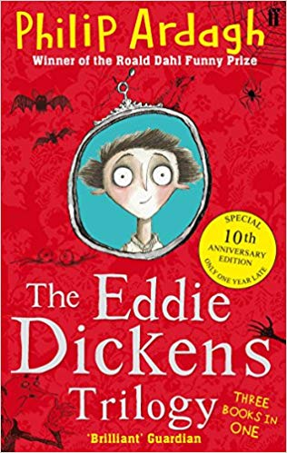 | Eddie Dickens Trilogy – Philip Ardagh  Awful End  When both of Eddie Dickens's parents catch a disease that makes them turn yellow, go a bit crinkly round the edges and smell of hot water bottles, it's agreed he should go and stay with relatives at their house Awful End. Unfortunately for Eddie, those relatives are Mad Uncle Jack and Even-Madder Aunt Maud, and it doesn't look as if the three of them are ever going to reach their destination ...  DREADFUL ACTS  Eddie Dickens narrowly avoids an explosion, a hot-air balloon and arrest, only to find himself falling head-over heels for a girl with a face like a camel's, and into the hands of a murderous gang of escaped convicts who have 'one little job for him to do'.  TERRIBLE TIMES  Eddie had been given the task of travelling to America to look after his family's interests there. But his life is never that simple; especially with a potential stowaway in his trunk, and Lady Constance Bustle at his side. She's a professional 'travelling companion', whose previous employers seem to have died under the most remarkable and unfortunate circumstances ...
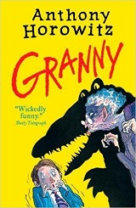 | Granny – Anthony Horowitz  Anthony Horowitz, creator of the bestselling Alex Rider series has written a wickedly funny story, with hilarious illustrations by Tony Ross. Twelve-year-old Joe has an unbelievably evil Granny. Not only is Granny physically repulsive and horribly mean, but she also has the look in her eye of a predatory crocodile. Soon Joe starts to suspect that she has unpleasant designs on him. But what are they and how can he foil them?
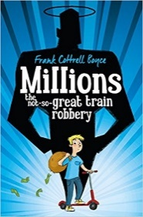 | Millions – Frank Cottrell Boyce  Two brothers, Damian and Anthony, are unwittingly caught up in a train robbery during Britain's countdown to joining the Euro. Suddenly finding themselves with a vast amount of cash, the boys have just one glorious, appalling dilemma – how to spend it in the few days before it becomes worthless. Torn between the vices of buying a million pizzas and the virtues of ending world poverty, the boys soon discover that being rich is a mug's game. For not only is the clock ticking – the bungling bank robbers are closing in too.  Pizzas or World Peace – what would you choose?
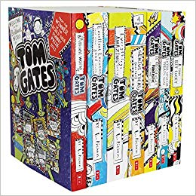 | Tom Gates Collection  The hilarious tales follow Tom as he goes about his daily life and has all kinds of unlucky adventures. I'm Tom Gates. When my teachers don't have their beady eyes on me, I like to draw pictures and think of ways to annoy Delia. My teachers think I am easily distracted and 'lack focus'. Which is a bit harsh, because right now I am very focused on which biscuit I should eat first... A hilarious set of books reminiscent of Adrian Mole, perfect for young boys and girls over the age of 9 years who love David Walliams and Diary of a Wimpy Kid.
Fantasy
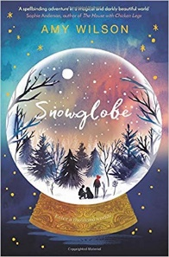 | Snowglobe – Amy Wilson  When daydreamer Clementine discovers a mysterious house standing in the middle of town that was never there before, she is pulled towards it by the powerful sense of a mother she never knew. The place is full of snowglobes, swirling with stars and snow and each containing a trapped magician, watched over by Gan, the bitter keeper of the house. One of these is Dylan, a boy who teases her in the real world but who is now desperate for her help. So Clem ventures into the snowglobes, rescuing Dylan and discovering her own powerful connection to the magic of these thousand worlds. Vowing to release the magicians from the control of their enchantments, Clem unknowingly unleashes a struggle for power that will not only put her family, but the future of magic itself in danger.
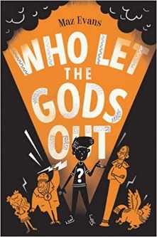 | Who Let The Gods Out? – Maz Evans  Elliot's mum is ill and his home is under threat, but a shooting star crashes to earth and changes his life forever. The star is Virgo - a young Zodiac goddess on a mission. But the pair accidentally release Thanatos, a wicked death daemon imprisoned beneath Stonehenge, and must then turn to the old Olympian gods for help. After centuries of cushy retirement on earth, are Zeus and his crew up to the task of saving the world - and solving Elliot's problems too?
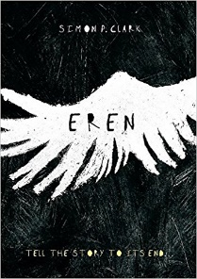 | Eren – Simon Clarke  People are keeping secrets from Oli. His mum has brought him to stay with his aunt and uncle in the countryside, but nobody will tell him why his dad isn’t with them. Where is he? Has something happened? Oli has a hundred questions, but then he finds a secret of his own: he discovers the creature that lives in the attic… Eren. Eren is not human. Eren is hungry for stories. Eren has been waiting for him. Sharing his stories with Eren, Oli starts to make sense of what’s happening downstairs with his family. But what if it’s a trap? Soon, Oli must make a choice: learn the truth – or abandon himself to Eren’s world, forever.
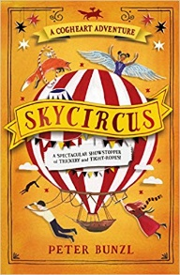 | Skycircus – Peter Bunzl  When a travelling skycircus arrives in Brackenbridge, Lily and Robert can't wait to step aboard... But there's something sinister about the hybrid children who appear as part of the act. And before Lily and Robert can do anything, they're captured by shadowy figures and whisked off in the mysterious flying circus to somewhere far, far away... Treachery, tight-ropes and trickery combine in this incredible third Cogheart adventure...
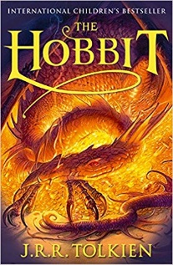 | Hobbit – J.R.R. Tolkien  The Hobbit is the unforgettable story of Bilbo, a peace-loving hobbit, who embarks on a strange and magical adventure. A timeless classic. Bilbo Baggins enjoys a quiet and contented life, with no desire to travel far from the comforts of home; then one day the wizard Gandalf and a band of dwarves arrive unexpectedly and enlist his services – as a burglar – on a dangerous expedition to raid the treasure-hoard of Smaug the dragon. Bilbo’s life is never to be the same again.
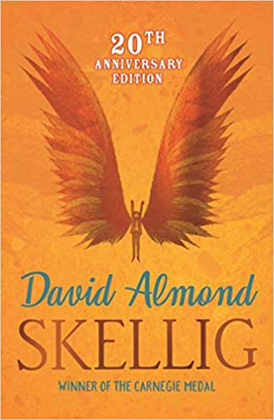 | Skellig – David Almond  When a move to a new house coincides with his baby sister's illness, Michael's world seems suddenly lonely and uncertain. Then, one Sunday afternoon, he stumbles into the old, ramshackle garage of his new home, and finds something magical. A strange creature - part owl, part angel, a being who needs Michael's help if he is to survive. With his new friend Mina, Michael nourishes Skellig back to health, while his baby sister languishes in the hospital. But Skellig is far more than he at first appears, and as he helps Michael breathe life into his tiny sister, Michael's world changes for ever . . .
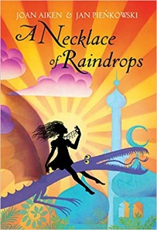 | A Necklace of Raindrops – Joan Aiken  From 'A Necklace of Raindrops' to 'The Patchwork Quilt', here are eight classic stories to treasure and enjoy. Beginning and ending with a birthday, this spell-binding collection conjures up a world filled with magic, where wishes can come true. A necklace of raindrops that keeps its owner dry in the heaviest rainstorm; a tiger that runs faster than the wind; a huge floating apple pie with a piece of sky in it; a baker's cat who swells to the size of a whale when his mistress feeds him yeast; a house that stands on one leg - these are just some of the objects and characters that figure in these delightful stories.
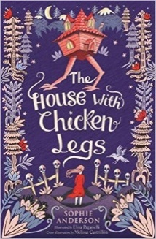 | The House With Chicken Legs – Sophie Anderson  Marinka dreams of a normal life, where her house stays in one place long enough for her to make friends. But her house has chicken legs and moves on without warning. For Marinka's grandmother is Baba Yaga, who guides spirits between this world and the next. Marinka longs to change her destiny and sets out to break free from her grandmother's footsteps, but her house has other ideas...
Classics
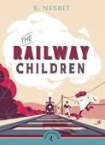 | The Railway Children – E Nesbit  The Railway Children, by E. Nesbit, is the charming and heart-warming tale of three children who are abruptly transported from a comfortable life in London to an impoverished existence in the country when their father has to go away. Where he has gone and why remains a mystery to the children but, in the meantime, their lives are filled with interesting adventures that will captivate young readers from 9+. The Railway Children is one of the...
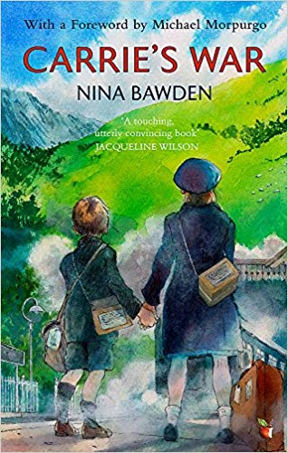 | Carrrie’s War – Nina Bawden  It is wartime and Carrie and her little brother Nick have been evacuated from their London home to the Welsh hills. In an unfamiliar place, among strangers, the children feel alone and find little comfort with the family they are billeted with: Mr Evans, a bullying shopkeeper and Auntie Lou, his kind but timid sister.
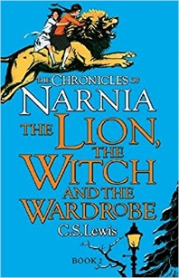 | Chronicles of Narnia; The Lion The Witch and The Wardrobe – C.S. Lewis  Four adventurous siblings―Peter, Susan, Edmund, and Lucy Pevensie― step through a wardrobe door and into the land of Narnia, a land frozen in eternal winter and enslaved by the power of the White Witch. But when almost all hope is lost, the return of the Great Lion, Aslan, signals a great change . . . and a great sacrifice.
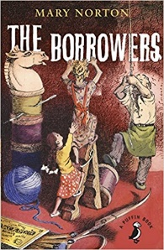 | The Borrowers – Mary Norton  The Borrowers live in the secret places of quiet old houses; behind the mantelpiece, inside the harpsichord, under the kitchen clock. They own nothing, borrow everything, and think that human beings were invented just to do the dirty work. Arrietty's father, Pod, was an expert Borrower. He could scale curtains using a hatpin, and bring back a doll's teacup without breaking it. Girls weren't supposed to go borrowing but as Arrietty was an only child her father broke the rule, and then something happened which changed their lives. She made friends with the human boy living in the house...
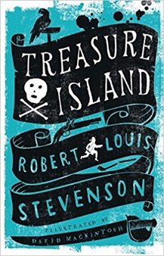 | Treasure Island – Robert Louis Stevenson  Treasure Island's timeless tale of pirates, lost treasure maps, mutiny and derring-do has appealed to generations of readers ever since Robert Louis Stevenson penned it in 1881 with the claim: "If this don't fetch the kids, why, they have gone rotten since my day." But more than just a children's classic, the novel is considered to be one of the greatest feats of storytelling in the English language, with characters such as the unforgettable Long John Silver becoming part of the cultural consciousness. Treasure Island is a coming-of-age story that will captivate both adults and children for as long as stories are told.
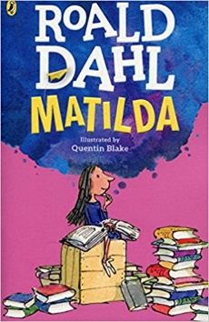 | Matilda – Roald Dahl  Matilda is the world's most famous bookworm, no thanks to her ghastly parents. Her father thinks she's a little scab. Her mother spends all afternoon playing bingo. And her headmistress, Miss Trunchbull? She's the worst of all. She's a big bully, who thinks all her pupils are rotten and locks them in the dreaded Chokey. Despite these beastly grownups trying to push her down, Matilda is an extraordinary girl with a magical mind. And she's had enough. So all the terrible adults had better watch out, because she's going to teach them a lesson they'll never forget!
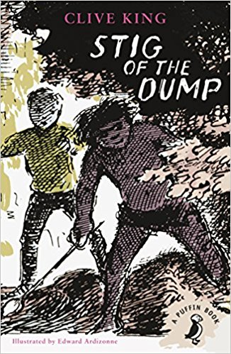 | Stig of the Dump – Clive King  Barney is a solitary little boy, given to wandering off by himself. One day he is lying on the edge of a disused chalk-pit when it gives way and he lands in a sort of cave. Here he meets 'somebody with a lot of shaggy hair and two bright black eyes' wearing a rabbit skin and speaking in grunts. He names him Stig. Of course nobody believes Barney when he tells his family all about Stig, but for Barney cave-man Stig is totally real. They become great friends, learning each other’s ways and embarking on a series of unforgettable adventures.
Adventure
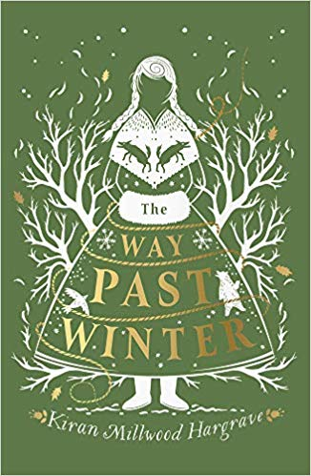 | The Way Past Winter – Kiran Millwood Hargrave  Mila and her sisters live with their brother Oskar in a small forest cabin in the snow. One night, a fur-clad stranger arrives seeking shelter for himself and his men. But by the next morning, they've gone - taking Oskar with them. Fearful for his safety, Mila and her sisters set out to bring Oskar back - even it means going north, crossing frozen wild-lands to find a way past an eternal winter.
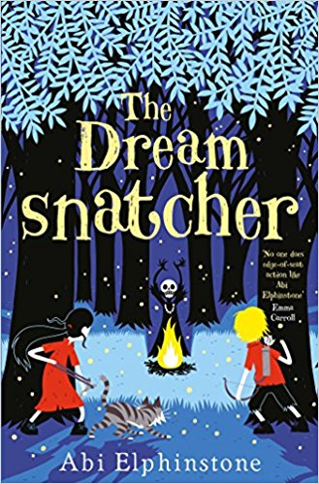 | Dream Snatcher – Abi Elphinstone  Twelve-year-old Moll Pecksniff wakes one night in the middle of the forest, lured there by a recurring nightmare - the one with the drums and the rattles and the masks. The Dreamsnatcher is waiting. He has already taken her dreams and now he wants her life. Because Moll is more important than she knows… The Oracle Bones foretold that she and Gryff, a wildcat that has always been by her side, are the only ones who can fight back against the Dreamsnatcher's dark magic. Suddenly everything is at stake, and Moll is drawn into a world full of secrets, magic and adventure.
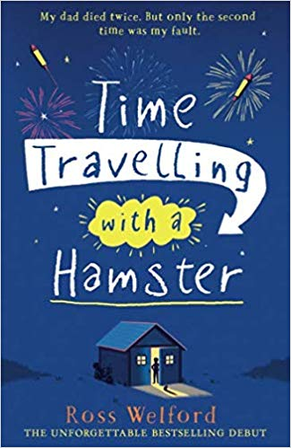 | Time Travelling With a Hamster – Ross Welford  On Al Chaudhury’s twelfth birthday his beloved Grandpa Byron gives him a letter from Al’s late father. In it Al receives a mission: travel back to 1984 in a secret time machine and save his father’s life. Al soon discovers that time travel requires daring and imagination. It also requires lies, theft, setting his school on fire and ignoring philosophical advice from Grandpa Byron. All without losing his pet hamster, Alan Shearer… Time Travelling With a Hamster is a funny, heart-warming race-against-time – and across generations – adventure that you will won’t be able to put down.
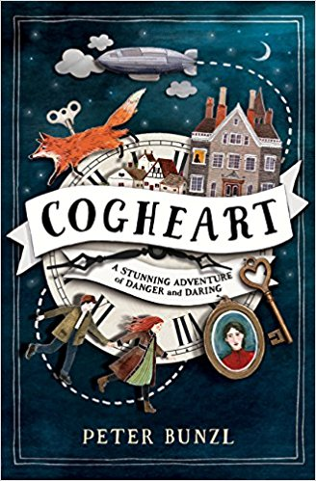 | Cogheart – Peter Bunzl  Lily's life is in mortal peril. Her father is missing and now silver-eyed men stalk her through the shadows. What could they want from her?  With her friends - Robert, the clockmaker's son, and Malkin, her mechanical fox - Lily is plunged into a murky and menacing world. Too soon Lily realizes that those she holds dear may be the very ones to break her heart... Murder, mayhem and mystery meet in this gripping Victorian adventure.
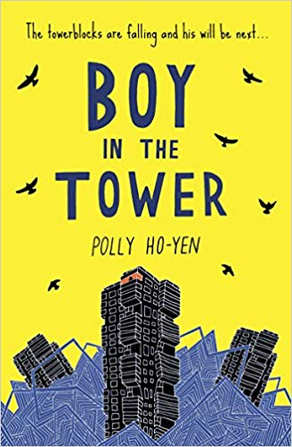 | Boy in the Tower – Polly Ho-Yen  Ade loves living at the top of a tower block. From his window, he feels like he can see the whole world stretching out beneath him. His mum doesn’t really like looking outside – but it’s going outside that she hates. She’s happier sleeping all day inside their tower, where it’s safe. But one day, other tower blocks on the estate start falling down around them and strange, menacing plants begin to appear. Now their tower isn’t safe anymore. Ade and his mum are trapped and there’s no way out . . .
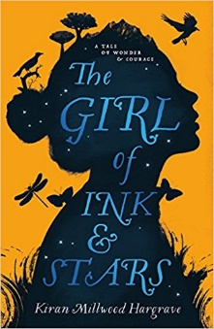 | The Girl of Ink and Stars – Kiran Millwood Hargrave  Forbidden to leave her island, Isabella dreams of the faraway lands her cartographer father once mapped. When her friend disappears, she volunteers to guide the search. The world beyond the walls is a monster-filled wasteland - and beneath the dry rivers and smoking mountains, a fire demon is stirring from its sleep. Soon, following her map, her heart and an ancient myth, Isabella discovers the true end of her journey: to save the island itself.
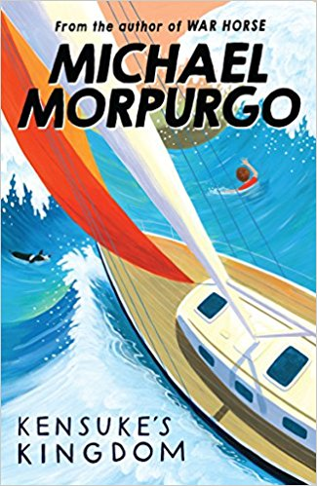 | Kensuke’s Kingdom – Michael Morpurgo  Washed up on an island in the Pacific, Michael struggles to survive on his own. With no food and no water, he curls up to die. When he wakes, there is a plate beside him of fish, of fruit, and a bowl of fresh water. He is not alone . . .
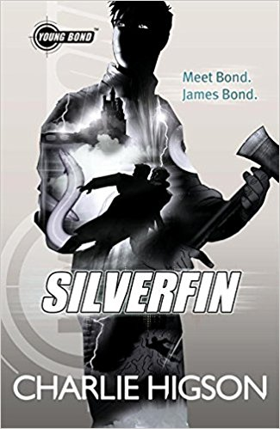 | Silverfin – Charlie Higson  Before the name became a legend. Before the boy became a man. Meet Bond. James Bond. There's something in the water at Loch Silverfin. Something deadly. Something that must be kept secret... It's James Bond's first day at Eton, and he's already met his first enemy. This is the start of an adventure that will take him from the school playing fields to the remote shores of Loch Silverfin and a terrifying discovery that threatens to unleash a new breed of warfare.
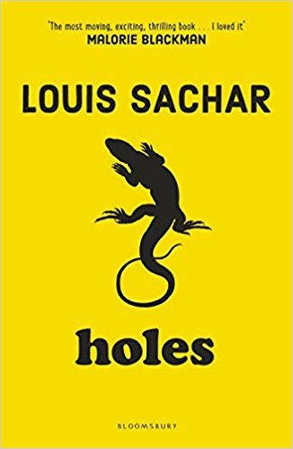 | Holes – Louis Sachar  Stanley Yelnats' family has a history of bad luck, so when a miscarriage of justice sends him to Camp Green Lake Juvenile Detention Centre (which isn't green and doesn't have a lake) he is not surprised. Every day he and the other inmates are told to dig a hole, five foot wide by five foot deep, reporting anything they find. The evil warden claims that it is character building, but this is a lie and Stanley must dig up the truth.
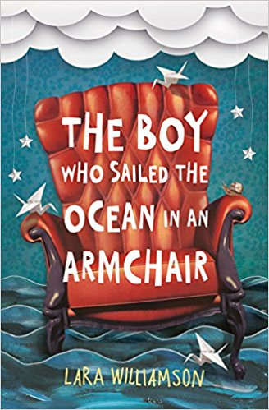 | The Boy Who Sailed The Ocean in an Armchair – Lara Williamson  Becket Rumsey is all at sea. His dad has run away with him and his brother Billy in the middle of the night. And they've left everything behind, including their almost-mum Pearl. Becket has no idea what's going on - it's a mystery. So with the help of Billy and a snail called Brian, Becket sets out on a journey of discovery. It's not plain sailing but then what journeys ever are? An extraordinary story of courage, dreams and finding your way,
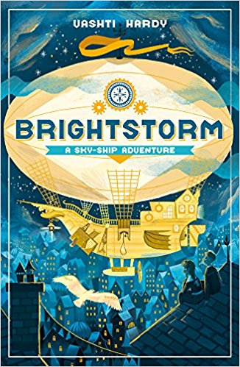 | Brightstorm – Vashti Hardy  Twins Arthur and Maudie Brightstorm receive word in Lontown that their famous explorer father has died in a failed attempt to reach the southernmost point in the world. Not only that, but he has been accused of stealing fuel before he died! The twins don't believe the news, and they answer an ad to join a new attempt to reach South Polaris. It's their only hope of learning the truth ... and salvaging their family's reputation. As the winged ship Aurora sets sail, the twins must keep their wits about them and prove themselves worthy of the rest of the crew. But will Arthur and Maudie find the answers?
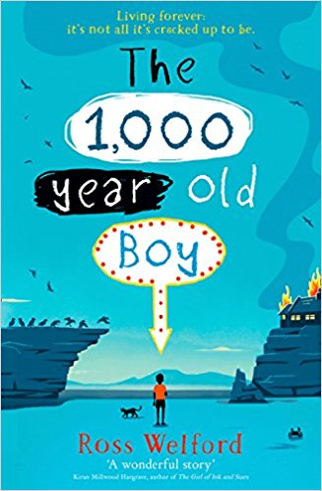 | The 1,000 Year Old Boy – Ross Welford  There are stories about people who want to live forever. This is not one of those stories. This is a story about someone who wants to stop… Alfie Monk is like any other nearly teenage boy – except he’s 1,000 years old and can remember the last Viking invasion of England. Obviously no one believes him. So when everything Alfie knows and loves is destroyed in a fire, and the modern world comes crashing in, Alfie embarks on a mission to find friendship, acceptance, and a different way to live… which means finding a way to make sure he will eventually die.
Children’s Life
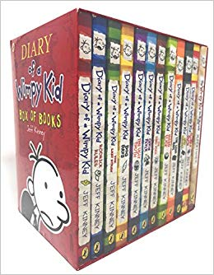 | Diary of a Wimpy Kid Collection – Jeff Kinney  Greg is an average American schoolboy, but he has a habit of getting into embarrassing but hilarious situations. These laugh-out-loud books follow his journal as he makes observations on his days and doodles away. From classic road trips to tales of hard luck and the terrifying prospect of finding a date for Valentine's Day, these misadventures are sure to have children (and you!) laughing out loud.
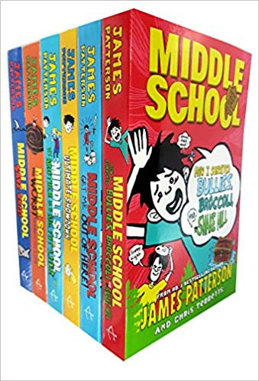 | Middle School Collection – James Patterson  the books follow the life of Rafe Khatchadorian and all the misadventures he embarks on as he tries to get through middle school - and survive his home life! Throughout the books, he plans for the best year ever by trying to break every one of his school's archaic rules; and heads to seventh grade for life at an art school in the big city. We also check in on his sister, Georgia, who is planning to excel in all the ways he failed. But proving herself the most popular girl in school is harder than it looks, especially with Rafe sneaking around.
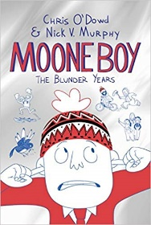 | Moone Boy – Chris O’Dowd  Martin Moone is eleven and completely fed up with being the only boy in a family of girls. He's desperate for a decent wingman to help him navigate his idiotic life. So when best mate Padraic suggests Martin get an imaginary friend - or 'IF' for short - he decides to give it a go. His first attempt is Loopy Lou, a hyperactive goofball who loves writing rubbish rap songs. But Martin soon gets fed up with Lou's loopiness and decides to trade in his IF for someone a little less wacky. Enter Sean 'Caution' Murphy, an imaginary office clerk in a bad suit with a passion for laziness and a head full of dodgy jokes. Sean is full of tips and tricks to guide Martin through the perils of the playground, from dealing with his sisters' pranks to beating the bullying Bonner boys. But getting rid of Lou is not that easy, and having TWO imaginary friends is a recipe for trouble!
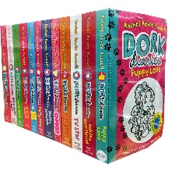 | Dork Diaries Collection – Rachel Renee Russell  Written in a fun-filled diary format, these books offer an insight into the life of the tween dork, Nikki. When she moves to a new school she decides it's the perfect time to leave her old lame ways behind - but things are never that simple. With fun sketches and doodles, the diary entries find Nikki opening up her heart as she battles with her arch-nemesis Mackenzie over her dreams of becoming a pop star and tackles the subject of love with hilariously dorky consequences.
Raspberries on the Tangtze – Karen Wallace
This is Nancy's story. Naturally inquisitive, she's always getting into trouble, along with her dreamer, pain-in-the-butt older brother Andrew, best friends Clare and Amy who live in the back of an old car, and weird sisters Sandra and Tracy, with their magazines full of boys. The children have known each other and their families for ever, but everything they thought they knew, is about to change.
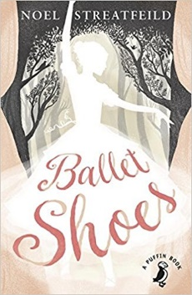 | Ballet Shoes – Noel Streatfeild  Pauline, Petrova and Posy Fossil are sisters - with a difference. All three were adopted as babies by Great Uncle Matthew, an eccentric and rich explorer who then disappeared, leaving them in the care of his niece Sylvia. The girls grow up in comfort until their money begins to run out and nobody can find Great Uncle Matthew. Things look bleak until they hit on an inspired idea: Pauline, Petrova and Posy will take to the stage. But it's not long before the Fossils learn that being a star isn't as easy as they first thought...
History Based
Armistice Runner – Tom Palmer
Lily has lots of worries. She's struggling to compete in her fell-running races and, worse, she's losing her gran to Alzheimer's. But then she discovers her great-great-grandfather's diaries from the First World War. Could his incredible story of bravery help her reconnect with her gran and even give her the inspiration she needs to push through and win?
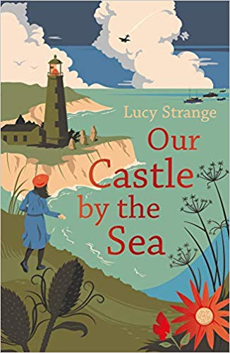 | Our Castle by the Sea – Lucy Strange  England is at war. Growing up in a lighthouse, Pet's world has been one of storms, secret tunnels and stories about sea monsters. But now the clifftops are a terrifying battleground, and her family is torn apart. This is the story of a girl who is small, afraid and unnoticed. A girl who freezes with fear at the enemy planes ripping through the skies overhead. A girl who is somehow destined to become part of the strange, ancient history.
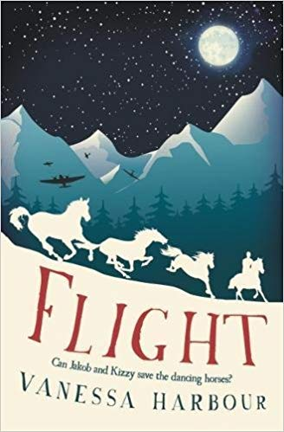 | Flight – Vanessa Harbour  Austria 1945. After losing his family, Jakob shelters with Herr Engel in a rural stable, where they hide the precious Lipizzanner stallions they know Hitler wants to steal. When a German officer comes looking for Jakob and finds the horses, Jakob and his guardian know they must get the stallions to safety, but the only way is straight through Nazi territory. Joined by Kizzy, an orphan Roma girl, the three must guide the horses across the perilous Austrian mountains. Will they reach safety? What will be waiting for them on the other side?
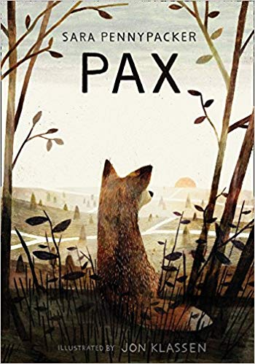 | Pax – Sara Pennypacker  Pax was only a kit when his family was killed and he was rescued by ‘his boy’, Peter. Now the country is at war and when his father enlists, Peter has no choice but to move in with his grandfather. Far worse than leaving home is the fact that he has to leave Pax behind. But before Peter spends even one night under his grandfather’s roof he sneaks out into the night, determined to find his beloved friend. This is the story of Peter, Pax, and their journeys back to each other as war rampages throughout the country.
Non-Fiction
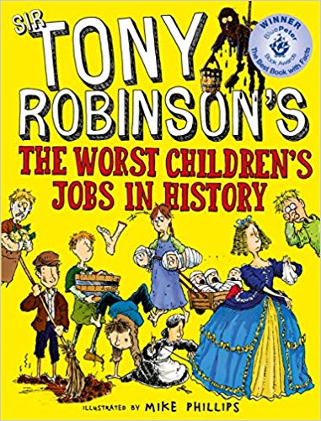 | Children’s Worst Jobs in History – Tony Robinson  n The Worst Children's Jobs in History Sir Tony Robinson takes you back to the days when being a kid was no excuse for getting out of hard labour. This book tells the stories of all the children whose work fed the nation, kept trains running, and put clothes on everyone’s backs, over the last few hundred years of Britain’s history.
Guinness Book of World Records 2019
Guinness World Records 2019 is fully updated with everything from the year's most significant sporting achievements and scientific discoveries to the latest chart toppers and digital TV releases. Our special 'Meet the Makers' and 'Making History' chapters celebrate build-at-home creativity on an epic scale, and anyone keen to break a record of their own will find some inspiration in a 'Do try this at home' bonus section.
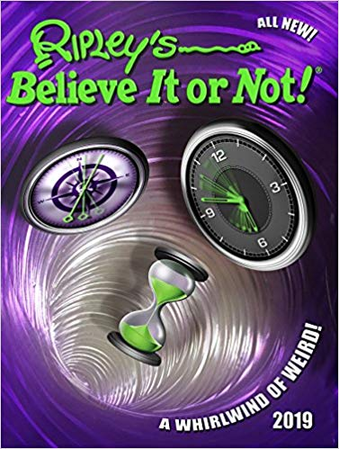 | Ripley’s Believe It Or Not  Ripley’s is back with another compendium of mind-boggling facts that will delight anyone drawn to the weirder side of life on Earth. Read about the scariest, grossest and funniest stories from around the world, including: EEK! The huge spider that spins webs that are stronger than steel.  WOW! The woman who can smash 920 roof tiles every minute – with her bare hands.  YUCK! The Japanese crab that grows as much as six metres long.
Match – Football Annual
Inside the Match Annual 2019, you can build your Ultimate Player, check out the wonder kids who’ll rip up 2019 and find out everything you need to know about Messi, Ronaldo, Kane, Salah, Mbappe, Lewandowski, Cavani, Icardi and Sessegnon!
Plus, it’s packed with football world records, legendary Prem No.10s, epic fashion fails, brain-busting quizzes, FIFA’s best team ever, bonkers pics, footy stars emojis, cool cartoons and loads more!

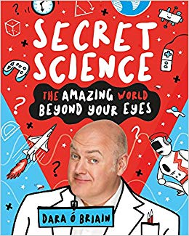 | Secret Science – Dara O’Briain  Science is a nonstop everywhere and everything adventure with some incredibly cool stuff going on, too. You've got your incredible brain, which has worked out how to read these words and make playing a video game feel as EXCITING as real life; you've got aeroplanes that can somehow get from the ground into the sky with all those people AND their luggage on board; you've got electricity and artificial intelligence and GPS and buses coming in threes (that's science too) and LOADS more.
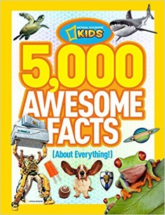 | 5,000 Awesome Facts  Presenting the next must-have, fun-filled gift book from the team that created Ultimate Weird But True, 5,000 Cool Facts About Everything treats kids to brain candy and eye candy all rolled into one treasure trove of high-interest fascinating facts.
Thought Provoking Texts
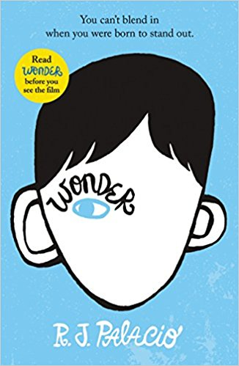 | Wonder – R J Palacio  'My name is August. I won't describe what I look like. Whatever you're thinking, it's probably worse.'  Born with a terrible facial abnormality, Auggie has been home-schooled by his parents his whole life. Now, for the first time, he's being sent to a real school - and he's dreading it. All he wants is to be accepted - but can he convince his new classmates that he's just like them, underneath it all?
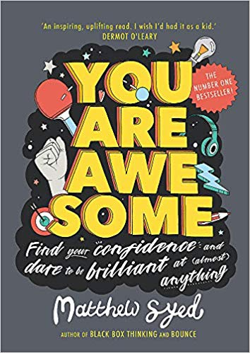 | You Are Awesome – Matthew Syed  I'm no good at sport ... I can't do maths ... I really struggle with exams ... Sound familiar? If you believe you can't do something, the chances are you won't try. But what if you really could get better at maths, or sport or exams? In fact, what if you could excel at anything you put your mind to?  You Are Awesome can help you do just that, inspiring and empowering young readers to find the confidence to realise their potential. The first children's book from Times journalist, two-time Olympian and best-selling mind set author Matthew Syed, it uses examples of successful people from Mozart to Serena Williams to demonstrate that success really is earned rather than given, and that talent can be acquired. With hard work and determination, practice and self-belief, and, most importantly, a Growth Mind-set, there's no reason why anyone can't achieve anything.
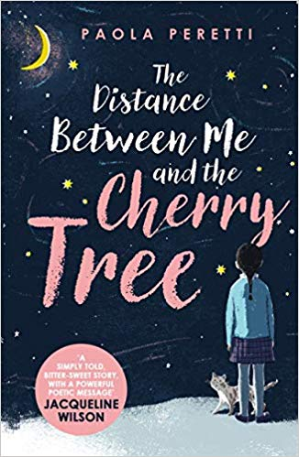 | The Distance Between Me and the Cherry Tree – Paola Peretti  Mafalda is a nine-year-old girl who knows one thing: some time in the next six months her sight will fail completely. Can Mafalda find a way through a seemingly dark future and still go to school, play football and look after her beloved cat? With the help of her family, and her friends, Mafalda needs to discover the things that will be important to her when her sight has failed. A moving, empowering tale of courage and determination that will inspire young and old.
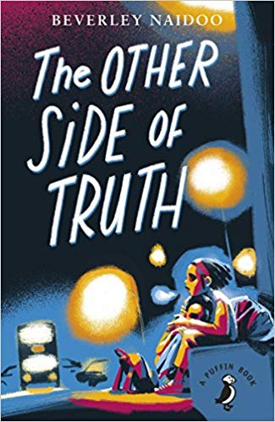 | The Other Side of Truth – Beverly Naidoo  This is the story of 12 year-old Sade and her brother Femi who flee to Britain from Nigeria. Their father is a political journalist who refuses to stop criticising the military rulers in Nigeria. Their mother is killed and they are sent to London, with their father promising to follow. Abandoned at Victoria Station by the woman paid to bring them to England as her children, Sade and Femi find themselves alone in a new, often hostile, environment. Seen through the eyes of Sade, the novel explores what it means to be classified as 'illegal' and the difficulties which come with being a refugee.
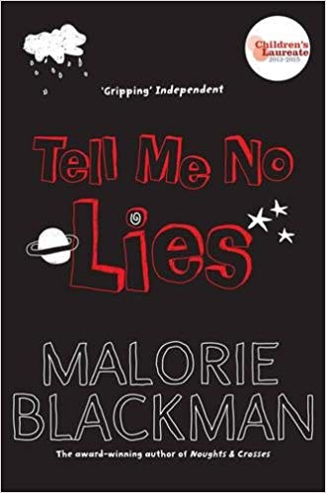 | Tell Me No Lies – Malorie Blackman  Gemma longs for her lost mother, taking comfort from the cuttings in her scrapbook; pictures of mothers who loved their children come what may.  Mike is new to the area; a boy with a terrible secret to hide. A secret about his missing mother. Gemma and Mike - two kids hurt by their past and now inextricably linked. Their effect on each other's lives will be explosive.
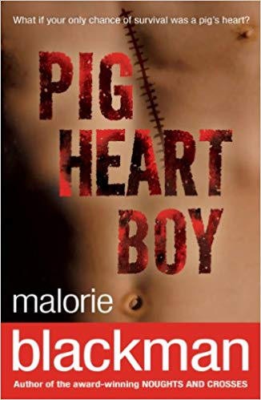 | Pig Heart Boy – Malorie Blackman  You're thirteen. All you want is a normal life. But most normal kids don't need heart transplants.  So there's this doctor. He says there's a chance for you. But he also says it's experimental, controversial and risky. And it's never been done before.
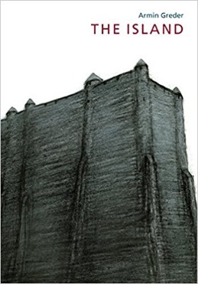 | The Island – Armin Greder  When the people of the Island discover a man and a tattered raft on their beach, they are reluctant to take him in. He doesn't look like them. But they cannot send him back to the sea where he will surely perish. Instead, they put him aside but even that doesn't solve their problem.
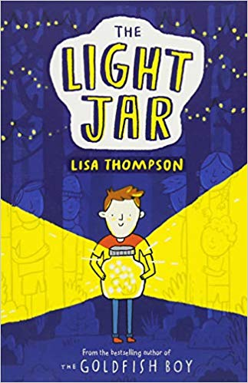 | The Light Jar – Lisa Thompson  Nate and his mother are running away, hiding out in a tumbledown cottage in the middle of a forest. When Mum heads off for provisions, and then doesn't return, Nate is left alone and afraid, with the dark closing in all around him. But comfort can come from the most unexpected of places - a mysterious girl trying to solve the clues of a treasure hunt and the reappearance of an old friend from his past. Will Nate find the bravery needed to face the troubles of his present and ultimately illuminate the future?
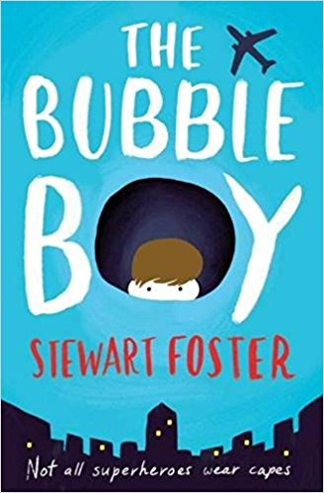 | Bubble Boy – Stewart Foster  Amir is mad. He’s crazy. But the hospital wouldn’t let a crazy person in. They must have interviewed him and checked his qualifications. But maybe he didn’t even meet them? Maybe he hasn’t even come from India. He might have arrived on an alien spaceship and snuck in here in the middle of the night.  Eleven-year-old Joe can't remember a life outside of his hospital room, with its beeping machines and view of London's rooftops. His condition means he's not allowed outside, not even for a moment, and his few visitors risk bringing life-threatening germs inside his 'bubble'. But then someone new enters his world and changes it for ever.
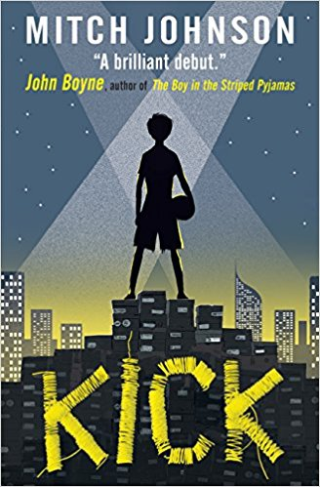 | Kick – Mitch Johnson  Budi's plan is simple. He's going to be a star. Budi's going to play for the greatest team on earth, instead of sweating over each stitch he sews, each football boot he makes. But one unlucky kick brings Budi's world crashing down. Now he owes the Dragon, the most dangerous man in Jakarta. Soon it isn't only Budi's dreams at stake, but his life. A story about dreaming big, about hope and heroes, and never letting anything stand in your way.
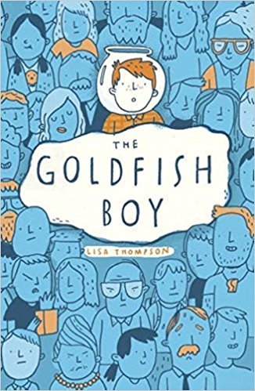 | The Goldfish Boy – Lisa Thompson  A story about finding friendship when you're lonely - and hope when all you feel is fear. Twelve-year-old Matthew is trapped in his bedroom by crippling OCD, spending most of his time staring out of his window as the inhabitants of Chestnut Close go about their business. Until the day he is the last person to see his next door neighbour's toddler, Teddy, before he goes missing. Matthew must turn detective and unravel the mystery of Teddy's disappearance - with the help of a brilliant cast of supporting characters. Page-turning, heart-breaking, but ultimately life-affirming, this story is perfect for fans of The Curious Incident of the Dog in the Night Time and Wonder. It is a book that will make you laugh and cry.

Suggested Websites/Stores
Amazon is one of the World’s largest and leading online retailers. With millions of texts on offer, Amazon also offer a next day delivery through their Amazon ‘Prime’ membership.
Book People was founded in 1988 by two book enthusiasts, Ted Smart and Seni Glaister, on the principle of making books available and affordable to everyone. We did this by delivering hand-picked favourites direct to people’s workplaces, at unbelievable prices.
Stock books, toys, gifts, stationery and arts & crafts at discount prices, and sell over one million of our products every week to consumers looking for a bargain.
Book Depository is one of the world's leading specialist online bookstores. We're proud to offer more than 19 million titles at low prices -- all with free delivery worldwide to over 100 countries. Whatever your interest or passion, you'll find something interesting in our bookshop full of delights.

