**Class Dojo**

We are now using Class Dojo as our reward system. We are also able to send you messages and updates about what we are getting up to and reminders of events. If you wish to receive this information please sign up using the code that has been given to you.

**Things to Remember**:

* P.E. kit for Tuesday and Wednesdays
* Reading book and home-school link book to be in school every day
* School starts at 8:50am with gates open at 8:40am
* Book Look is on Thursdays 8:40am-9:00am starting after half term.

**Our school website address is:**

<http://www.denton.e-sussex.sch.uk/> and our class page is there for you to find out information about the class, upcoming events and links to useful websites: [http://denton.eschools.co.uk](http://denton.eschools.co.uk/website/dolphins_year_1/)

**Dates for your diary:**

Phonics and reading information: Thursday 14th February 8.30am or 3.30pm or

Friday 15th February 5.00pm

Half Term: Monday 18th February till Friday 22nd February

Term 4 starts for pupils: Tuesday 26th February

Parents’ Evening: Tuesday 12th March 3.30pm – 5.30pm

Thursday 14th March 4.00pm – 6.00pm

Thursday 21st March 5.30 – 7.30pm

Lobster Class Assembly: Thursday 28th March 9.10am

End of Term 4 for pupils: Friday 5th April

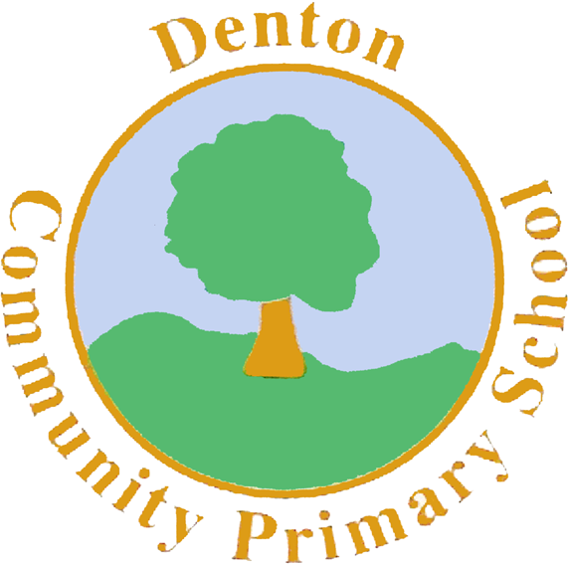

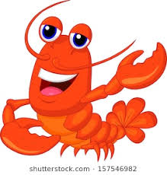

Lobster Class

Curriculum Information

Term 3 & Term 4

Learning Journey:



China and India

**&**

**Food and Festivals**

If you have any concerns please do talk to me. You can either,

- find me on the playground at the beginning and end of the day

- write a note in the home link book

-make an appointment to see me with the office

Many thanks

Mrs Savage

**P.E.**

Our PE days are Tuesdays and Wednesdays. Children need to bring their shorts, a t-shirt, trainers and plimsolls on these days as we may be inside or outside.

Children need to remove earrings on these days as they cannot do PE with them in, or we can cover them with tape.

We are currently looking at gymnastics and coach is teaching the children hockey skills.

**Geography**

We will look at continents and oceans in the world. We will find China and India on a world map. We will look at physical and human and features in these countries.



**R.E.**

In R.E. the class will be learning about the bible and how Christians use it to help them understand their religion.

We will learn the Moses story. 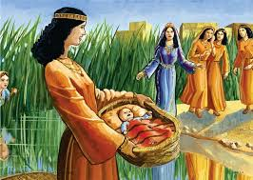

**Science**

We will be learning about different animals. We will learn the animal groups and how scientists use these to help them understand animal features.

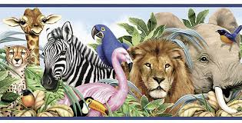

**Computing**

Our Computing work will be around collecting data and sorting it into a pictogram..

**Art & Design Technology**

We will continue our work in sketchbooks. We will start to learn about shading with pencils and how to use dark and light colours. We will make, draw and paint dragons as part of our China work.

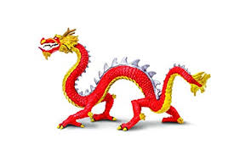

**P.S.H.E.**

This term in P.S.H.E. we focus on understanding money and responsibilities. We are also working on identifying our feelings and which ones are good and which ones are bad.

**Music**

We will be learning how to keep a rhythm using our hands and different instruments. We will also listen to lots of music from China and India.

**Literacy**

Our key text this term will be The Magic Paintbrush. This is a beautiful book which we hope will inspire the children. We will be working towards writing a different ending using our amazing capital letters, full stops and finger spaces.

We will produce an information sheet on different types of animals as part of our Chinese New Year learning.

We will learn the story of Rama and Sita.

We will produce various recipes for different foods from these countries.

**Phonics and Reading**

During the phonics information session you will be given a reading and phonics work book for your child to work on at home. Set pages will be given each week. We hope this will motivate and inspire reading.

**Numeracy**

In Year 1 we will be learning how to;

* Write our numbers in words and digits.
* What is 1 more and 1 less.
* Count in 2s, 10s and 5s.
* Understand numbers made with tens and units.

We will teach this through a mixture of play based activities and whole class learning.