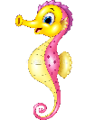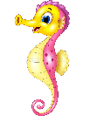

Dates for your diary:

Term 5 starts: Tuesday 19th April 2022

Bank Holiday: Monday 2nd May 2022

Last day of Term 5: Friday 27th May 2022

Half Term: Monday 30th May – Friday 3rd June 2022

Term 6 starts: Monday 6th June 2022

Last day of Term 6: Thursday 21st July 2022

Year 2 Class

Code of Conduct

We will:

* Look after classrooms, make sure rubbish goes in the bin
* Show good listening and good learning
* Listen to all adults
* Put our hand up to speak
* Be kind to all
* Never give up!

Things to Remember:

* P.E. kit for Tuesday and Thursday
* Reading book and home-school link book to be in school every day
* Homework projects set each long term
* Spelling test on Fridays
* Our school start time is between 8:30am and 8.50am and finish time is 3.10pm

Our school website address is:

<http://www.dentonprimaryschool.co.uk/website/sea_horses_year_2__/501477>

and our online blog is there for you to find out information about the class, upcoming events and links to useful websites.

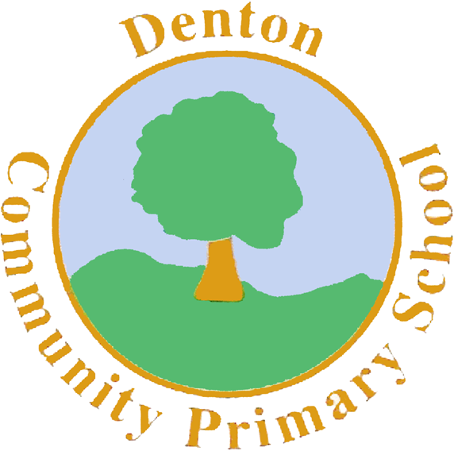

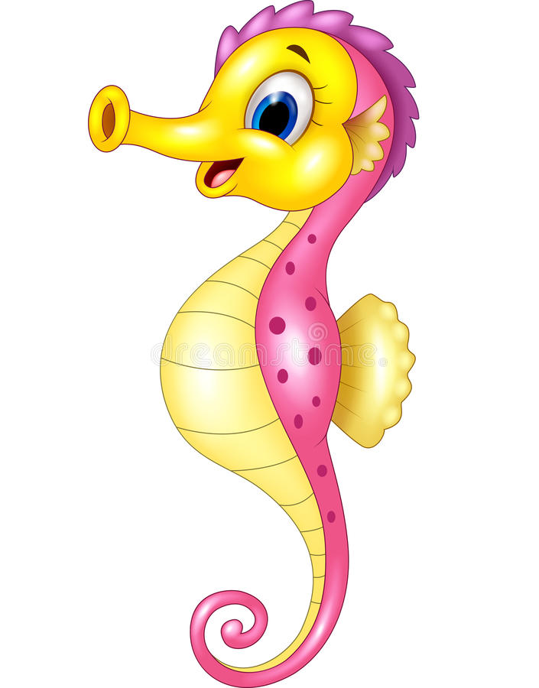

Sea Horse Class

Curriculum Information

Term 5 and 6

2022

If you have concerns or questions please let us know via the children’s Home School Link Book or through the office to make an appointment to meet at a mutually convenient time.

Thank you,

Miss Blotz and Mrs Buss

Computing

Using PurpleMash, children will explore using the program 2paint to create pointillist style pictures inspired by artists Piet Mondrian and William Morris.

Finally, we use 2sequence to put sounds together to create short pieces of music.

R.H.S.E.

In RSHE this long term, we will explore a range of themes including our body and the changes we begin to go through, our rights and responsibilities as people and the effects of global warming and how we can help to save our planet.

Geography/ History

We will start Term 5 with Geography. Our focus being on our planet; the continents and oceans, climate zones, mountain ranges and famous landmarks.

In Term 6, we will move on to History, thinking about how our planet has changed over time. This will include a little work on life in the prehistoric era and what life was life when dinosaurs roamed the earth.

Art and Design and Technology

In Art we focus on natural collages. Children will explore the art created by Andy Goldsworthy and using materials found on a walk around the school, will create their own natural art pieces.

In Design and Technology, children will design and make their own hinge and lever dinosaur.

Music

We are using a piece of music by Hans Zimmer called, Earth. Children will explore the instruments and rhythms in this piece and have a go at creating their own short pieces inspired by sounds around them and in the natural world.

Literacy

We begin this exciting topic by looking at stories such as ‘Beegu’ by Alexis Deacon and ‘Here we are’ by Oliver Jeffers. We will be creating a range of non-fiction pieces including a diary entry written as Beegu and an information mini book on our world, using the Oliver Jeffers story. In Term 6, we focus on prehistoric life and using the story ‘If I had a dinosaur’ by Gabby Dawnay to create our own dinosaur stories. We will explore the life of Mary Anning through the story ‘Stone girl, bone girl’ by Laurence Anholt and create an information page on her life. Finally, a poem by Spike Milligan called ‘On the Ning, Nong, Nang’ will finish our year!

Topic

Our topic this term is ‘Planet Earth’. We will be exploring our planet; where it sits in the solar system, geographical landmarks and climate zones and how our planet has changed over time, including life in the prehistoric eras. We will be exploring plants and wildlife around the around and thinking about how we can minimize global warming.

Homework

Homework Projects will be set in the first few weeks of each long term. Each project will be tailored towards our current topic and will contain a range of different activities for children to complete. Spellings will be set weekly, then tested on a Friday. Please also ensure nightly reading is completed with your child and noted in their reading logs.

P.E.

Our PE days are a Tuesday, with our sports coach, and a Thursday with me. Children need to bring in their shorts or joggers, a t-shirt and trainers or plimsolls on these days. Children need to remove earrings as they cannot do PE with them in. **Long hair needs to be tied back every day please**.

During Term 5, coach will be focusing on ______ and I will be taking children outside to teach them rounders. In Term 6, coach will focus on ______ and I will be re-capping our Athletics training, practising throwing and catching and running and jumping.

Numeracy

We begin Term 5 by finishing our work on fractions which we started before the Easter Holidays. Children will focus on finding halves and quarters of amounts. Then, we move on to measurement. Children will focus on finding measurement for length and mass, telling the time to 15 minutes on a clock and naming coins and solving money word problems. In Term 6, we finish the year by completing our work on shape, investigating both 2d and 3d shapes and finally re-capping over any concept’s children have found tricky over the year.

Science

Science in Term 5 and 6 is all about plants. We will conduct a series of experiments on finding the best conditions for growing plants. We will also look at parts of both plants and trees, create observational drawings of them both and look at their life cycles.

Finally, we will look at the plants we eat and different types of plants around the world.

R.E.

During Term 5, we look at Nature in Religion. Starting with the Christian creation story, then Harvest and the Jewish festival of Sukkot.

In Term 6, we look at Ceremonies, including weddings.

.