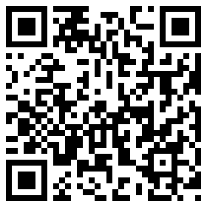My Signature 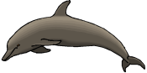

Dates for your diary:

Open Afternoon: Friday 30th September 2pm – 3pm

Parents’ Evening: Tuesday 11th October 5.30pm – 7.30pm

Thursday 13th October 3.30pm – 5.30pm

Tuesday 18th October 4pm – 6pm

Half Term: Monday 24th October – Friday 28th October

Term 2 starts for pupils: Tuesday 1st November

Dolphin Class Assembly: Thursday 1st December 9.10am

Christmas Fair: Friday 9th December

End of Term 2 for pupils: Wednesday 21st December

Our school website address is:

<http://www.denton.e-sussex.sch.uk/> and our class page is there for you to find out information about the class, upcoming events and links to useful websites: <http://denton.eschools.co.uk/website/dolphins_year_1/> or scan the QR code:

Things to Remember:

* P.E. kit for Mondays and Wednesdays
* Reading book and home-school link book to be in school every day
* School starts at 8:50am with gates open at 8:40am
* Book Look is on Thursdays 8:40am-9:00am (except our assembly day)

Take One Author

Throughout the school we are currently linking our learning to Roald Dahl to celebrate 100 years since his birth!

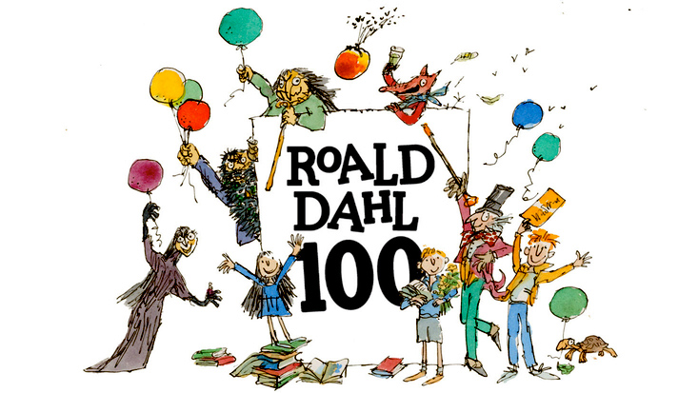

Dolphin Class Code of Conduct

We agreed to:

* Talk nicely and listen to each other
* Keep our hands, feet and other objects to ourselves
* Help other people
* Tidy up what you get out

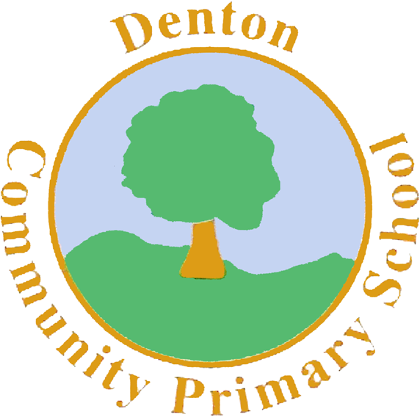

MC900120819[1]

Dolphin Class

Curriculum Information

Term 1 & Term 2

Learning Journey:

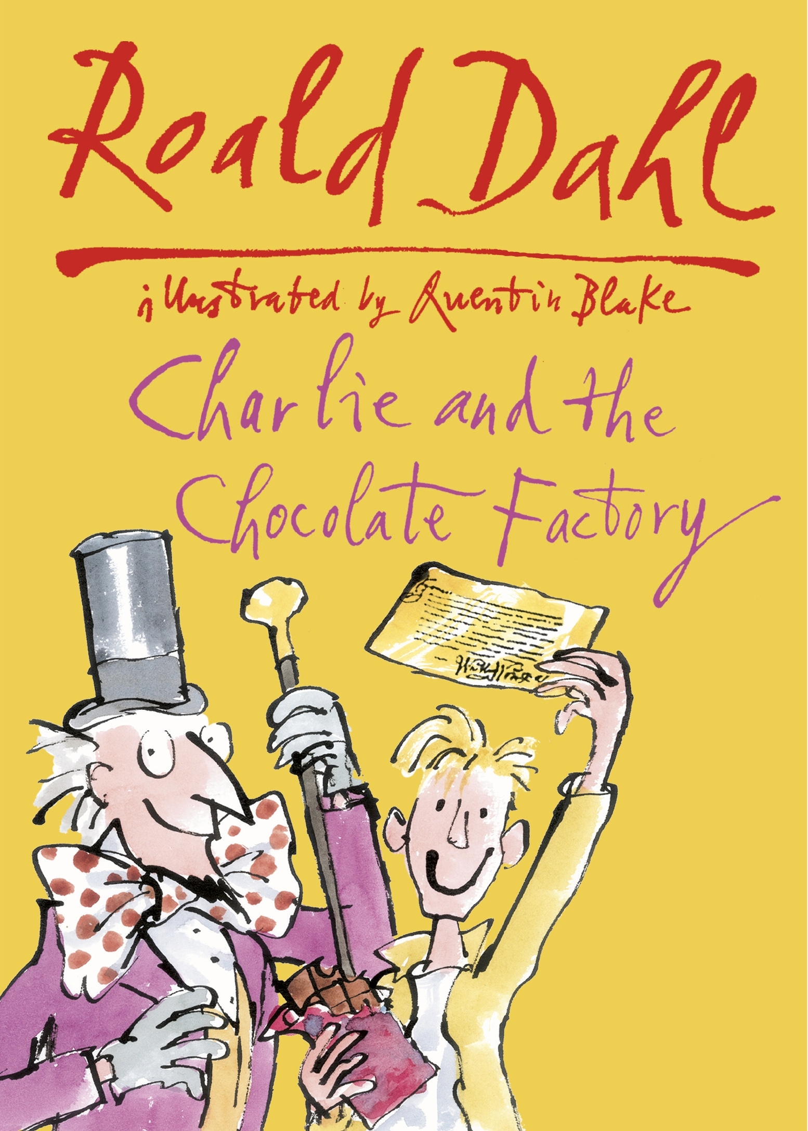

If you have concerns or questions please let me know.

I will be in the playground before school where you can make an appointment to see me at a mutually convenient time.

Thank you,

Mr Turner

R.E.

In R.E. the class will be learning about the signs and symbols of Christianity and Judaism. We will also explore the related festivals and stories, making items connected to these.

Later in the term Year 1 will learn about special buildings related to various religions.

P.E.

Our PE days are Monday and Wednesday. Children need to bring their shorts, a

t-shirt, trainers and plimsolls on these days as we may be inside or outside.

Children need to remove earrings on these days as they cannot do PE with them in.

**Long hair needs to be tied back every day please**.

We are currently looking at dance inside and football outside so it is essential that suitable footwear is packed.

Science

Throughout Term 1 Dolphin Class will learn about materials and their properties.

We start by looking at various boats and ships and sorting them according to their criteria. Children will then use different materials to create their own boat based on what they think is the best material.

Alongside ‘The Three Little Pigs’ in Literacy, Year 1 will explore the materials used in house construction and then attempt to make the best house possible.

Geography

Linked to both the new curriculum and our over-arching learning journey, Year 1 will learn about the originating countries for the characters in Charlie and the Chocolate Factory as well as where chocolate and sugar comes from. We will explore these using various materials, such as the interactive whiteboard and large maps.

Design and Technology

Keeping to the learning journey of Charlie and the Chocolate Factory, children will explore various sweets, describe them using their senses and then design their own.

Year 1 will also evaluate fudge and learn how to use equipment hygienically and safely. Children will also learn the importance of measuring.

Computing

Computing within Term 1 looks at children as collectors. The class will be finding images of underwater animals then learn how to group and resize images. They will also be introduced to the term ‘algorithm’. In Term 2 Dolphin Class will become TV chefs and film the steps of a recipe.

Music

Dolphins will focus on the Oompa Loompa songs. They will look at the lyrics and choreograph their own actions. The children will also use various instruments to accompany the song.

P.H.S.E.

This term in P.S.H.E. we focus on developing children’s knowledge, understanding and skills in four aspects of social and emotional learning: empathy, self-awareness, social skills and motivation.

Spellings

Later in the term spellings will be stuck into Reading Record books. These spellings are to be practised and learnt for a test the following Friday.

Numeracy

In Year 1 we have carefully planned our Numeracy to link to our Literacy lessons and our learning journey.

Over the course of Term One we will look at number recognition, 1 more / 1 less, capacity, shape, subtraction, time and addition.

In Term Two we continue looking at these same areas but in greater depth, becoming masters of each mathematical skill.

Every day we do counting activities to help speed up their mental calculations and pattern recognition. A counting stick is used during these activities. In school we strongly promote the use of apparatus and have a whole range of tools to support your child. These include number lines and Numicon.

Literacy

It is vital that children are exposed to quality texts.

The text we have chosen for Term 1 is ‘Charlie and the Chocolate Factory’. While learning this story the children will be taught about how to write using descriptions. We will then move on to ‘The Three Little Pigs’ allowing the children to discuss materials, linking to Science.

We encourage all children to read to someone at home every day for about 5-10 minutes. Reading does not have to be just with school book. It could also simply involve reading street signs on the way home.

Every day the class have a 30-minute phonics lesson where they learn new sounds and spelling patterns to help them read and spell.