Term __3____- Week____1_____
These spellings will be tested on Friday 19th January
How many words can you think of that use this spelling pattern?
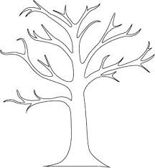
Learn the words listed and add to your spelling tree with leaves showing a different word that use the sound. Write a sentence with those words.
bear
ing

looking

being

The blue spiky clouds are other words the children need to learn. There will be four of these each
child
Mrs

hopping

playing

people

Term __2_____- Week____2_____
These spellings will be tested on Friday 26th January
How many words can you think of that use the I sound?
Learn the words listed and add to your spelling tree with leaves showing a different word that use the sound. Write a sentence with those words.
when
Ing and c
rice
finding
city

jumping

The blue spiky clouds are other words the children need to learn. There will be four of these each
because
where
children

Term __3_____- Week____3_____
These spellings will be tested on Friday 26th January
How many words can you think of that use the sound?
Learn the words listed and add to your spelling tree with leaves showing a different word that use the sound. Write a sentence with those words.
looked
washed
played
jumped

looked

The blue spiky clouds are other words the children need to learn. There will be four of these each
clothes

ed words

beautiful
trousers

Term __3____- Week____4_____
These spellings will be tested on Friday 2nd February
How many words can you think of that use the sound?
Learn the words listed and add to your spelling tree with leaves showing a different word that use the sound. Write a sentence with those words.
could
I’ve
can’t
haven’t

don’t

The blue spiky clouds are other words the children need to learn. There will be four of these each
whole
would
should

Contracted forms

The last week of term will be a mixture of all the terms words in a spelling bee type contest.
So mix them up and use them in lots of different sentences.

