Can you cut out and put the pictures in the right order to show how bread is made? https://www.youtube.com/watch?v=BGb8ZFgNDhc
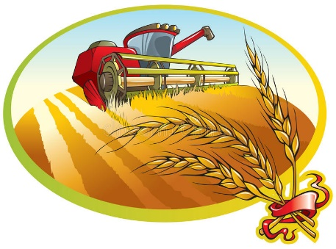
The wheat is harvested.
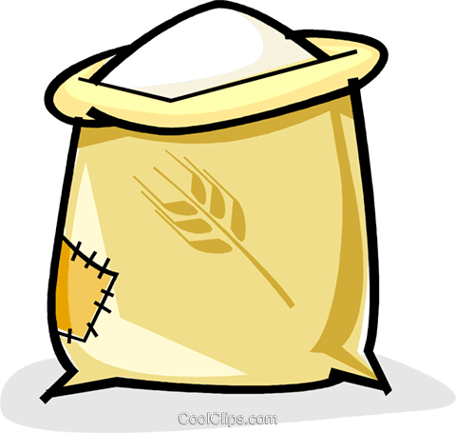
The wheat is ground into flour.
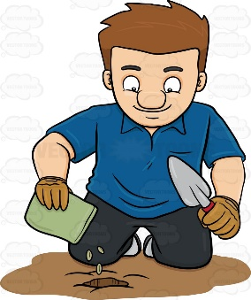
The seeds are planted.
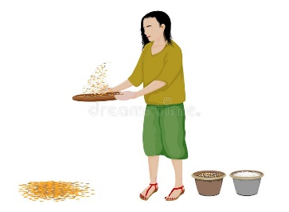
The wheat is threshed.
The flour is made into bread.
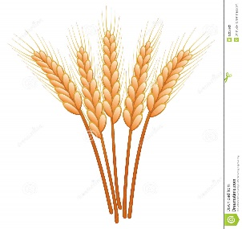
The wheat grows.

