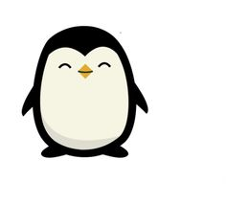 

Dates for your diary:

Term 1 finishes for children: Friday 19th October 2018

Half Term: Monday 22nd October – Friday 26th October 2018

Term 2 starts for children: Tuesday 30th October 2018

Penguin Class Assembly: Thursday 15th November 2018

Term 2 finishes: Wednesday 19th December 2018

Christmas Holidays: Thursday 20th December 2018 – Wednesday 2nd January 2019

Year 3 Class

Code of Conduct

We will:

* Look after classrooms, make sure rubbish goes in the bin
* Sit quietly
* Listen to all adults
* Put our hand up to speak
* Be kind to everyone
* Do our best work in every lesson

Our school website address is:

<http://www.denton.e-sussex.sch.uk/> and our online blog is there for you to find out information about the class, upcoming events and links to useful websites

Things to Remember:

* P.E. kit for Monday and Wednesday
* Reading book and home-school link book to be in school every day
* Spelling test on Fridays
* School starts at 8:50am with gates open at 8:40am

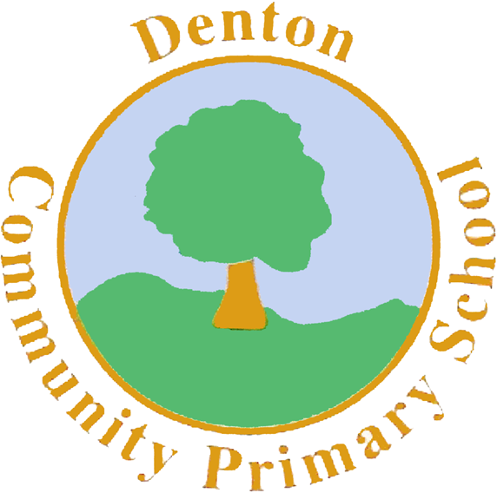

Penguin Class

Curriculum Information

Term 1 and 2

2018

If you have concerns or questions please let us know.

We will be in the Key Stage Two playground before school where you can make an appointment to meet at a mutually convenient time.

Thank you,

Miss Blotz ☺

Topic

We begin the school year with a whole school approach called ‘Take One Nursery Rhyme’. We will focus on the Nursery Rhymes Jack and Jill, Incy Wincy Spider and Humpty Dumpty.

After these 3 weeks; we move on to investigating the rainforests of the world. Children will explore climate, animals and how deforestation is effecting the environment.

Science

Our science focus throughout Terms’ 1 and 2 will be ‘Evolution’. We will focus on how plants and animals have adapted over time and how they live successfully in their environments. Children will learn about animal classifications and food chains, exploring how animals and plants live in our local environment.

Literacy

We start off the year learning, performing and creating our own nursery rhymes for our whole school ‘Take One’ learning journey.

After this, children will be taking part in a drama for learning sequence in which they will become Rainforest Explorers. Children will have the opportunity to complete a range of written pieces throughout the week including diaries, adverts and descriptive paragraphs.

Term 1 ends with children using ‘Talk for Writing’ to learn the story of Pongo, an orangutan in the Amazon rainforest.

During Term 2 children will create information pages, write Haikus about the Rainforest and write persuasive letters on deforestation.

Numeracy

Our focus throughout Term 1 in Numeracy will be on place value. We begin the year re-capping our knowledge of hundreds, tens and units, plotting numbers on a number line and using the greater and less than symbols to compare numbers. As our confidence grows, we will begin to introduce negative numbers and focus on problem solving using place value ideas. During Term 2 we will focus on addition and subtraction and using a range of methods including the introduction of the column method to answer larger number problems.

Spanish

Year 3 sees the introduction of Spanish to our curriculum. During the Autumn Term, children will learn how to count to 20, name the days of the week and months of the year, recognise colours and name animals.

Computing

Children will begin the year investigating how to use online search toolbars. After this they will be learning how to create their own virtual reality games, linked to our rainforest topic.

Music

Children will begin by learning a range of nursery rhymes.

We then progress to listening to rainforest sounds; trying to re-create these sounds by making instruments of our own. We will then use these instruments to make our own rainforest music focusing on rhythm.

P.H.S.E.

We begin the year with our topic ‘New Beginnings’. We focus on feeling settled in our new classroom environments and feeling confident to express our feelings with our class mates.

Homework

Homework projects will be set within the first few weeks of each long term. Children then have the remaining time to complete a selection of tasks. Spellings will be stuck into reading records to be practised and learnt for a test the following Friday.

P.E.

Our PE days are Monday and Wednesday. Children need to bring their shorts, a t-shirt, trainers and plimsolls on these days. Children need to remove earrings on these days as they cannot do PE with them in.

**Long hair needs to be tied back every day please**.

Our focus in Term 1 is Dance. Children will use the rainforest music to create a sequence of movements in keeping with the sounds. Children will also take part in a PE session each week with our sports coach who will focus on football.

In Term 2 we look at Gymnastics. Children will explore a range of balances and movements along the beams, mats and wall bars. Our sports coach will focus on basketball.

Art and Design and Technology

During Term 1 children will focus on Art and the work of artist Henri Rousseau. Children will investigate how Rousseau used colour and focal points to create rainforest pictures.

In Term 2, children move onto Design and Technology. Children will design and make their own 3d insects using papier-mâché and then design their own frog teddies using basic stitching techniques.

R.E.

During Term 1 we focus on Light. Children will explore how a range of religions use light to celebrate their festivals.

In Term 2, we focus on the Christmas Story and the significance of the different journeys made by those in the story.

Geography/History

With the Rainforests being our topic we focus mainly on Geography during Term 1 and 2. Children will investigate biomes and where rainforests can be found around the world. They will explore the rainforest layers, the animals that live within the rainforest and climate and deforestation. In History children will look at how the tribes in the rainforests have developed over time.