Our school website address is:
http://www.dentonprimaryschool.co.uk/website
You can access Puffin’s class page to keep up with events and to see how you can help with our charity this year.
Here is a useful website to inform you about Early Years education:
https://www.early-education.org.uk/

Dates for your diary:
- Open Afternoon- Take One Author- Friday 30th September
- Parent Consultations- Tuesday 11th October, Thursday 13th October, Tuesday 18nd October.
- Half Term- Break up on- Friday 21st October
Return on Tuesday 1st November
- Early Years Xmas Performance: Thursday 15th December

Welcome to

Puffins Class


Curriculum Information

Autumn Term
Please help your child at home by encouraging them to:-

Talk about school in a positive way.
Dress themselves; including putting on their coat, shoes and socks and turning their clothes the right way.
Take charge of personal hygiene.
Have good table manners (including practising using a knife and fork!).
Be aware of the needs, feelings and safety of others.

Things to remember:
- Our P.E. sessions are on Mondays; please remove earrings at home.
- Book bag and reading diary every day please.
- Milkshake/juice money in a named purse or envelope.
Thank You
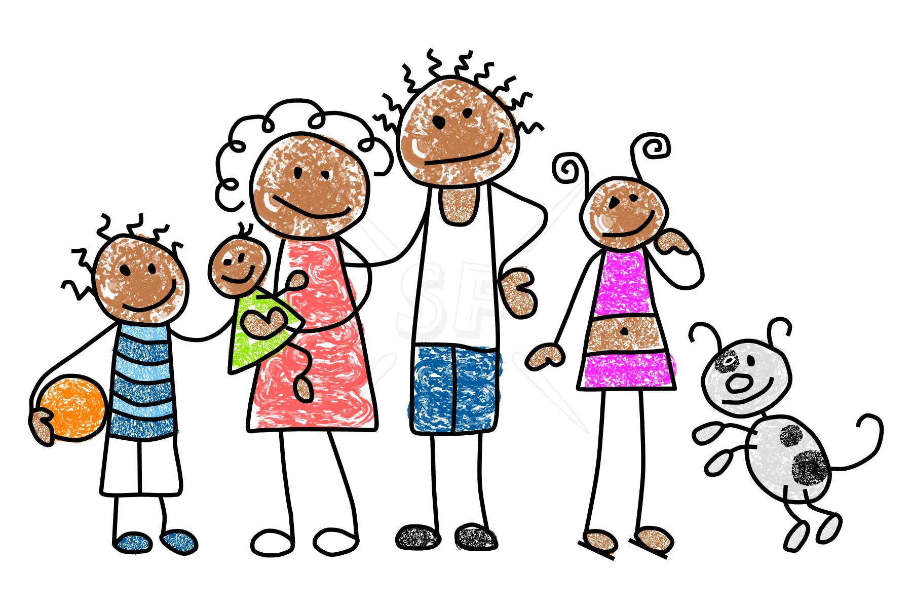
Communication and Language
There will be many opportunities for the children to talk about themselves, friends and family and to share their experiences. Speaking and listening skills will be a big focus and children will be strongly encouraged to take turns in conversation and listen to others. Our role-play areas aim to encourage creative play and to develop the use of imaginative language. We will be creating chatterboxes to encourage talk in our circle times too.
Personal, Social and Emotional Development
These early days are vital in terms of each child’s school career. It is important that the children settle in well and feel safe, happy and secure. We will establish expected codes of behaviour, promote the consistent use of good manners and introduce daily routines. There will be plenty of opportunities for them to familiarise themselves with their new environment, form new relationships and deepen established ones. Circle time is an occasion for those who wish, to express views and feelings about such topics as why they are special, praising the qualities of others and sharing their experiences.
Fantastic Families!
Physical Development

Playtime and PE will allow the children to explore a range of equipment where they can practise travelling, balancing, jumping and landing safely and taking others’ safety into consideration. This is also reinforced as part of our outdoor play provision.
Using junk modelling and large construction, children will be challenged to build models. Play dough, pasta, cornflour and shaving foam will be investigated and manipulated using hands and a range of appropriate tools.
Literacy
The mark making areas primarily promote writing and drawing and a wide range of media and tools are available for children to express themselves. We have a graffiti wall too! Book corners welcome children and adults to share a book and listening to stories based on being special and being part of a family, home and school will be a regular feature of our school day. Letters and sounds will be introduced, reinforced and consolidated through a range of fun small group activities.
Expressive Arts and Design
The children will have the opportunity to dress up and enjoy role-play in our baby clinic and Paw Patrol Rescue Centre. We will be creating and making sweets for our Chocolate Factory and there will be lots of Christmas art to engage with. Song and dance will be plentiful and we will share action rhymes and songs as well as encouraging percussion accompaniment!

Mathematics
Mathematical based activities such as number rhymes and songs, setting a table for 4 people, finding missing numbers in a number line, as well as sorting and counting objects and number recognition will be supported and extended by adults where appropriate.
This term we will be talking about and choosing our favourite sweets, representing them in graphs and answering questions about the data. How many children like Skittles? How many more like chocolate?
Understanding the World
Through conversation the children will begin to develop an understanding of time as they talk about special occasions that they can recall and share photographs of themselves with their families. Activities such as our role play home corners, Paw Patrol Rescue Centre and our amazing garden will encourage children to take on different roles and learn about different jobs people do.

