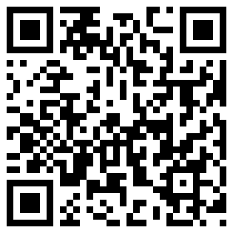 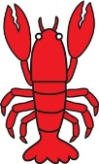

Things to Remember:

* P.E. kit for Tuesdays and Fridays.
* Reading book and home-school link book to be in school every day
* Homework is given out on a Friday and due in by the following Friday
* School starts at 8:50am with gates open at 8:40am
* Book Look is on Thursdays 8:40am-9:00am

Dates for your diary:

Half Term: Monday 15th February – Friday 19th February

Term 4 starts for pupils: Monday 22nd February

End of Term 4 for pupils: Thursday 24th March

Term 5 starts for pupils: Tuesday 12th April

Lobster Class Assembly: Thursday 17th March 9.10am

Parent’s Evening: Tuesday 8th March 3.30pm – 5.30pm

Thursday 10th March 5.30pm – 7.30pm

Tuesday 15th March 4pm – 6pm

Class Charity

This year Lobster Class have voted to support

The Dogs Trust.

Stay tuned for our first event!

Lobster Class Code of Conduct

We agreed to:

* Put your hand up when you want to share and listen to each other.
* Take care of each other.
* Share nicely.
* Be quiet in the classroom so that everyone can concentrate.
* Look after the classroom.

Our school website address is:

<http://www.denton.e-sussex.sch.uk/> and our class page is there for you to find out information about the class, upcoming events and links to useful websites: <http://denton.eschools.co.uk/website/lobsters_year_1/> or scan the QR code:





Lobster Class

Curriculum Information

Term 3 & Term 4

Learning Journey:

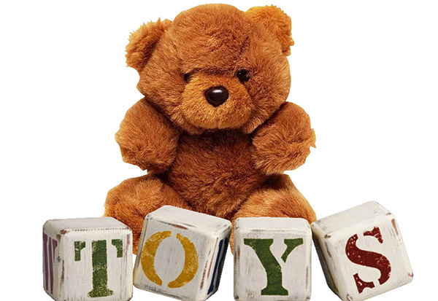

If you have concerns or questions please let me know.

I will be in the playground before school where you can make an appointment to see me at a mutually convenient time.

Thank you, Miss Wheelhouse

**History**

Linking to our learning journey, our History lessons will involve children exploring old and new toys and discussing which ones they prefer and why. To extend learning outside the classroom we will be asking children to create a toy museum at home using labelled specimens they have selected. These will then be displayed in our classrooms for viewing.

**R.E.**

Lobster Class will be visiting our local church this term as our topic will be Christianity. While there the class will look at the features of a church and the process involved when being baptised. Year 1 will then look at various festivals.

**Design and Technology**

Keeping to the learning journey of Toys, Year 1 will investigate, design and then create a pull-along toy using basic materials.

It will be a six week process finding out what they like about existing toys, how to produce a smooth rolling mechanism and evaluate how well their finished toy compares to their design.

**Computing**

Computing within Term 3 looks at children as treasure hunters. The class will be using a programmable toy to make it follow a route that they have designed. In Term 2 Lobster Class will become digital painters and produce an eBook that will hopefully end up on the class webpage.

**Science**

Throughout the term Lobster Class will look at animals, including humans.

By the end of the topic most children will be able to identify and then classify animals into various groups, such as mammals, reptiles, amphibians, birds and fish.

Year 1 will also look at the growth, basic needs, exercise, food and the hygiene of different animals. This will include grouping animals into herbivores, carnivores and omnivores.

**P.E.**

Our PE days are Tuesday and Friday. Children need to bring their shorts, a

t-shirt, trainers and plimsolls on these days as we may be inside or outside.

Children need to remove earrings on these days as they cannot do PE with them in.

**Long hair needs to be tied back every day please**.

We are currently looking at gymnastics and games so it is essential that suitable outdoor footwear is also packed.

**Music**

The topic ‘Feel the Pulse’ develops the children's ability to recognise the difference between beat and rhythm and to perform in time to a beat. We will be using various pieces of music to support us.

**P.S.H.E.**

This term in P.S.H.E. we focus on developing children’s idea of goals and allow them to set their own for the term. During Term 4 we discuss the important issue of medicines and the risks involved.

**Homework**

Homework is set on a Friday for children to return by the following Friday and will relate to previous or future work in class. Later in the term spellings will be stuck into reading records to be practised and learnt for a test the following week.

**Numeracy**

Throughout this term we will continue to look at numbers, recognising them by amount, image or name but will also embed our number knowledge by applying them into various areas. Initially the class will focus on partitioning and place value but then move on to measuring weights using comparison and non-standard units, such as cubes. Lobster Class will also start learning to tell the time to the nearest hour, half hour and pay amounts of money up to 20p in real-life contexts.

Every day we do counting activities to help speed up their mental calculations and pattern recognition. A counting stick is used during these activities but we also have a whole range of tools to support your child.

**Literacy**

It is vital that children are exposed to quality texts and in Year 1 we have linked all our texts to our learning journey of toys.

The texts we have chosen are ‘Traction Man’ by Mini Grey and Michael Morpurgo’s version of ‘Pinocchio’. While enjoying these stories the children will learn about poetry, how to write a story with a familiar setting as well as instructions for constructing a toy.

We encourage all children to read to someone at home every day for about 5-10 minutes and we still have a storyteller coming in for workshops!

Every day the class have a 30-minute phonics lesson where they learn new sounds and spelling patterns to help them read and spell.