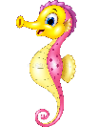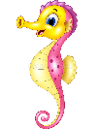

Dates for your diary:

Term 1 starts: Thursday 2nd September 2021

INSET DAY: Monday 20th September 2021

Last day of Term 1: Friday 22nd October 2021

Half Term: Monday 25th October – Friday 29th October 2021

Term 2 starts: Monday 1st November 2021

Last day of Term 2: Thursday 16th December 2021

INSET Day: Friday 17th December 2021

Year 2 Class

Code of Conduct

We will:

* Look after classrooms, make sure rubbish goes in the bin
* Show good listening and good learning
* Listen to all adults
* Put our hand up to speak
* Be kind to all
* Never give up!

Things to Remember:

* P.E. kit for Tuesday and Thursday
* Reading book and home-school link book to be in school every day
* Homework projects set each long term
* Spelling test on Fridays
* Our school start time is between 8:30am and 8.50am and finish time is 3.10pm

Our school website address is:

<http://www.dentonprimaryschool.co.uk/website/sea_horses_year_2__/501477>

and our online blog is there for you to find out information about the class, upcoming events and links to useful websites.



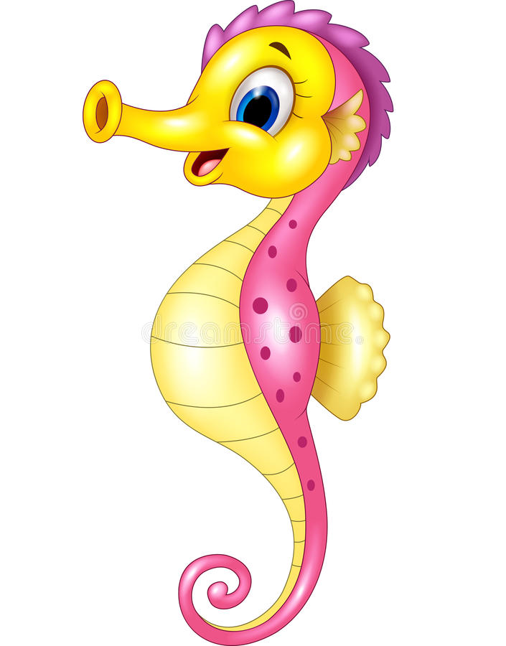

Sea Horse Class

Curriculum Information

Term 1 and 2

2021

If you have concerns or questions please let us know via the children’s Home School Link Book or through the office to make an appointment to meet at a mutually convenient time.

Thank you,

Miss Blotz and Mrs Buss

Literacy

We will start the year looking at a piece of poetry by Kenn Nesbit called ‘My senses are backwards’. We will use this poem to create our own senses poem. Then we move on to a story by Eric Carle called ‘From head to toe’, we will use this story to learn and create our own versions. Finally, we will read the story of ‘Avocado baby’ by John Burningham. We will use this story to create both a newspaper report about avocado baby and to create a piece of drama, producing a recipe book of foods for avocado baby.

Music

During Term 1 we will be looking at Body Percussion and how we can make sounds and rhythms with our different body parts. In Term 2, we look at pulse and play instruments to create different short beats.

P.H.S.E.

We will start the year looking at ‘Zones of Regulation’ and how we can use the zones to help us regulate our emotions. We then move on to the importance of hygiene and sleep for a healthy lifestyle.

Topic

Our topic this term is ‘Ourselves’. We will be investigating our local area and looking into our family trees. We will explore artists who painted self – portraits and create our own in these styles. Finally, we will explore our bodies, looking at the importance of diet and exercise and the life cycles of human and other animals.

Homework

Homework Projects will be set in the first few weeks of each long term. Each project will be tailored towards our current topic and will contain a range of different activities for children to complete. Spellings will be set weekly, then tested on a Friday. Please also ensure nightly reading is completed with your child and noted in their reading logs.

P.E.

Our PE days are a Tuesday, with our sports coach, and a Thursday with me. Children need to wear their shorts or joggers, a t-shirt and trainers or plimsolls on these days. Children need to remove earrings as they cannot do PE with them in. **Long hair needs to be tied back every day please**. Term 1 with coach is football and with me is gymnastics. In Term 2, coach will be teaching _____ and I will be teaching children dance and yoga.

Numeracy

Throughout Term 1, we will be recapping basic place value skills with the children; ensuring they are confident counting forwards and backwards, reading and writing numbers and understanding how many tens and units each number contains. We will compare and order numbers and practise counting in 2’s, 5’s and 10’s. In Term 2, addition and subtraction methods are our main focus; ensuring children can confidently use a range of methods including the part/whole model and the number line method to add and subtract independently.

Computing

Computing this term will focus on internet safety and how we can stay safe online. Then we move on to creating pictures using the picture tools to copy and paste images before adding filters and texts to them.

Science

Our topic for Science this term is ‘Animals including humans’, where we will investigate life cycles and the importance of living a healthy lifestyle. In Term 2, we will look at ‘Living things and their habitats’. This involves finding out about microhabitats in our local area and habitats around the world.

R.E.

We begin the year looking at Christian stories and the messages you can take from these stories.

In Term 2, we focus on the Christmas story, thinking about the main characters and their roles within the story.

Geography/ History

In Geography this term, we will be finding out about our local area. Children will investigate the houses, jobs and places of interest within our community and creating maps to show where we live.

In History, we will begin by finding out about the family tree of Queen Elizabeth I and then investigating our own family trees.

Art and Design and Technology

We begin Term 1 with Art and our topic is Self – Portraits. We will be researching artists such as Picasso, Van Gogh, Frida Kahlo and Andy Warhol and then creating our own self - portraits in their styles. In Term 2, we focus on D&T and will researching healthy eating and making healthy recipes.