Term __1_____- Week____1_____
These spellings will be tested on Friday 15th September____
How many words can you think of that use the ai / ay sound?
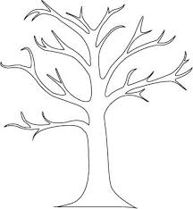
Learn the words listed and add to your spelling tree with leaves showing a different word that use the sound. Write a sentence with those words.
again
ai
ay
tail
sail
tray

stay

The blue spiky clouds are other words the children need to learn. There will be four of these each week.
who
whole
beautiful

Term __1_____- Week____2_____
These spellings will be tested on Friday 22nd September____
How many words can you think of that use the oo / ue sound?
Learn the words listed and add to your spelling tree with leaves showing a different word that use the sound. Write a sentence with those words.
sugar
oo
ue
moon
blue
pooh

glue

The blue spiky clouds are other words the children need to learn. There will be four of these each
bath
busy
door

Term __1_____- Week____3_____
These spellings will be tested on Friday 29th September____
How many words can you think of that use the ph / ew sound?
Learn the words listed and add to your spelling tree with leaves showing a different word that use the sound. Write a sentence with those words.
sure
elephant
blew
chew

dolphin

The blue spiky clouds are other words the children need to learn. There will be four of these each
children
great
grass

ew
ph

Term __1_____- Week____4_____
These spellings will be tested on Friday 13th October
How many words can you think of that use the ee /ey sound?
Learn the words listed and add to your spelling tree with leaves showing a different word that use the sound. Write a sentence with those words.
half
ee
ey
trolley
money
tree

green

The blue spiky clouds are other words the children need to learn. There will be four of these each
pass
last
class

