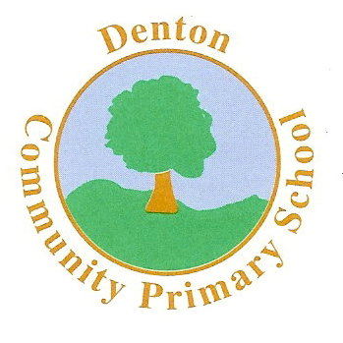
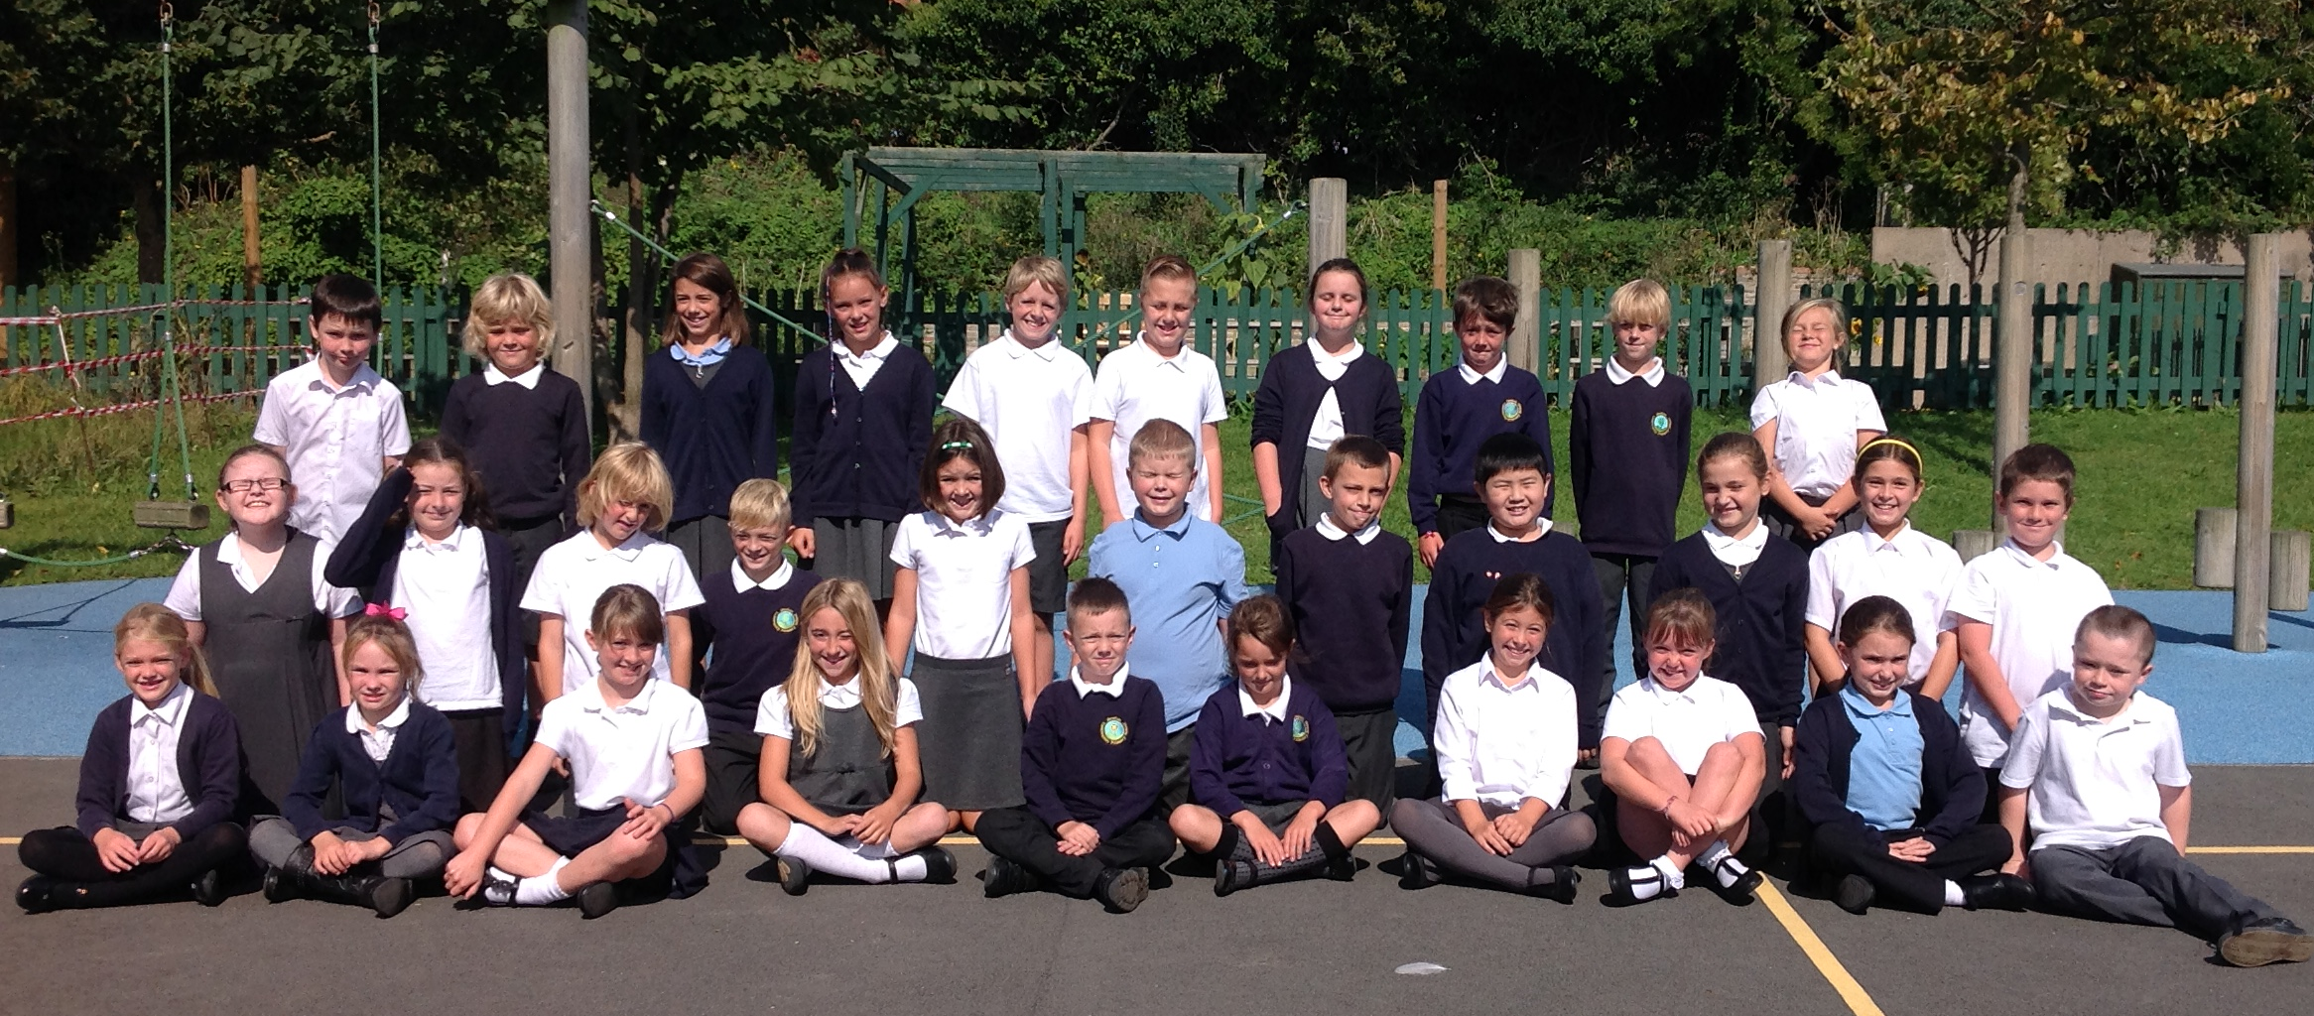
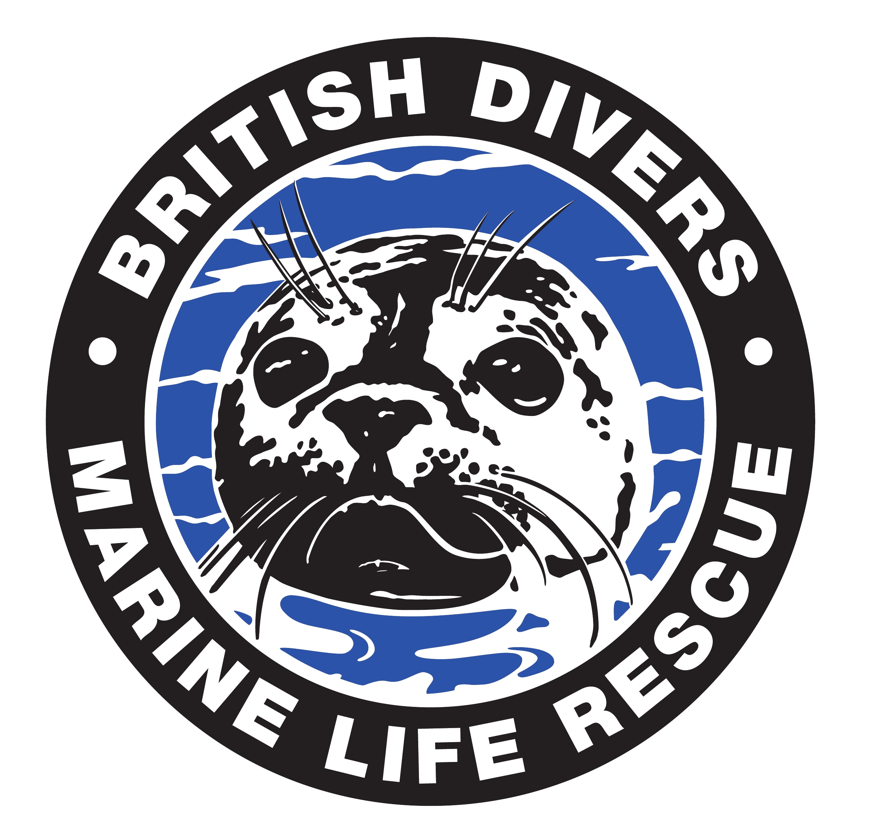
Welcome to

Turtle
Class

Curriculum Information
Terms 5 and 6
Summer 2018
Things to remember:

- Gates open at 8:40am with school starting at 8:50am
- Swimming starts on Tuesday 1st May for 10 weeks till the 10th July
- PE is on Wednesdays
- Have a reading experience every day and record in your
Reading Journal
- Spelling test every Friday
- Ancient Egypt Project due in on Monday, 4th June
- All school books in your bookbag everyday!
Our school website address is:
http://www.denton.e-sussex.sch.uk/ and the Turtle page is there for you to find out information about the class, upcoming events and links to useful websites.
Dates for your diary:

‘Our Water Matters’ school workshop: Wednesday, 2nd May
May Bank Holiday: Monday, 7th May
Half Term: Monday, 28th May
Term 6 starts for pupils: Monday, 4th June
Class and team photographs: Thursday, 7th June
Denton Community Challenge: Saturday, 9th June
Turtle Class Assembly: Wednesday, 13th June
Recorder Concert: Wednesday, 4th July
Sports Day: Thursday, 21st June (Reserve date Thursday, 28th June)
KS2 Musical: Wednesday, 4th July at 6pm and Thursday, 5th July at 6pm

You will be informed of other important dates via your child’s Home-School Link book over the term!

Turtles, Stingrays and Penguin Classes will be fundraising to support the British Divers Marine Life Rescue.
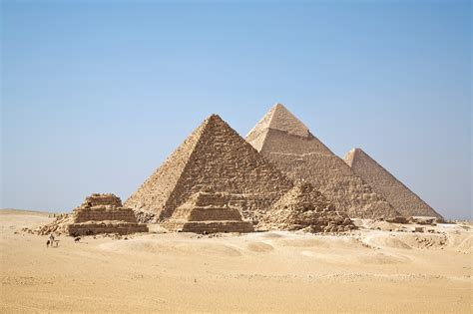

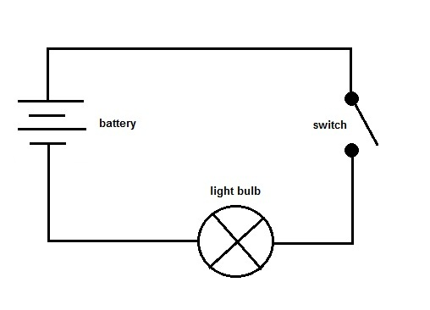
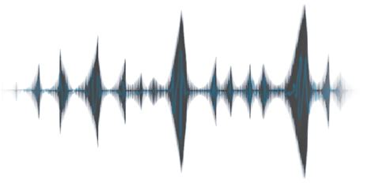
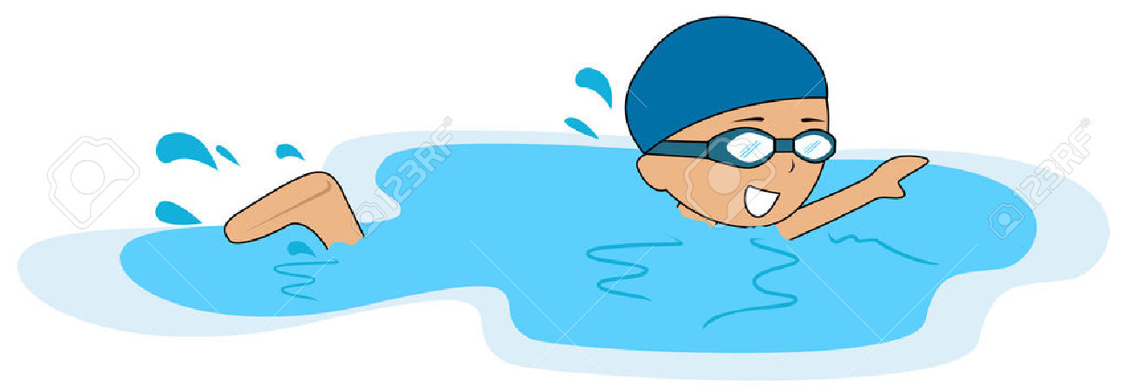
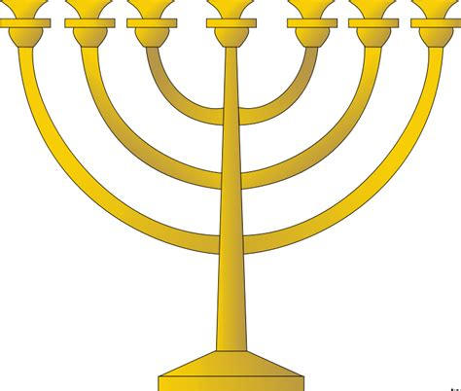
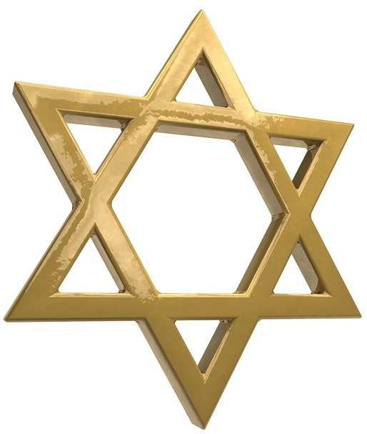
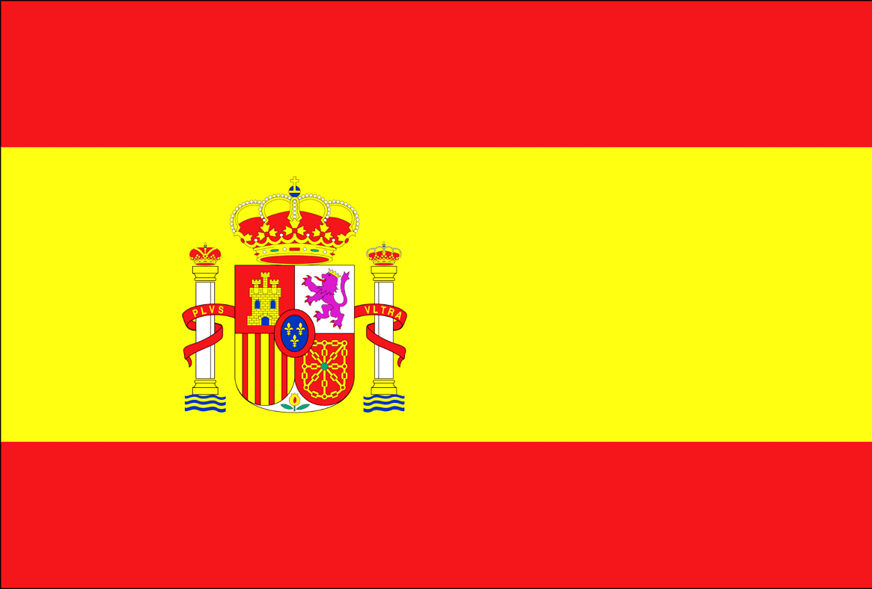
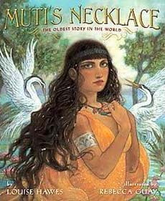

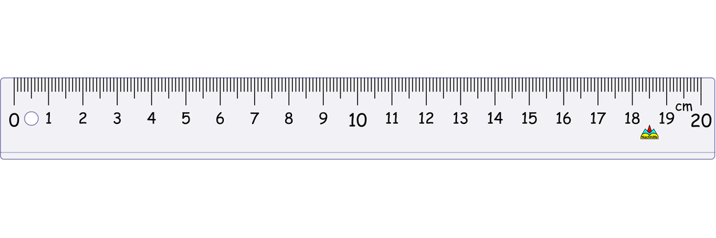
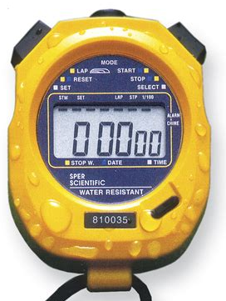
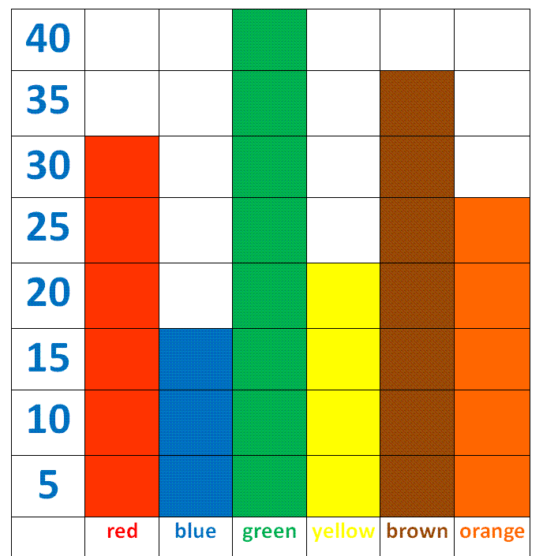
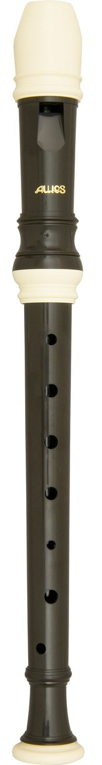
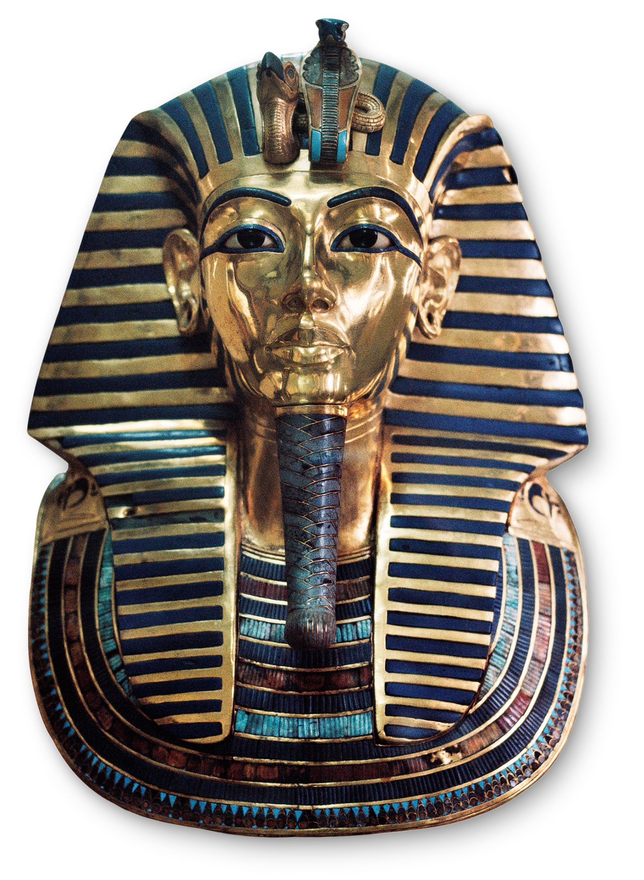
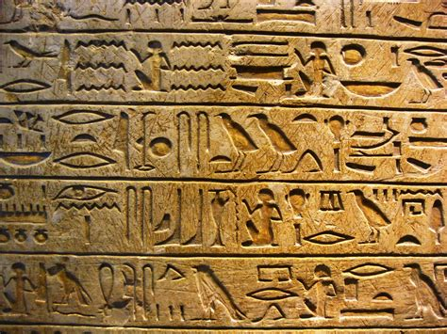
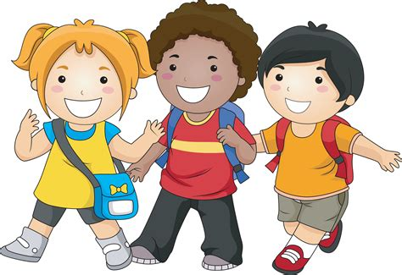
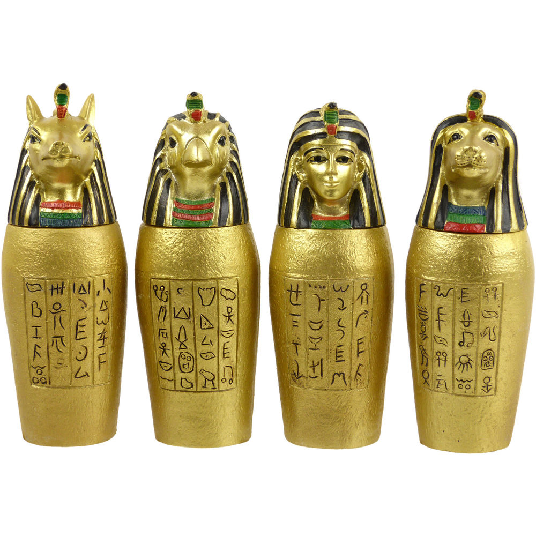
MATHEMATICS

We will be focussing on geometry, measurement and statistics this term, as well as revisiting previously learned maths skills which are important to keep fresh in our minds!
PE

The Turtles will be swimming at Seahaven every Tuesday morning and Coach will be teaching the Turtles on a Wednesday.
COMPUTING

The children will be learning how to create and manage their own blogs using Weebly. We will continue to use our other computing skills across the other subject areas.
SCIENCE

Our Science topics will be ‘Electricity’ and ‘Sound’.

HUMANITIES

Our Ancient Egypt topic will involve both History and Geography lessons this term. The children will discover the ways the early civilisation lived and will also research
further about the country in
cross-curricular Literacy
lessons.

RE

The RE focus will be Judaism, including responsibilities in Jewish families and worshipping at a synagogue.

PSHE

This term we will be talking about ethnic diversity and in Summer 6 will be covering the Year 4 Sex and Relationships scheme of work. Further information of these sessions will be shared with you nearer the time.
MUSIC

Mrs Blythe will continue to teach the Turtles new songs every Wednesday and we shall practise playing our recorders the rest of the week.
We will be working towards our end of term concert!

LITERACY

We will be using fiction stories based in Ancient
Egypt to write our own narratives.

The children will also use their Literacy skills in their
Humanities lessons by using non-fiction structures to
create travel brochures.
ART and DESIGN & TECHNOLOGY

Our Art and D&T work will be based around the pharaoh Tutankhamun.

Our Learning Journey is…

Ancient Egypt

SPANISH

We shall continue with our daily use of Spanish in the classroom and using conversation, songs and games to learn new words and phrases!

