Homework Grid for Key Stage 1
Topic: Ourselves and Christmas
To help enhance the children’s learning it would be great if you were able to support your children in completing at least 3 of the tasks below by Christmas. You can bring in your work at any point between now and Christmas. If you need any resources to help you please ask and we can provide you with materials. Have fun learning together.
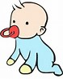  PSHE  Bring in pictures of you as a baby and maybe information of what you were like as a baby. How much you weighed and where you were born. Write this down or come in and tell us. | 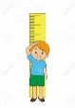  Maths  Measure and record the height of your family. You may want to present this as a graph, or in pictures. Who is the tallest? Who is the shortest? | 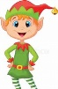  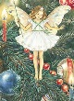  Art  Create a home for a Christmas Elf or Fairy. You can create a model or picture of their home. Think about what type of food and shelter they might need.
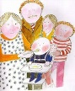  Science  Avocado Baby ate avocados for strength. What food do you eat to give you strength? Create a recipe and maybe make it to keep you strong and healthy. | Computers  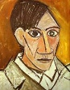  Find artists that are famous for creating portraits. Do you like their portraits? | Geography  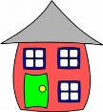  Create a map, picture or model of where you live. This could be your house, your street or your town.

