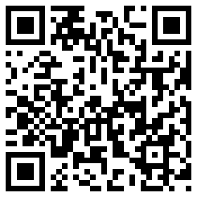My Signature 



MC900120819[1]

Dolphin Class

Curriculum Information

Term 5 & Term 6

Learning Journey:

**&**

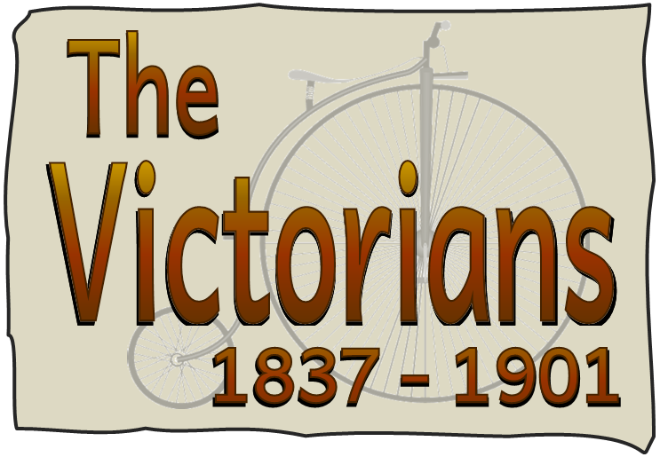

Dates for your diary:

Half Term: Monday 29th May – Friday 2nd June

Term 6 starts for pupils: Monday 5th June

**Year 1 Phonics Screening Week: Monday 12th June**

Year 1 joint class assembly: Wednesday 28th June at 9.10am

Sports Day: Thursday 29th June (if wet, Friday 7th July)

Annual Reports out: Friday 7th July

End of Term 6 for pupils: Thursday 20th July

Class Charity

We have raised over £78 for Raystede! Thank you so much!

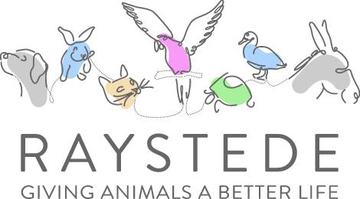

Stay tuned for our next fundraising event.

Dolphin Class Code of Conduct

We agreed to:

* Talk nicely and listen to each other
* Keep our hands, feet and other objects to ourselves
* Help other people
* Tidy up what you get out

Our school website address is:

<http://www.denton.e-sussex.sch.uk/> and our class page is there for you to find out information about the class, upcoming events and links to useful websites: <http://denton.eschools.co.uk/website/dolphins_year_1/> or scan the QR code:

If you have concerns or questions please let me know.

I will be in the playground before school where you can make an appointment to see me at a mutually convenient time.

Thank you,

Mr Turner

Things to Remember:

* P.E. kit for Mondays and Wednesdays
* Reading book and home-school link book to be in school every day
* Homework is given out on a Friday and due in by the following Friday
* School starts at 8:50am with gates open at 8:40am
* Book Look is on Thursdays 8:40am-9:00am

Geography & History

In Term 5, Year 1 will learn about the local area and gain map making skills and find out the importance of a key.

In Term 6 Dolphins will be looking at the important events during the Victorian period. Activities include plotting events on to a timeline to provide a context of time for the children and looking at key figures.

R.E.

In R.E. the class will be hearing stories that Jesus told, respond to the values and concerns of others, understand that Jesus was teaching about repentance and forgiveness and discuss what a ‘friend’ is.

Art & Design Technology

Art in Term 5 looks at the artist Claude Monet. Each lesson will require the children to replicate a style Monet used or picture that Monet painted, with a focus on plants.

During Term 6 we are looking at designing and making our very own decorative clay tiles. These were popular around fireplaces and on floors.

Computing

Our Computing work in Term 5 will involve children using sound recording equipment to record sounds and develop skills in saving and storing sounds to produce a talking book. In Term 6 Dolphins will be designing and making their own E-Cards about their experiences over the past year.

Science

Throughout Term 5 Dolphin Class will learn about the parts of a plant and plan an investigation to see what plants need to grow. They will then examine the types of trees around the school using QR codes to identify each one. Children will also revise the words deciduous and evergreen that we encountered earlier in the year.

Moving into Term 6 our focus will be on Summer and the seasonal changes this involves.

P.E.

Our PE days are Monday and Wednesday. Children need to bring their shorts, a

t-shirt, trainers and plimsolls on these days as we may be inside or outside.

Children need to remove earrings on these days as they cannot do PE with them in.

**Long hair needs to be tied back every day please**.

We are currently looking at football and rounders so it is essential that suitable outdoor footwear is also packed.

Music

The topic ‘Reflect, Rewind and Replay’ makes cross curricular links to our Victorian topic by listening to and thinking about Western Classical music. Children will also consolidate the language of music.

P.H.S.E.

Dolphin’s P.S.H.E. topic is about relationships. We will be focusing specifically on feelings. It explores feelings within the context of our important relationships including family and friends.

Spellings

In a couple of weeks spellings will be stuck into Reading Record books. These spellings are to be practised and learnt for a test the following Friday.

Numeracy

Throughout this term we will look at mental addition and subtraction of 2- and 3-digit numbers as well as learning how to use jottings for mental multiplication. Dolphin Class will also be expanding their knowledge of 3D shapes and applying their skills through 1- and 2-step word problems.

We will also be covering time to the ½ hour, division through sorting into sets, finding totals and change related to money.

Every day we do counting activities to help speed up their mental calculations and pattern recognition. A counting stick is used during these activities. In school we strongly promote the use of apparatus and have a whole range of tools to support your child. These include number lines and Numicon.

Literacy

Our key text this term will be Jack and the Beanstalk. The children will be exposed to several versions of the story and there will be opportunities for drama as well as written work. Other stories will also link to our topic of Plants and growing things. Towards the end of the term, we shall be sharing Elmer stories in readiness for our Elmer Day on 26th May. The texts used in Term 6 will ink to our topic on the Victorians and will enlighten children to what everyday life was like for children of their age.

We encourage all children to read to someone at home every day for about 5-10 minutes. Every day the class have a 30-minute phonics lesson where they learn new sounds and spelling patterns to help them read and spell.