Term __2____- Week____1_____
These spellings will be tested on Friday 10th November
How many words can you think of that use the i__e, o___e, u___e sound?
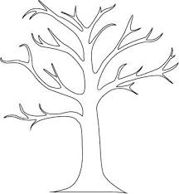
Learn the words listed and add to your spelling tree with leaves showing a different word that use the sound. Write a sentence with those words.
other
i__e, o___e, u___e
slide
use
awoke

flute

The blue spiky clouds are other words the children need to learn. There will be four of these each
dog
stop
children

Term __2_____- Week____2_____
These spellings will be tested on Friday 17th November
How many words can you think of that use the I sound?
Learn the words listed and add to your spelling tree with leaves showing a different word that use the sound. Write a sentence with those words.
eat
I
stick
find
milk

child

The blue spiky clouds are other words the children need to learn. There will be four of these each
cat
take
think

Term __2_____- Week____3_____
These spellings will be tested on Friday 24th November
How many words can you think of that use the I and g sound?
Learn the words listed and add to your spelling tree with leaves showing a different word that use the sound. Write a sentence with those words.
who
I
g
cycle
gem
ice

danger

The blue spiky clouds are other words the children need to learn. There will be four of these each
came
made
because

Term __2_____- Week____4_____
These spellings will be tested on Friday 1st December
How many words can you think of that use the sound?
Learn the words listed and add to your spelling tree with leaves showing a different word that use the sound. Write a sentence with those words.

The blue spiky clouds are other words the children need to learn. There will be four of these each

