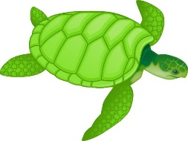 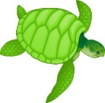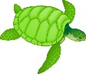

Things to Remember:

* P.E. kit for Wednesdays and Fridays
* Reading book and home-school link book to be in school every day
* Spelling test on Fridays
* School starts at 8:50am with gates open at 8:40am

Our school website address is:

<http://www.denton.e-sussex.sch.uk/> and our online blog is there for you to find out information about the class, upcoming events and links to useful websites. We also use Class Dojo for communicating with parents- please see me for further details.

Dates for your diary:

Term 1 finishes for children: Friday 25th October 2019

Inset day: Monday 14th October 2019

Half Term: Monday 28th October – Friday 1st November 2019

Term 2 starts for children: Monday 4th November 2019

Turtle Class Assembly: Thursday 7th November 2019

Term 2 finishes: Friday 20th December 2019

Year 4 Class

Code of Conduct

We will:

* Look after classrooms, make sure rubbish goes in the bin
* Sit quietly
* Listen to all adults
* Put our hand up to speak
* Be kind to everyone
* Do our best work in every lesson

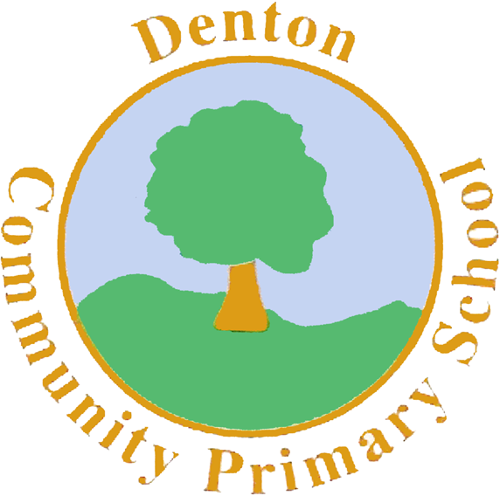

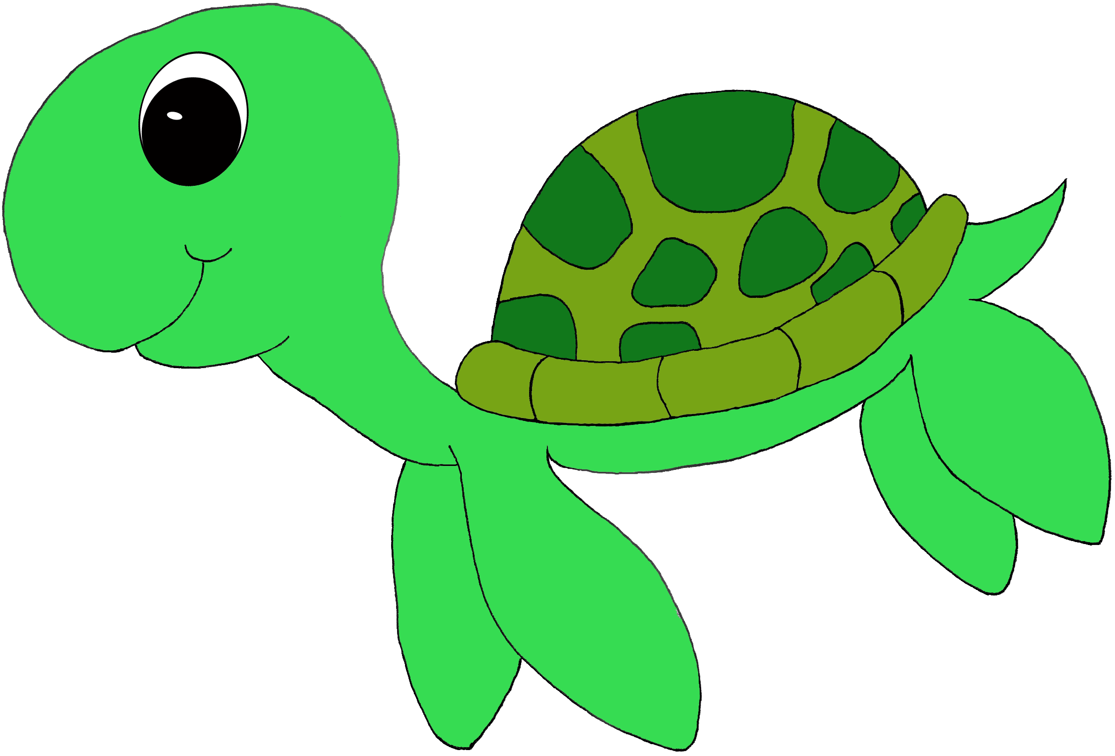

Turtle Class

Curriculum Information

Term 1 and 2

2019

If you have concerns or questions please let me know.

I will be in the Key Stage Two playground before school where you can make an appointment to meet at a mutually convenient time.

Thank you,

Miss Morgan ☺

R.E.

In the first term we will be looking at what makes a person trustworthy, and the story of Abraham and Isaac. We will also be exploring well known festivals such as Diwali and creating our own Rangoli and Mehndi patterns. In the second term there will be a strong focus on the Christmas Story, but also how Christmas is celebrated across the globe.

Computing

In term one the children will be mastering the art of Coding, creating algorithms in order to sequence simple events. In term two the Turtles will be learning how to use spreadsheets to support their understanding of place value, and to check their understanding of mathematical concepts. We will also be looking at how to remain safe online.

Science

Science this year will be split into 3 units: biology, chemistry and physics. We begin the year with our biology unit which is called ‘Living Things, Habitats and Lifecycles’. Children will investigate the characteristics of different animals and explore their different life cycles and food chains. After this, we move onto the life cycle of a human and how we age and reproduce.

Spanish

Turtles will be further developing their Spanish skills by speaking it on a regular basis. We will be learning how to introduce and give information about ourselves, identify feelings and recapping phrases, colours and numbers.

Topic

We begin the year with a whole school focus called ‘Take One Village.’ This is based on the school turning 50 years old in September! Children will be exploring how Denton village has changed and expanded over time, exploring Newhaven’s involvement in World War 2 and creating maps and sketches of our beautiful village! After this we move on to Vikings, where children will explore Viking Settlements and how Vikings used to live.

Literacy

We begin the year exploring a story called the ‘Freya Connection’, a World War 2 story based in Newhaven. We then move on to a short project where children will explore Viking settlements through a drama approach called ‘Mantle of the Expert’. Children will become archaeologists, excavating an old Viking settlement to which they will then write and create a short film script explaining their learning. After this, children will write a set of instructions based on ‘How to train your dragon.’ After Half Term, children will write their own stories based on the myth’ Thor and his hammer’ and create Viking poetry.

Numeracy

Our focus throughout Term 1 in Numeracy will be on place value. We begin the year re-capping our knowledge of thousands, hundreds, tens and units, plotting numbers on a number line and using the greater and less than symbols to compare numbers. As our confidence grows, we will begin to introduce negative numbers and focus on problem solving using place value ideas. Later in the term we will be focusing on our multiplication tables and ensuring that we are confident in these.

Music

In Year Four we are lucky enough to have weekly Music lessons where we will be learning to play the recorder. Mrs Moisan and I will be teaching the children a variety of songs and the children will be learning all of the different notes needed to play them perfectly!

P.H.S.E.

This term will include…

•Reflecting on and celebrating achievements

•Identifying strengths and setting goals

•Developing the skills to form and maintain positive and healthy relationships

Homework

Homework projects will be set within the first few weeks of each long term. Children then have the remaining time to complete a selection of tasks. Spellings will be stuck into reading records to be practised and learnt for a test the following Friday.

P.E.

Our PE days are Wednesday and Friday. Children need to bring their shorts, a t-shirt, trainers and plimsolls on these days. Children need to remove earrings on these days as they cannot do PE with them in.

**Long hair needs to be tied back every day please**.

Our focus in Term 1 is Dance.

Children will use different parts of their bodies to create movement, and will explore travelling, the use of levels and music for stimulus. Children will also take part in a PE session each week with our sports coach who will focus on football.

In Term 2 we will be focusing on Gymnastics.

Art and Design and Technology

We will be using our sketchbooks across the curriculum this year, to explore our topics in a creative and stimulating way.

Relating to our topic of The Vikings, we will be looking at longships and their structure. Turtles will design, build and evaluate their own Viking longships using what they know. Turtle class will also look at Viking shields and jewellery.

Geography/History

Our focus In Term 1 and 2 will be History. Children will explore what life was like during the Viking era. We will learn about Viking rules, jobs and food. We will explore the countries that the Vikings both lived and those they invaded. All our information will go towards creating a survival guide on being a Viking. In Term 2 we focus on Geography. We will be exploring the Scandinavian regions and how Vikings managed to survive in the cold climates.