Denton CP School & Nursery

PE and Sport Premium Expenditure 2018-19

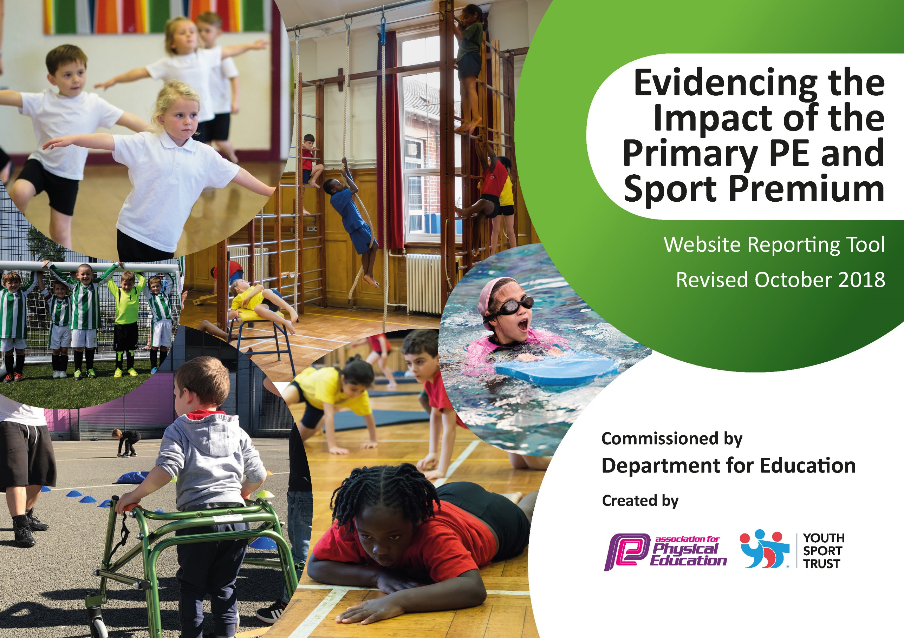
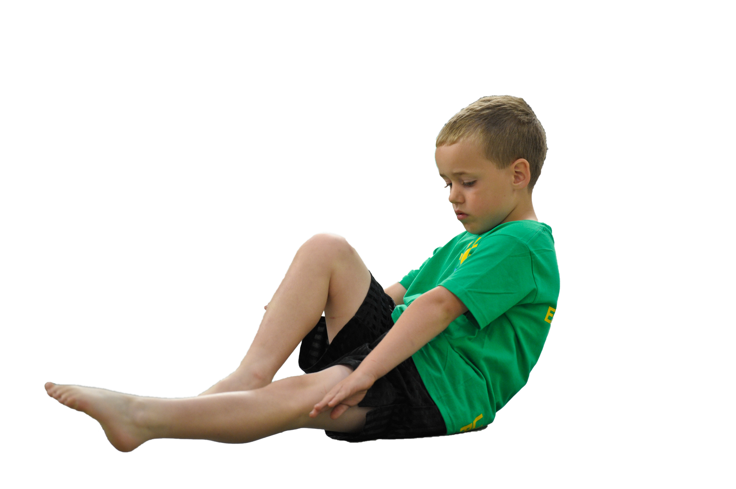
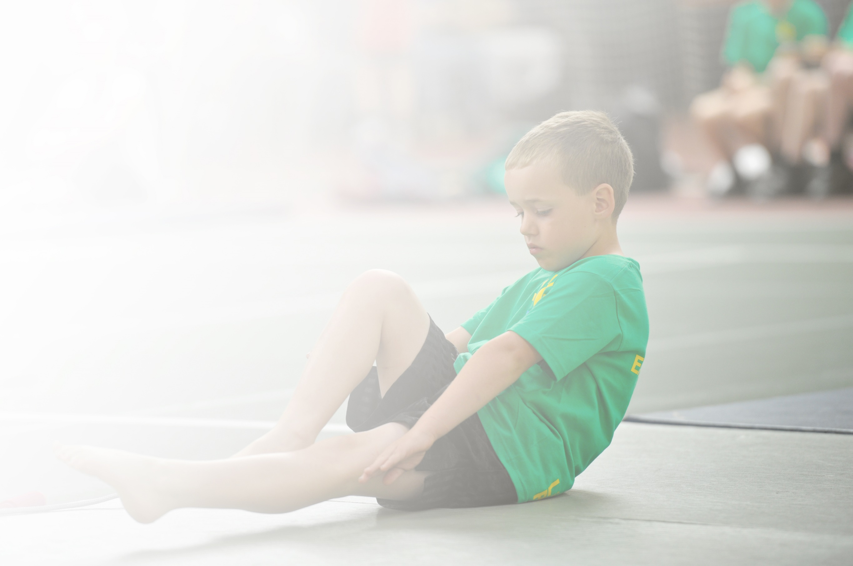
Schools must use the funding to make additional and sustainable improvements to the quality of Physical Education, Sport and Physical Activity (PESPA) they offer. This means that you should use the Primary PE and Sport Premium to:

- Develop or add to the PESPA activities that your school already offer
- Build capacity and capability within the school to ensure that improvements made now will benefit pupils joining the school in future years

Please visit gov.uk for the revised DfE guidance including the 5 key indicators across which schools should demonstrate an improvement. This document will help you to review your provision and to report
your spend. DfE encourages schools to use this template as an effective way of meeting the reporting requirements of the Primary PE and Sport Premium.

We recommend you start by reflecting on the impact of current provision and reviewing the previous
spend. Under the Ofsted Schools Inspection Framework, inspectors will assess how effectively leaders use the Primary PE and Sport Premium and measure its impact on outcomes for pupils, and how effectively governors hold them to account for this.

Schools are required to publish details of how they spend this funding as well as on the impact it has on pupils’ PE and sport participation and attainment by the end of the summer term or by 31 July 2019 at the
latest.
We recommend regularly updating the table and publishing it
on your website throughout the year, as evidence of your
ongoing review into how you are using the money to
secure maximum, sustainable impact. To see an
example of how to complete the table please
click HERE.

Support for review and reflection - considering the 5 key indicators from DfE, what development needs are a priority for your setting and your students now and why? Use the space below to reflect on previous spend, identify current need and priorities for the future.

Key achievements to date: | Areas for further improvement and baseline evidence of need:
- Association of Physical Education Quality Mark for Physical Education and Sport  - School Games Mark Bronze Award achieved July 2018  - Acquisition of ‘outstanding’ PE practitioner  - Enhanced staff CPD  - Whole school ‘Land’s End to John O’Groats’ cycling event  - PE Coordinator sent on School Games Mark training to improve good practice within and across the county | - Further develop CPD opportunities for class teachers and increase teacher confidence in delivering a range of physical activities  - Introduce top-up swimming for Year 6 pupils to ensure 100% of pupils can swim competently, confidently and proficiently over a distance of at least 25 metres  - Introduce 30 minutes of daily exercise to every class to engage less active members of the school community; increase participation in external events (eg. Beat the Street)  - Develop outside areas to increase opportunity for physical activity  - Evidencing of PE across the school, including pupil progress; develop whole school approach to tracking progress

Meeting national curriculum requirements for swimming and water safety | Please complete all of the below:
What percentage of your current Year 6 cohort swim competently, confidently and proficiently over a distance of at least 25 metres?  N.B. Even though your children may swim in another year please report on their attainment on leaving  primary school. | 91%
What percentage of your current Year 6 cohort use a range of strokes effectively [for example, front crawl, backstroke and breaststroke]? | 75%
What percentage of your current Year 6 cohort perform safe self-rescue in different water-based situations? | 91%
Schools can choose to use the Primary PE and Sport Premium to provide additional provision for swimming but this must be for activity over and above the national curriculum requirements. Have you used it in this way? | Yes

Action Plan and Budget Tracking
Capture your intended annual spend against the 5 key indicators. Clarify the success criteria and evidence of impact that you intend to measure to evaluate for students today and for the future.

Academic Year: 2018/19 | Total fund allocated: £20,000 approx. | Date Updated: September 2018
Key indicator 1: The engagement of all pupils in regular physical activity – Chief Medical Officer guidelines recommend that primary school children undertake at least 30 minutes of physical activity a day in school |  |  |  | Percentage of total allocation:
 |  |  |  | 5%
School focus with clarity on intended impact on pupils: | Actions to achieve: | Funding allocated: | Evidence and impact: | Sustainability and suggested next steps:
- To enhance the quality of PE and Sport provision across the school; To ensure all pupils access quality provision on a regular basis | - PE specialist (together with PE coordinator) used at lunchtimes and playtimes to establish activities, rotas and zones that will encourage suitable activity and aim to make every pupil more active  - Plan activities, rotas and zones, and purchase necessary equipment | £1,000 approx | - Increased levels of activity for all pupils  - Football clubs well-attended
Key indicator 2: The profile of PESSPA being raised across the school as a tool for whole school improvement |  |  |  | Percentage of total allocation:
 |  |  |  | 10%
School focus with clarity on intended impact on pupils: | Actions to achieve: | Funding allocated: | Evidence and impact: | Sustainability and suggested next steps:
- To ensure outstanding resources available to every child and therefore improve taught PE throughout the school.  - To promote & celebrate success across the school  - To increase participation in netball club; To increase participation in mums’ netball | - PE equipment audited  - Necessary equipment purchased  - New kit and trophies/medals purchased  - Success shared regularly in assemblies  - Acquisition of netball equipment | £2,000 approx | - Review end of year data  - Teams have performed exceptionally well at matches and tournaments  - Increased participation at netball club; Mums’ netball well attended

Key indicator 3: Increased confidence, knowledge and skills of all staff in teaching PE and sport |  |  |  | Percentage of total allocation:
 |  |  |  | 60%
School focus with clarity on intended  impact on pupils: | Actions to achieve: | Funding  allocated: | Evidence and impact: | Sustainability and suggested  next steps:
- PE Specialist employed to support staff CPD - an assured outstanding practitioner delivering at least one hour to each class in the school each week- encouraging further activity in the school week.  - PE subject leader to attend regular training and networking events | - All class teachers to regularly observe Coach  - Timetable ensures each class has one hour of PE with Coach each week  - Units of work developed by Coach and delivered with staff  - ESCC network meetings attended  - CPD opportunities identified and attended  - Subject leader to feedback at staff meetings, provides regular CPD for teachers  - Complete staff questionnaire to review CPD strengths & areas for development | £11,000 approx.  £1,000 approx | - All class teachers have observed Coach  - Levels of participation and engagement in session is extremely high  - End of year data review to be completed
Key indicator 4: Broader experience of a range of sports and activities offered to all pupils |  |  |  | Percentage of total allocation:
 |  |  |  | 20%
School focus with clarity on intended  impact on pupils: | Actions to achieve: | Funding  allocated: | Evidence and impact: | Sustainability and suggested  next steps:
- To increase levels of participation in physical activity; To increase range of sports experienced by all pupils  - To develop children’s leadership of PE & sport | - Skipping workshop event held for all pupils  - Up-skilling of Year 6 pupils to lead playground games  - Scoot-Fit workshop event for all pupils  - Register for range of cycling/scooting events with SUSTRANS  - Register school and all pupils for the Big Pedal and Beat the Street  - Introduce Sports Crew | £4,000 | - Review number of participating pupils at year end
Key indicator 5: Increased participation in competitive sport |  |  |  | Percentage of total allocation:
 |  |  |  | 5%
School focus with clarity on intended  impact on pupils: | Actions to achieve: | Funding  allocated: | Evidence and impact: | Sustainability and suggested  next steps:
- To provide pupils with opportunities for competitive sport, including inter-school competition | - Register with Seahaven Academy event leaders  - Introduce a Dodgeball Day (school-wide tournament)  - Provide transport when necessary to sporting events | £1,000 | - Review number of pupils taking part in competitive sport by year end

