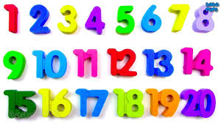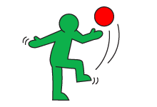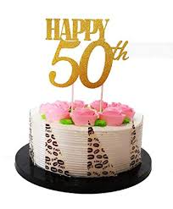

**Dates for your diary:**

Open Morning: Friday 27th September 8.50am – 10am

Parents’ Evening: Tuesday 8th October 3.30 – 5.40pm

Thursday 10th October 5.30 – 7.30pm

Thursday 4.00 – 6.00pm

Half Term: Monday 28th October – Friday 1st November

Term 2 starts for pupils: Monday 4th November

Lobster Class Assembly: Thursday 28th November 9.10 – 9.30am

Christmas Decoration Morning: Friday 6th December

End of Term 2 for pupils: Friday 20th December

**Take One Village**

Throughout the school we are currently linking our learning to the history of Denton School and the village. It is 5o years since the school was built.

Year 1 are focussing on maps, happy birthday singing, and cake designing. We are lucky to be welcoming a special visitor Mr English, who was the first headteacher of Denton School.

**Our school website address is:**

<http://www.denton.e-sussex.sch.uk/> and our class page is there for you to find out information about the class, upcoming events and links to useful websites:

**Things to Remember**:

* P.E. kit for Mondays and Tuesdays
* Reading book to be in school every day
* School starts at 8:50am with gates open at 8:40am
* Book Look will start after half term once the children have settled.



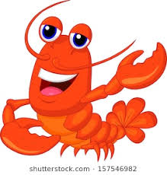

Lobster Class

Curriculum Information

Term 1 & Term 2

2019

Learning Journey:

Take One Village

**&**

Ourselves

If you have any concerns please do talk to me. You can either,

- find me on the playground at the beginning and end of the day

- write a message via Class Dojo

-make an appointment to see me with the office

Many thanks

Mrs Savage

**Numeracy**

In Year 1 we will be learning how to;

* Write our numbers in words and numbers.
* What is 1 more and 1 less.
* Count in 2s.
* Understand numbers made with tens and units.

We will teach this through a mixture of play based activities and whole class learning.

**Music**

We will be learning the song Happy Birthday, understanding what melody, pitch and rhythm is. We will try and draw the melodies of the music we listen to, and clap the rhythm.

**Literacy**

Our key text this term will be First Day at Bug School. We will learn where capital letters and full stops go. We will match our capital letters with our lowercase and start talking about forming our letters correctly.We will also learn about question marks when interviewing Mr English.

During Term two our quality texts will link to our topic of Ourselves, as well as a lot of work around Christmas, including T’was The Night Before Christmas.

We encourage all children to read to someone at home every day for about 5-10 minutes. Reading does not have to be just with a school book, it could also simply involve reading street signs on the way home.

Every day the class have a 30-minute phonics lesson where they learn new sounds and spelling patterns to help them read and spell.

**P.S.H.E.**

This term in P.S.H.E. we focus on developing children’s knowledge of themselves. We will work on how to listen to each other and understand that we are all different.

**R.E.**

In R.E. the class will be learning about what Christians believe to be the creation of the world story. Nearer to Christmas they will learn the importance of light in religion and what Advent means to Christians. Children will hear Christmas stories and take part in some carol singing in early December at the church.

**Science**

We will begin by looking at the seasons Summer and Autumn. We will explore evergreen and deciduous trees and think about the changes in weather.

In term 2 we will be learning about different materials. What there uses are and why certain materials are used for certain objects.

**Art & Design Technology**

We will be starting to use sketchbooks to try different techniques and ideas. We will look at the artist Andy Warhol and recreate our own Pop Art prints of Denton School.

In D.T we will design and create our own birthday cakes to celebrate Denton School’s 50th birthday.

**P.E.**

Our PE days are Mondays and Tuesdays. Children need to bring their shorts, a t-shirt, trainers or plimsolls on these days as we may be inside or outside.

Children need to remove earrings on these days as they cannot do P.E with them in, or we can cover them with tape.

We are currently looking at ball skills and dance. Coach will be teaching football and basketball skills.

**Geography**

We will look at our local area; Studying maps and comparing them to older maps of the village.



**Computing**

Our Computing work will be around staying safe on the computer. How to turn a computer on and off and saving a document..