Mountains, Rivers and Coast
Year 3 Penguin Class
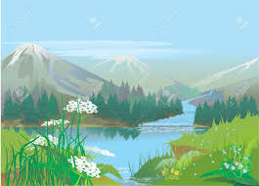

You can do as many of these as you wish but please complete at least 2 by the end of the year.
Choose whichever ones you find of interest and take your time.
Create an artistic interpretation of a river  This could be a painting, sculpture, collage, drawing.  Think about the textures and different shades of colour.  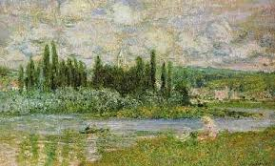 | Choose a famous river in the world and write a factfile about it.  Find at least 10 facts.  Remember fact files are written in a special way.  Headings, subheadings.  Bullet points  Pictures and diagrams. | Find out how water is used or has been used by people living near it.  This may be a watermill.  Water power  Or something else….  Once you have found something then draw and label a diagram.
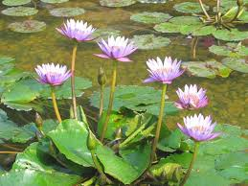  Find out about plants that live next to rivers and coasts.  Draw and/or list these then tell me what is different about plants near rivers and ones you fins on coasts? | 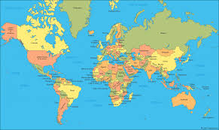  Where does water come from?  Label a map of the world with as many water sources you can find.  If you look at water bottles the label should tell you where the spring the water came from is. | 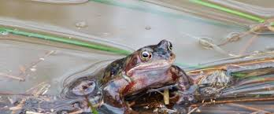  What animals live next to rivers in England?  Draw or take photos of animals that live near rivers in England.  How many can you find out about?

