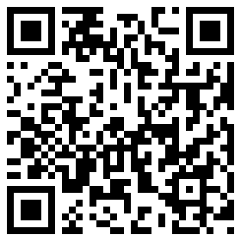My Signature 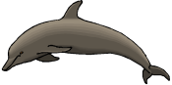

Dolphin Class Code of Conduct

We agreed to:

* Talk nicely and listen to each other
* Keep our hands, feet and other objects to ourselves
* Help other people
* Tidy up what you get out

Phonics Screening

This year’s Phonics Screening will start Monday 11th June.

I will test one child at a time so your child may be later in the week.

As mentioned at Parent Consultation Evening children will be asked to read 40 words using their phonics.

Any questions please speak to me.

Dates for your diary:

Bank Holiday: Monday 7th May

Half Term: Monday 28th May – Friday 1st June

Term 6 starts for pupils: Monday 4th June

Year 1 Phonics Screening Week: Monday 11th June

Sports Day: Friday 21st June (if wet, Thursday 28th July)

Year 1 Class Assembly: Thursday 5th July at 9.10am

Annual Reports out: Friday 6th July

End of Term 6 for pupils: Wednesday 18th July

Our school website address is:

<http://www.denton.e-sussex.sch.uk/> and our class page is there for you to find out information about the class, upcoming events and links to useful websites: <http://denton.eschools.co.uk/website/dolphins_year_1/> or scan the QR code:

Things to Remember:

* P.E. kit for Tuesdays and Fridays
* Reading book and home-school link book to be in school every day
* School starts at 8:50am with gates open at 8:40am
* Book Look is on Thursdays 8:40am-9:00am (except our assembly day)

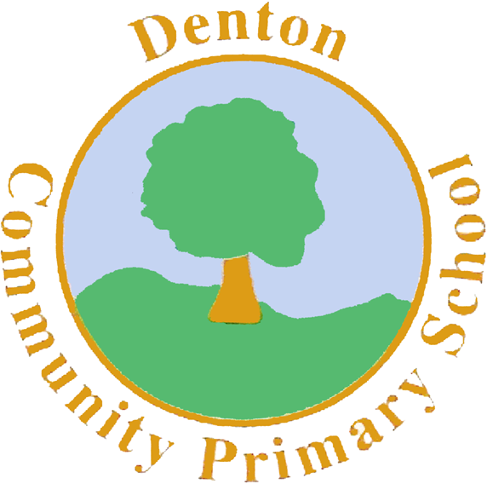

MC900120819[1]

Dolphin Class

Curriculum Information

Term 5 & Term 6

Learning Journey:

[](https://www.google.co.uk/url?sa=i&rct=j&q=&esrc=s&source=images&cd=&cad=rja&uact=8&ved=2ahUKEwjpwrrE47TaAhVJ1hQKHVAjCvMQjRx6BAgAEAU&url=https://www.zazzle.com/planet_earth_sticker-217133003646144078&psig=AOvVaw1gGhklwUao3qEjI84OIssb&ust=1523623857922149)

Planet Earth

If you have concerns or questions please let me know.

I will be in the playground before school where you can make an appointment to see me at a mutually convenient time.

Thank you,

Mr Turner

Science

Year 1 will be finding out about different plants and how to grow these. We will be labelling plants and trees and discover which plants produce food we can eat.

In Term 6 we will be planting our own plants and watching them grow. We will observe what happens and how best to look after these to ensure they continue to grow.

P.E.

Our PE days are Tuesday and Friday. Children need to bring their shorts, a

t-shirt, trainers and plimsolls on these days as we may be inside or outside.

Children need to remove earrings on these days as they cannot do PE with them in.

**Long hair needs to be tied back every day please**.

We are currently looking at athletics so it is essential that suitable outdoor footwear is also packed as we will be on the field.

Geography & History

In Term 5 Dolphins will be learning about Neil Armstrong. They will learn how to research and then write about his life.

In Term 6 we will be learn about Christopher Columbus and what discoveries he made. We will then focus on Geography and look at continents, oceans and weather on planet Earth. Using photos we will look at changes.

R.E.

Dolphin Class will be learning about special places, particularly what children would find in a Jewish home.

The class will also hear about the festival of Shabbat.

In Term 6 Year One will be visiting our local church.

Art and Design & Technology

In Art we will be learning how to use clay to make a bowl. We will look at examples and sketch our own ideas before making it.

In DT Dolphins will be making salads, linking this to our Science topic about where our food comes from. We will taste and evaluate what is on the market and then design, make and evaluate our own salad.

Computing

In Term 5 we will begin by looking at how to be safe on the internet. Dolphin Class will then move on to looking at how to use a search engine and find out about Planet Earth.

In Term 6 children will be using technology to help them explore their local area.

Music

We will be learning songs we can sing together about plants and giants. Dolphins will look at melodies and rhythms make their own instruments showing how we can reuse what would have been wasted.

P.H.S.E.

In Term 5 the class will be looking at how we can help look after the environment that we live in. In Term 6 we will be looking at relationships and changes, including changing classes ready for next year.

Spellings

Each Friday a sheet with your child’s spelling sound or pattern will be handed to them, sometimes along with High Frequency Words. These spellings are to be practised and learnt for a test the following Friday.

Numeracy

In Term 5 and 6 we will be mastering what we have already learnt and develop new skills as well.

In Term 5 we will be focusing on money and positional language.

In Term 6 Year One will focusing on measuring for different purposes and creating graphs from data collected.

Every day we do counting activities to help speed up their mental calculations and pattern recognition. A counting stick is used during these activities.

In school we strongly promote the use of apparatus and have a whole range of tools to support your child. These include number lines and Numicon.

Literacy

For our last two terms we will be looking at becoming more independent writers. We will be using our phonics, remembering punctuation and re-reading our own work to check it makes sense. The children will be working to improve their handwriting and ensure it is consistent in all our work. Also, Dolphins will be learning about Planet Earth and how to look after it.

In Term 6 we will be finding out about the Earth and sharing our knowledge with a ‘giant’ visitor. They will also be writing instructions on how to reach our new giant friend. Throughout the terms children will be continuing to read regularly and work on our fluency and understanding of texts. We will continue to learn new spellings and spelling rules to support us in our writing.