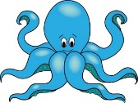

Dates for your diary:

Term 3 starts for children:

Octopus Class Assembly: Thursday 9th March at 9:10am

Sea Horse Class Assembly: Thursday 2nd March at 9:10am

Half Term: Monday 13th February – Friday 17th February

Term 4 starts for children: Monday 20th February

Parents evening dates: 7th, 9th and 14th March.

Term 4 finishes: Friday 31st March

Year 2 Class

Code of Conduct

We will:

* Look after classrooms, make sure rubbish goes in the bin
* Sit quietly
* Listen to all adults
* Put our hand up to speak
* Be kind to everyone
* Do our best work in every lesson

If you have concerns or questions please let us know.

We will be in the Key Stage One playground before school where you can make an appointment to meet at a mutually convenient time.

Thank you,

Miss Blotz and Miss George

Our school website address is:

<http://www.denton.e-sussex.sch.uk/> and our online blog is there for you to find out information about the class, upcoming events and links to useful websites.

Things to Remember:

* P.E. kit for Mondays and Fridays
* Reading book and home-school link book to be in school every day
* Homework in on Fridays
* Spelling test on Fridays
* School starts at 8:50am with gates open at 8:40am

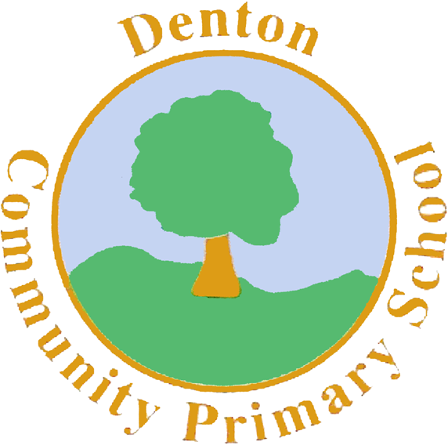

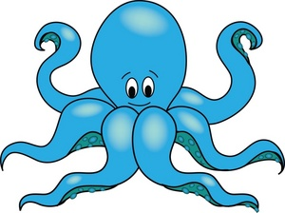

Sea Horse and Octopus Class

Curriculum Information

Term 3 and 4

2017

Art and Design and Technology

We will be focusing on Art throughout Term 3 and 4. We begin by looking at colour mixing and the artist, Wassily Kandinsky, who uses block colour to create his paintings. After this we will take our colour knowledge to design and create our own Rangoli patterns.

P.H.S.E.

In PSHE we are looking at how we keep ourselves healthy. This involves looking not only at our diet and exercise but our emotional well-being also, how we keep ourselves happy and using our voices to express when we’re feeling sad.

Music

Our focus in music is to develop our knowledge of musical instruments and play a selection of these. We continue our work on tempo and rhythm, making sure we can follow a beat.

Science

Our topic in Science is called ‘Animals Including Humans’. We begin by exploring life cycles and growing from a child to an adult. We are going to explore the basic needs both animals and humans need to survive. We end the term focusing on animals and how some have adapted to suit their environment.

Literacy

In Literacy we begin Term 3 with an Indian trickster tale which the children will be learning, making changes to and re-writing their own versions. In Term 4 we will be looking at a range of non-fiction information books about India and creating our own information pages.

We begin our Spelling, Punctuation and Grammar sessions this term and children will be focusing on sentence types, correctly punctuated sentences and our Year 2 spelling of common exception words, which can be found on our class pages.

We will continue our ‘Book Look’ on a Wednesday morning between 8:40 and 9.00am if you wish to come in and read.

Homework

Homework is set on a Friday for children to return by the following Friday and will relate to previous or future work in class. Later in the term spellings will be stuck into reading records to be practised and learnt for a test the following week.

Numeracy

We will continue to build on the knowledge we have learnt in Terms 1 and 2. This includes reading and writing numbers to 100 and adding and subtracting two digit numbers using a range of methods. We will also focus on fractions and finding halves and quarters of amounts, measuring length and capacity and begin to understand basic multiplication and division for the 2, 5 and 10 times tables.

P.E.

Our PE days are Tuesday and Friday. Children need to bring their shorts, a t-shirt, trainers and/or plimsolls on these days. Children need to remove earrings on these days as they cannot do PE with them in.

**Long hair needs to be tied back every day please**.

During Term 3 we will be exploring Indian dance, learning a particular dance called the ‘Indian Stick Dance.’ In Term 4 our focus is developing skills. This includes throwing and catching, balancing, kicking a football and hitting a ball with a bat.

R.E.

In Term 3 we are going to focus on the story of Rama and Sita and in Term 4 we will be finding out all about the colour festival called ‘Holi’.

Topic

We begin Term 3 with a Healthy Eating initiative where children will research food groups and how we keep ourselves healthy. After this our main topic is ‘Food and Festivals’. We will be focusing our learning on India and the festivals and celebrations they hold.

Computing

In Computing this term we are going to focus on basic computer programs. This will including saving a piece of work independently, finding and opening a file and printing a piece of work. We will be practising these skills whilst creating Rangoli patterns on Paint.

Geography/History

In Term 3 and 4 Geography will be our main focus. We are going to find out all about India, looking at the famous landmarks, the food, where India is in relation to the UK and the climate. We will take all of this information and create our own travel brochures for India.