HOMEWORK GRID
Year 3 Penguin Class
You can do as many of these as you wish but please complete at least 2 by the Easter holidays.
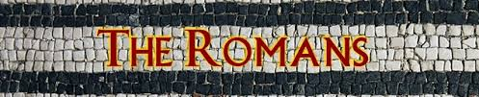
Choose whichever ones you find of interest and take your time.

ROMANS
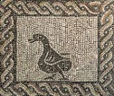  Create a Roman Mosaic  Using any materials you wish, paper, glue, colouring pencils the programmes on our class page or something else. Create a Roman Mosaic using a repeating pattern border and a picture in the middle. | 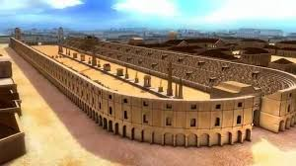  Recreate the Circus Maximus Chariot Race track  You can use anything you wish to create this. It can be 3D or a picture. You could draw a detailed diagram and label it. | 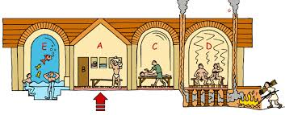  Write a diary entry of a Roman who has spent the day at the Roman Baths.  What did you eat there?  Who did you go with?  Which part did you like the most?
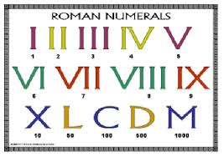  Create a clock or calendar using Roman Numerals  Use the Roman numerals to create a clock with a second hand and hour hand OR a wall calendar showing every month and day in the month. | 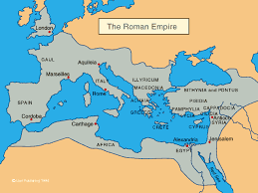  Draw or recreate a map of the Roman Empire  Recreate a map either using the computer, drawing or another way….  Label where Rome is.  Label where Hadrian’s Wall is. | Write a factsheet about The Romans  Remember to include features of a factsheet, headings, diagrams, captions and labels.  It could include;  What they ate.  What we still use today that Romans created.  What a Roman solider wore.  A Roman timeline.  How they were entertained.

