Dates

* Whales Class Assembly: 31/1/19 at 9:10am
* Inset Day: 25/2/19
* Term 4 Starts: 26/2/19
* E-Safety at Harbour: 5/3/19
* World Book Day: 7/3/19
* Parent Consultations: 12th, 14th and 21st March

Whales Class Rules

Be Kind, Be Polite, Be Honest

Homework

Homework is set on Tuesdays and due in on Mondays. It is important that you support your child with their homework. Any problems, please don’t hesitate to come and speak to me.

Things to remember:

* P.E. kit for **Wednesdays** and **Fridays**
* Reading book every day
* School starts at 8.50am – it is really important that your child is on time.
* Please ensure your child is in correct school uniform every day.
* If your child brings a mobile phone to school it must be left at the school office.

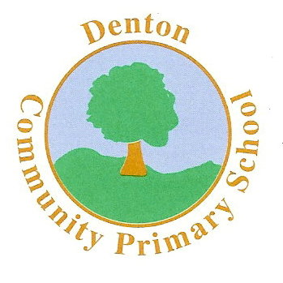 Whales Class

Terms 3 and 4

P.E.

The children will be learning how to play a range of sports. We will begin with Hockey for Term 3 and then the focus will be Tag Rugby. Mr Hymers (Coach) will be taking the children for at least one lesson a week.

R.E.

Our RE work over the next two terms will be based around learning about Jesus and who he was. We will discuss Jesus’ life and how he died. This will lead us into our Easter topic where we will explore terms such as, Lent.

HISTORY & GEOGRAPHY

Our History & Geography topic this term will be Anglo-Saxons. We will learn the chronology of events and begin to understand why the Anglo-Saxons invaded Britain.

We will compare our lives today to that of the Saxons and begin to understand how resources have developed and improved over the centuries.

ENGLISH

This term our focus will be Anglo-Saxons. We will be reading Beowulf and our writing activities will be based on this. The children will participate in writing letters, stories, news reports and much more! We will also compare Beowulf with other stories and begin to find differences and similarities. By the end of the two terms, the children will have improved their writing skills and become confident using the correct grammar and punctuation.

Art and D.T.

Much of our Art and DT work will be based on our topic, Anglo-Saxons. The children will be involved in the planning, designing and making of Anglo-Saxon shields and jewellery.

The children will continue to use the colour wheel to create different tones and contrasting colours to compliment their artwork.

Computing

The children will use ICT where possible as a cross curricular link. They will use popular search engines to gather information required and use programs such as Word and PowerPoint to present their findings.

MUSIC

The children will take part in a range of singing in assemblies and there will also be the opportunity to sing in the school choir.

In class we will continue to learn songs in Spanish!

SCIENCE

The children are going to begin by exploring the topic ‘Light.’ We will look at our solar system in great detail and begin to explore the properties of some of the planets.

During these two terms, the children will also take part in a range of experiments, from which they will draw conclusions.

MATHS

In Maths the children will cover a range of topics. We will be covering addition, subtraction, multiplication and division. Fractions, decimals and percentages will also be covered in great detail, including adding, subtracting and even multiplying fractions! Times tables will be a regular feature of class work.

We will also continue to look at past SATS papers, and take part in SATs - like weeks.

Modern Foreign Languages

We will be studying Spanish and developing our basic conversation skills, including meeting and greeting.

P.S.H.E.

In PSHE we will begin by exploring balanced diets and how to stay healthy. We will also discuss social media and how that may impact on how we feel about ourselves. In Term 2, we will explore what constitutes a positive, healthy relationship and develop the skills to form and maintain positive and healthy relationships.

MC900358181[1]