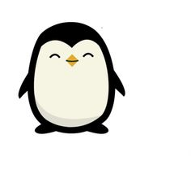 

Dates for your diary:

Term 1: Thursday 5th September – Friday 25th October 2019

Inset Day: Monday 14th October 2019

Half Term: Monday 28th October – Friday 1st November 2019

Term 2 starts for children: Monday 4th November 2019

Penguin Class Assembly: Thursday 14th November 2019 at 9:10am

Term 2 finishes: Friday 20th December 2019

Year 3 Class

Code of Conduct

We will:

* Look after classrooms, make sure rubbish goes in the bin
* Sit quietly
* Listen to all adults
* Put our hand up to speak
* Be kind to everyone
* Do our best work in every lesson

Our school website address is:

[www.dentonprimaryschool.co.uk](http://www.denton.e-sussex.sch.uk/) and our online blog is there for you to find out information about the class, upcoming events and links to useful websites

Things to Remember:

* P.E. kit for Monday and Thursday
* Reading book and home-school link book to be in school every day
* Homework projects set each long term
* Spelling test on Fridays
* School starts at 8:50am with gates open at 8:40am

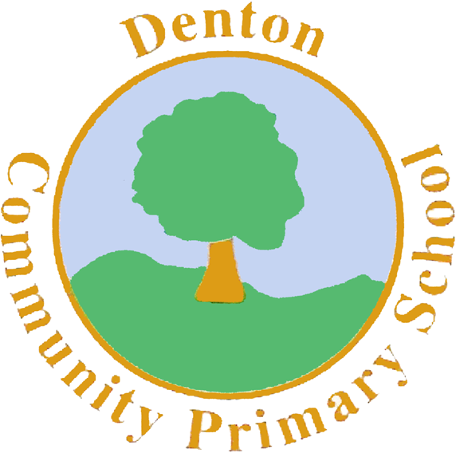

Penguin Class

Curriculum Information

Term 1 and 2

2019

If you have concerns or questions please let me know.

I will be in the Key Stage Two playground before school where you can make an appointment to meet at a mutually convenient time.

Thank you,

Miss Blotz and Mr Dooley

P.E.

Our PE days are a Monday, with coach, and a Thursday with me. Children need to bring their shorts, a t-shirt, trainers and plimsolls on these days. Children need to remove earrings on these days as they cannot do PE with them in.

**Long hair needs to be tied back every day please**.

Our focus in PE is Dance. Children will use the hall equipment to experiment with travelling and creating short sequences of movements to Viking music. In Term 2 children will take part in Gymnastics, where they will practice their balance, creating sequences of movements across mats and the beam. Children will also take part in a PE session each week with our sports coach. Term 1 will be football.

Computing

In Computing we are going to focus on Coding and creating Spreadsheets. In Coding, children will explore how to create flowcharts and design characters to give commands. They will look at debugging and creating different variables. When creating spreadsheets, children will use excel and Purple Mash to collect data.

Spanish

Year 3 sees the introduction of Spanish to our curriculum. We begin the year learning body parts and will learn the song ‘Head, shoulders, knees and toes’. After this we will focus on basic greetings and colours.

R.E.

We’ll begin our RE sessions focusing on Light. Children will explore how different religions use light to celebrate festivals. In Term 2, we’ll focus on Christianity and in particular the Christmas Story. Children will have the opportunity to visit our local church during Term 2.

Art and Design and Technology

During our Art sessions children will explore Viking runes and pictoral symbols. They will design their own Viking symbol to become part of their Viking shield design. In Design and Technology, children will research Viking long ships and then design their own. They will make their Viking long ships out of junk modelling materials and finally evaluate their designs and process at the end.

Geography/History

Our focus In Term 1 will be History. Children will explore what life was like during the Viking era. We will learn about Viking rules, jobs and food. We will explore the countries that the Vikings lived in and those they invaded. All our information will go towards creating a survival guide on being a Viking. In Term 2 we focus on Geography. We will be exploring the Scandinavian regions and how Vikings managed to survive in the cold climates.

Literacy

We begin the year exploring a story called the ‘Freya Connection’, a World War 2 story based in Newhaven. We then move on to a short project where children will explore Viking settlements through a drama approach called ‘Mantle of the Expert’. Children will become archaeologists, excavating an old Viking settlement to which they will then write and create a short film script explaining their learning. After this, children will write a set of instructions based on ‘How to train your dragon.’ After Half Term, children will write their own stories based on the myth’ Thor and his hammer’ and create Viking poetry.

Topic

We begin the year with a whole school focus called ‘Take One Village.’ This is based on the school turning 50 years old in September! Children will be exploring how Denton village has changed and expanded over time, exploring Newhaven’s involvement in World War 2 and creating maps and sketches of our beautiful village! After this we move on to Vikings, where children will explore Viking Settlements and how Vikings used to live.

Science

Science this year will be split into 3 units: biology, chemistry and physics. We begin the year with our biology unit which is called ‘Living Things, Habitats and Lifecycles’. Children will investigate the characteristics of different animals and explore their different life cycles and food chains. After this, we move onto the life cycle of a human and how we age and reproduce.

Music

We will be thinking about rhythm and tempo during our music lessons during Term 1 and 2. We will learn a range of Viking camp songs and also make our own instruments such as drums and shakers to play alongside.

P.H.S.E.

We begin the year with our topic ‘New Beginnings’. We focus on feeling settled in our new classroom environments and feeling confident to express our feelings with our class mates.

Homework

Homework Projects will be set in the first few weeks of each long term. Each project will be tailored towards our current topic and will contain a range of different activities for children to complete. Spellings will be set weekly, then tested on a Friday. Please also ensure nightly reading is completed with your child and noted in their reading logs.

Numeracy

Our focus throughout Term 1 and 2 in Numeracy will be on place value. We will be recapping our work on units, tens and hundreds, plotting numbers on number lines and counting in steps of 2, 3, 5, 10 and 100. For some, we will begin thinking about counting down to negative numbers and becoming confident plotting them on a number line. We will introduce recognising basic Roman numerals, whilst also focusing on counting and adding money. We will end Term 2 by recapping written methods for addition and subtraction.