Our school website address is:
http://www.denton.e-sussex.sch.uk/
Here you will find Octopus and Sea Horses class pages.
Dates for your diary:
Half Term: Monday 30th May
May Bank Holiday: Class Assembly:
Octopus Class THURSDAY 16th June 9.10AM
Sea Horse Class THURSDAY 23rd June 9.10AM
Book Look: WEDNESDAY 8.40AM – 9.10AM
Towner Schools Exhibition Trip: April 26th
SATs Parent Information Sessions: Tuesday 19th April 3.30 – 4.00pm
Or Wednesday 20th April 8.30 – 9.00am

SATS will be taken in May
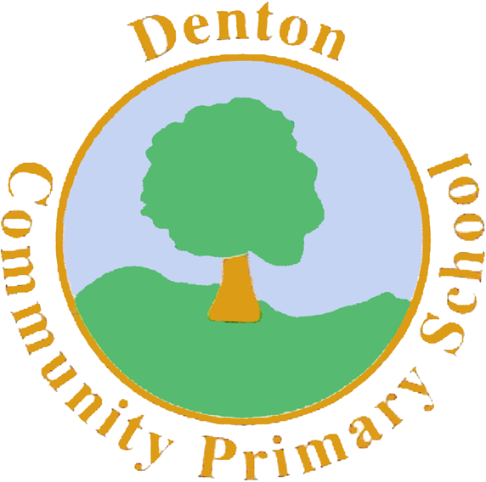

Welcome to
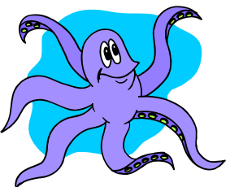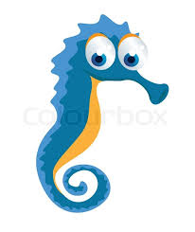

OCTOPUS and SEA HORSE
Classes

Curriculum Letter
Summer Term
5 and 6
Things to Remember:
- P.E. kit for MONDAY and FRIDAY – be prepared for going outside!
- Reading book and home-school link book every day.
- School starts at 8:50am with gates open at 8:40am
If you have any questions or you need to let us know any information please don’t hesitate to see us in the playground or make an appointment.

The children are allowed squash or juice drinks at lunch time but can you please ensure they only have water in their bottles for class.

Numeracy
We will be continuing to learn how to add, subtract, multiply and divide with a variety of methods.
We will be looking at measuring distance, weight, capacity and temperature for different purposes across the curriculum.
We will be learning how to tell the time using analogue and digital clocks, learning different positional language and putting this into situations. We will be recapping and learning further about fractions, and collecting and using data.
R.E.
We will look at stories from different religions and why they are told. We will be learning David and Goliath and The Lost Sheep.
PLANET EARTH


P.E.
The children will be working with the coach every Friday.
On Mondays they will be continuing to learn and show how to catch and throw accurately and learning how to play rounders.
Computing
We will be learning how to research a topic and present this to the class using PowerPoint.
P.H.S.E.
The children will be looking at friendships and family relationships. They will learn about sharing and trust, and how everyone’s relationships are different.

Music
To celebrate the Queen’s 90th birthday the children will learn the National Anthem.
The children will create their own musical narratives for Jack and the Beanstalk.
We will continue to learn many songs and develop our singing.
.

Literacy
The children will continue to read regularly at school to improve their fluency, expression and comprehension.
In Term 5 we will be telling traditional tales and creating our own based on what we have read. We will be looking at instructions and information pages and creating our own on plants.
In Term 6 we will be looking at traditional tales from other countries and linking this with our science of animals and their habitats. We will then write our own traditional tales based on what we have read. We will be researching and finding out about animals and their habitats and creating information pages on these.
Science
In Term 5 we will be learning about plants. We will observe and classify plants and create tests to show what plants need to grow well.
In Term 6 we will be looking at different animals and their habitats. We will look at local and distant habitats and how they are the same and different.

Art

In Term 5 we will be visiting the Towner Schools Exhibition. We will see our own artwork in a real gallery. We will use inspiration from this to learn the skill of weaving.
The children will then use weaving to create 3D giant plants and beanstalks.
In Term 6 we will be creating collages of animals in their habitats. We will look at different collage artists and how they create their work, taking inspiration from these to create our own.
Geography
We will look at the United Kingdom, and use positional language to understand where each part of the United Kingdom is in relation to each other. Children will learn to identify these on a map. The children will learn about specific traditions of England, Scotland, Wales and Northern Ireland.

