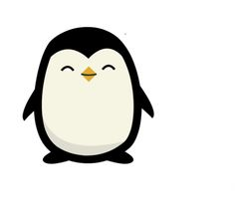 

Dates for your diary:

Term 5 finishes for children: Friday 24th May 2019

Half Term: Monday 27th May 2019 – Friday 31st May 2019

Term 6 starts for children: Monday 3rd June 2019

Penguin Class Assembly: Thursday 13th June 2019

Term 6 finishes: Monday 22nd July 2019

Year 3 Class

Code of Conduct

We will:

* Look after classrooms, make sure rubbish goes in the bin
* Sit quietly
* Listen to all adults
* Put our hand up to speak
* Be kind to everyone
* Do our best work in every lesson

Our school website address is:

<http://www.denton.e-sussex.sch.uk/> and our online blog is there for you to find out information about the class, upcoming events and links to useful websites.

Also find our class Dojo page: <https://www.classdojo.com/>

Things to Remember:

* P.E. kit for Tuesday and Wednesday
* Reading book and home-school link book to be in school every day
* Spelling test on Fridays
* School starts at 8:50am with gates open at 8:40am

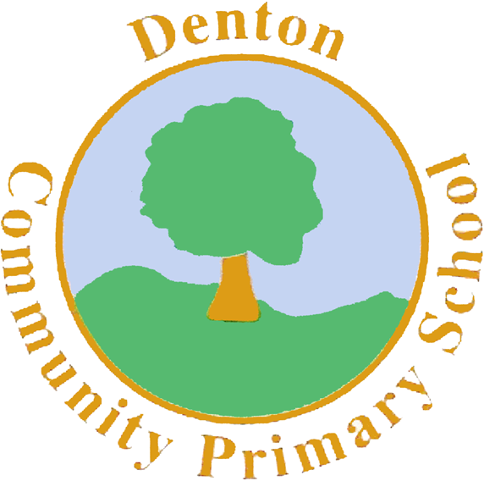

Penguin Class

Curriculum Information

Term 5 and 6

2019

If you have concerns or questions please let us know.

We will be in the Key Stage Two playground before school where you can make an appointment to meet at a mutually convenient time.

Thank you,

Miss Blotz ☺

Art and Design and Technology

In Term 5 we focus on Art and sketching our local landscape. Children will explore art created by local artist David Scott Moore. Using paintings he has created we will explore foreground and background before creating our own pieces. In Term 6 children will design and make their own bridges.

Geography/History

During Term 5 and 6 we focus predominately on Geography. Children will explore the different types of mountain ranges around the world, rivers and the water cycle and coastal geography. Children will explore our local coastal area, thinking about beach safety and keeping our beaches clean.

Literacy

We start Term 5 with another ‘Mantle of the Expert’. Children will become mountain explorers who have been asked to create a survival kit. They will write instructions and information pages on staying safe when climbing a mountain. We then move on to ‘Talk for Writing’. We will use the story ‘Flotsam’ to learn and re-create our own versions. In Term 6 children will create river poems, information pages on coast lines and use the story ‘The River’ to create fact files on a river’s journey.

Topic

Our topic throughout Term 5 and 6 is Mountains, Rivers and Coasts. Children will explore how mountain ranges are formed and some of the most famous mountain ranges in the world. They will find out all about the water cycle and how rivers are formed. Finally we move on to coastal work, where children will explore our local coast line and landscape.

Science

Our topic in science this term is Chemistry. We will be focusing on changes of state. Children will have the opportunity to safely use a range of chemicals to cause reactions that explain changes in state to different materials. Children will explore how different chemicals create light, affect mass, discolouration and change temperature.

Numeracy

We will spend the rest of the academic year re-capping our objectives, looking into more detail and exploring how to reason and problem solve using the concepts we have learnt this year. In Term 5 we once again look at the column method for addition and subtraction, exploring how we can incorporate missing number problems into this. We will also recap the grid method for multiplication and sharing for division. In Term 6 we re-cap fractions, time, shape and measurement to ensure children are confident with each objective.

Spanish

In Spanish children will continue to build their vocabulary. Progressing to numbers to 100, school equipment, time and basic questions and answers.

Computing

In Term 5 children will look at grouping objects on the computer to create simple databases. In Term 6 children will explore how to create simple simulations on Purple Mash.

Music

In Term 5 we will be focusing on listening to and learning a range of water themed songs. Children will be making a range of musical instruments to play alongside these songs. In Term 6 we focus on interpreting a piece of music called Night on the Bare Mountain by Modest Mussorgsky.

P.H.S.E.

In Term 5 children look at environmental safety in particular water safety and how charities such as the RNLI keep us safe. In Term 6 we focus on our ‘Sex and Relationships’ topic, this year thinking about personal space and our family heritage.

Homework

Homework projects will be set within the first few weeks of each long term. Children then have the remaining time to complete a selection of tasks. Spellings will be stuck into reading records to be practised and learnt for a test the following Friday.

P.E.

Our PE days are Tuesday and Wednesday. Children need to bring their shorts, a t-shirt, trainers and plimsolls on these days. Children need to remove earrings on these days as they cannot do PE with them in.

**Long hair needs to be tied back every day please**.

PE in Term 5 is Athletics. Both our sports coach and I will be focusing on preparing the children for District Sports. They will take part in a range of activities such as sprinting, long distance running, throwing and the long jump.

In Term 6 we will be playing rounders outside on the field. Children will learn how to confidently bat the ball and field. Coach will be focusing on Tennis.

R.E.

In Term 5 we will be investigating signs and symbols from a range of different cultures including Judaism, Sikhism and Buddhism. During Term 6 we will learn about Judaism and the Sukkot.