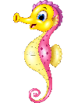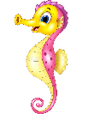

Dates for your diary:

Term 3 starts: Tuesday 4th January 2022

Last day of Term 3: Friday 11th February 2022

Half Term: Monday 14th – Friday 18th February 2022

INSET Day: Monday 21st February 2022

Term 4 starts: Tuesday 22nd February 2022

Last day of Term 4: Friday 1st April 2022

Year 2 Class

Code of Conduct

We will:

* Look after classrooms, make sure rubbish goes in the bin
* Show good listening and good learning
* Listen to all adults
* Put our hand up to speak
* Be kind to all
* Never give up!

Things to Remember:

* P.E. kit for Tuesday and Thursday
* Reading book and home-school link book to be in school every day
* Homework projects set each long term
* Spelling test on Fridays
* Our school start time is between 8:30am and 8.50am and finish time is 3.10pm

Our school website address is:

<http://www.dentonprimaryschool.co.uk/website/sea_horses_year_2__/501477>

and our online blog is there for you to find out information about the class, upcoming events and links to useful websites.



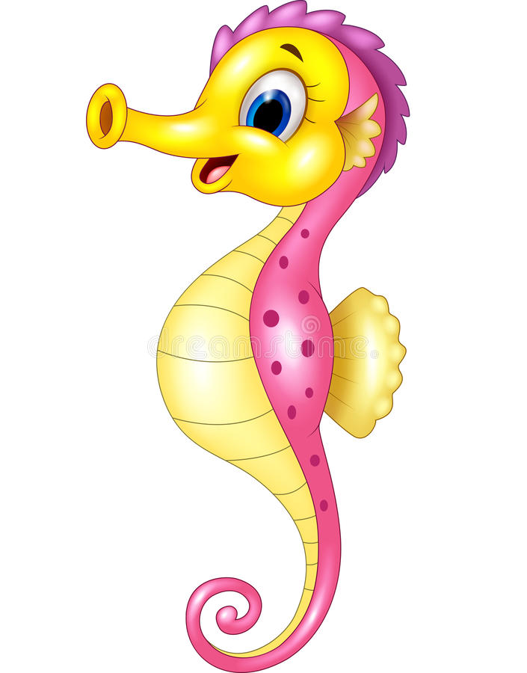

Sea Horse Class

Curriculum Information

Term 3 and 4

2021

If you have concerns or questions please let us know via the children’s Home School Link Book or through the office to make an appointment to meet at a mutually convenient time.

Thank you,

Miss Blotz and Mrs Buss

Art and Design and Technology

In Term 3, we focus on Art. Children will be making observational sketches of their own teddy bears and using a range of medias to colour them in. We will also look at the work of Henri Matisse and will have a go at creating some artwork inspired by his style. In Term 4, we will focus on D&T where we will be designing, making and evaluating our own teddy bears. We will learn how to create a template and using a simple sewing stitch to sew these together.

Literacy

We begin the term with the lovely poem ‘We’re going on a bear hunt’ by Michael Rosen. We will learn this poem and have a go at writing our own versions. We then move on to Traction Man by Mini Grey, where will write descriptive paragraphs and instructions on being a superhero.

In Term 4, we will become a group of knights searching for a magical toy to help soothe the Fairy Queens’ baby and will create adverts and posters for our pieces of writing. Finally, we look at the Old Bear stories by Jane Hissey, where again we will learn them and create our own teddy bear stories.

Music

In music we continue to think about musical instruments and using them to create short pieces that include changing pitch and pace. We will also be making our own musical instruments with different materials.

P.H.S.E.

In Circle Time throughout Term 3 and 4 we focus on our body and relationships. We think about how our bodies grow and begin to change and the relationships we have with our family and friends. We will also link our RE learning of rules and routines to think about rules we follow in everyday life.

Topic

Our topic this term is ‘Toys’. We will explore a range of stories all about toys and investigate and make a range of toys from around the world. We will find out about how toys have changed over time and use different media techniques to draw our own toys. We will explore the different types of materials that make toys.

Homework

Homework Projects will be set in the first few weeks of each long term. Each project will be tailored towards our current topic and will contain a range of different activities for children to complete. Spellings will be set weekly, then tested on a Friday. Please also ensure nightly reading is completed with your child and noted in their reading logs.

P.E.

Our PE days are a Tuesday, with our sports coach, and a Thursday with me. Children need to wear their shorts or joggers, a t-shirt and trainers or plimsolls on these days. Children need to remove earrings as they cannot do PE with them in. **Long hair needs to be tied back every day please**. Term 3 with coach is ____and with me is bench ball. In Term 4, coach will be teaching _____ and I will be teaching children how to play netball. Throughout Term 3 and 4 we will focus on our throwing and catching skills and learning how to play team games.

Numeracy

We begin Term 3 continuing our work on addition and subtraction. We have been using a selection of methods including the number line, column and part whole models to add and subtract two digit and one - digit numbers. We will use these methods to practice solving word problems.

After this, we move on to multiplication and division. Children will continue to learn their 2’s, 5’s and 10’s times tables and we also introduce the 3’s and 4’s for those confident. We will use the grouping and sharing methods for multiplication and division to solve word problems.

Computing

In Term 3, we use Purple Mash to make spreadsheets about our favourite toys at home.

In Term 4, we use Purple Mash again to create musical sounds and put together short melodies.

Science

Our topic throughout Term 3 and 4 is materials. We will investigate different materials and their properties. We will then conduct a range of experiments to test the durability, flexibility and strength of different materials. When conducting the experiments, we will learn how to make plausible predictions and write up our findings.

R.E.

In Term 3 we look at ‘Rules and Routines’, thinking particularly at Christianity and the 10 commandments. In Term 4, our topic is called ‘Beginnings and Endings’ which is use to focus on the Easter story.

.

Geography/ History

We begin Term 3 looking at History where we will be finding about how toys have changed over the last 100 years. Children will put the toys on a timeline and look at the similarities and differences between toys then and now.

In Geography in Term 4, we look at toys around the world and investigate how different materials are used in different parts of the world.