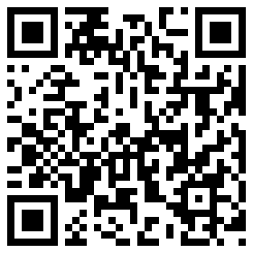My Signature 



MC900120819[1]

Dolphin Class

Curriculum Information

Term 3 & Term 4

Learning Journey:

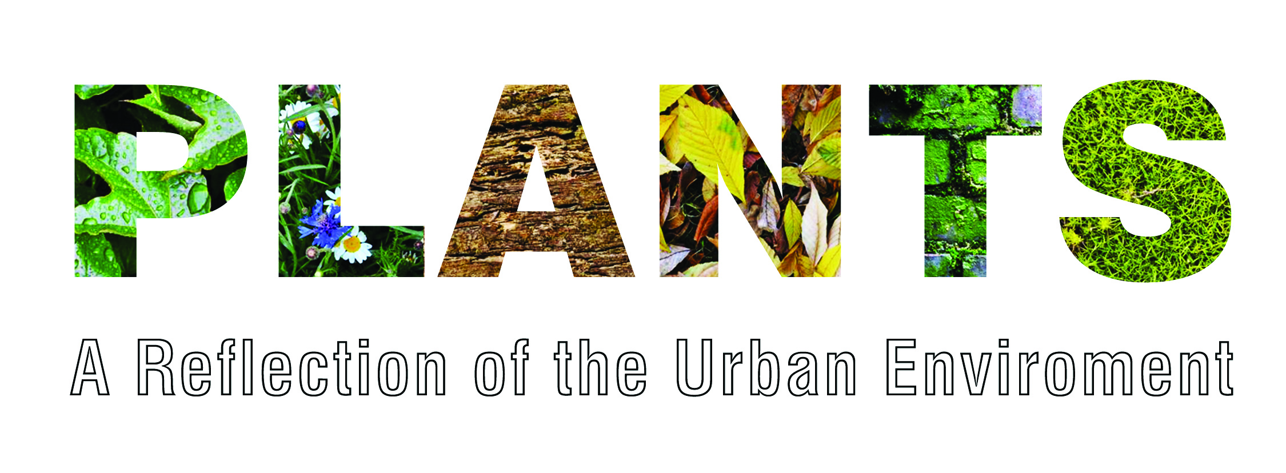**&**

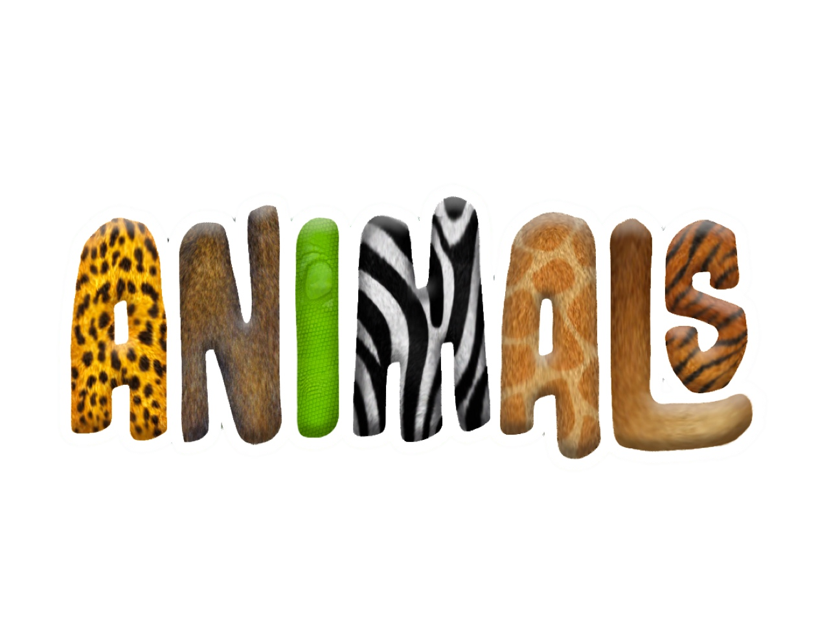

**Dolphin’s**

**Valentine’s Disco**

Dates for your diary:

Half Term: Monday 13th February – Friday 17th February

Term 4 starts for pupils: Monday 20th February

Parents’ Evening: Tuesday 7th March 3.30pm – 5.30pm

Thursday 9th March 5.30pm – 7.30pm

Tuesday 14th March 4pm – 6pm

Dolphin Class Assembly: Thursday 16th March at 9.10am

End of Term 4 for pupils: Friday 31st March

Term 5 starts for pupils: Wednesday 19th April

Class Charity

This year Dolphin Class have voted to support Raystede. 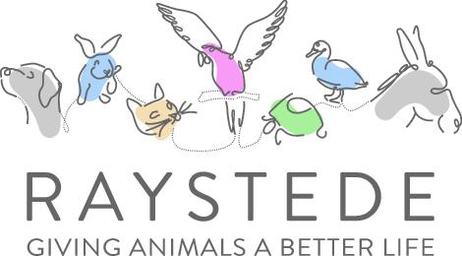

Stay tuned for our next event:



Dolphin Class Code of Conduct

We agreed to:

* Talk nicely and listen to each other
* Keep our hands, feet and other objects to ourselves
* Help other people
* Tidy up what you get out

Our school website address is:

<http://www.denton.e-sussex.sch.uk/> and our class page is there for you to find out information about the class, upcoming events and links to useful websites: <http://denton.eschools.co.uk/website/dolphins_year_1/> or scan the QR code:

If you have concerns or questions please let me know.

I will be in the playground before school where you can make an appointment to see me at a mutually convenient time.

Thank you,

Mr Turner

Things to Remember:

* P.E. kit for Mondays and Wednesdays
* Reading book and home-school link book to be in school every day
* Homework is given out on a Friday and due in by the following Friday
* School starts at 8:50am with gates open at 8:40am
* Book Look is on Thursdays 8:40am-9:00am (except our assembly day)

Geography

For Term 3 we will look at China, the flag, location, climate, food and the New Year celebrations. The class will use all the information collected over the term to create a fact file that they will be able to share for other children to learn from.

During Term 4 a similar scheme of work will be followed but for India.

R.E.

Dolphin Class will be looking at various festivals during Term 3, with particular focus on the Chinese New Year. In Term 4 children will learn about Holi and the Christian story behind Easter with a visit from our local vicar.

Design & Technology

Our topic for D.T. links to Healthy Eating Week and our Computing topic. Children will investigate and taste different foods and develop vocabulary to describe the appearance, taste, smell and texture. This activity provides opportunities for children to apply hygienic practices and to use tools and equipment effectively and safely.

Computing

Computing within Term 3 looks at children as treasure hunters. The class will be using a programmable toy to make it follow a route that they have designed. In Term 4 Dolphin Class will become TV chefs. They will plan and film the various steps involved in creating a recipe video.

Science

Throughout the term Dolphin Class will look at animals, including humans.

By the end of the topic most children will be able to identify and then classify animals into various groups, such as mammals, reptiles, amphibians, birds and fish.

Year 1 will also look at the growth, basic needs, exercise, food and the hygiene of different animals. This will include grouping animals into herbivores, carnivores and omnivores.

P.E.

Our PE days are Monday and Wednesday. Children need to bring their shorts, a

t-shirt, trainers and plimsolls on these days as we may be inside or outside.

Children need to remove earrings on these days as they cannot do PE with them in.

**Long hair needs to be tied back every day please**.

We are currently looking at gymnastics and games so it is essential that suitable outdoor footwear is also packed.

Music

The topic ‘Feel the Pulse’ develops the children's ability to recognise the difference between beat and rhythm and to perform in time to a beat. We will be using various pieces of music to support us.

P.H.S.E.

This term in P.S.H.E. we focus on bullying and try and answer questions such as: What is bullying? What are the different types of bullying? How can we stop bullying? How can we stay safe online?

Spellings

Later in the term spellings will be stuck into Reading Record books. These spellings are to be practised and learnt for a test the following Friday.

Numeracy

Throughout this term we will continue to look at numbers, recognising them by amount, image or name but will also embed our number knowledge by applying them into various areas. Initially the class will focus on partitioning and place value but then move on to measuring weights using comparison and non-standard units, such as cubes. Dolphin Class will also start learning to tell the time to the nearest hour, half hour and pay amounts of money up to 20p in real-life contexts.

Every day we do counting activities to help speed up their mental calculations and pattern recognition. A counting stick is used during these activities but we also have a whole range of tools to support your child.

Literacy

It is vital that children are exposed to quality texts and in Year 1 we have linked all our texts to our learning journey, Plants and Animals or even China and India which we look at in Geography.

While enjoying these stories the children will learn about poetry, how to write a fantasy story as well as finding out how to use a dictionary effectively.

We encourage all children to read to someone at home every day for about 5-10 minutes and have another reading challenge currently underway in the lead up to Valentine’s Day! We will repeat this competition before Easter.

Every day the class have a 30-minute phonics lesson where they learn new sounds and spelling patterns to help them read and spell.