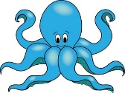

Dates for your diary:

Term 5 starts for children: Wednesday 19th April 2017

Term 5 finishes for children: Friday 26th May 2017

Half Term: Monday 29th May – Friday 2nd June 2017

Term 6 starts for children: Monday 5th June 2017

Octopus Class Assembly: Thursday 15th June 2017

Sea Horse Class Assembly: Thursday 22nd June 2017

Term 6 finishes for children: Thursday 20th July 2017

Year 2 Class

Code of Conduct

We will:

* Look after classrooms; make sure rubbish goes in the bin
* Sit quietly
* Listen to all adults
* Put our hand up to speak
* Be kind to everyone
* Do our best work in every lesson

If you have concerns or questions please let us know.

We will be in the Key Stage One playground before school where you can make an appointment to meet at a mutually convenient time.

Thank you,

Miss Blotz and Miss George

Our school website address is:

<http://www.denton.e-sussex.sch.uk/> and our online blog is there for you to find out information about the class, upcoming events and links to useful websites.

Things to Remember:

* P.E. kit for Mondays and Fridays
* Reading book and home-school link book to be in school every day
* Homework in on Fridays
* Spelling test on Fridays
* School starts at 8:50am with gates open at 8:40am

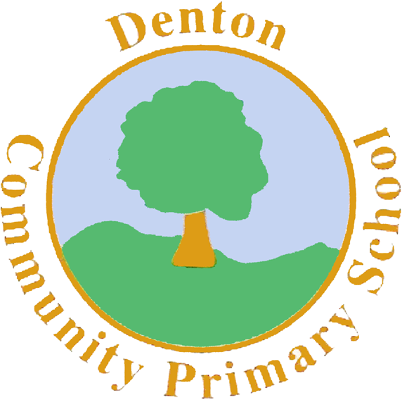

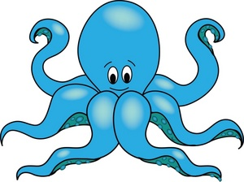

Sea Horse and Octopus Class

Curriculum Information

Term 5 and 6

2017

Topic

We begin Term 5 focusing on plants and how they grow. Term 5 is also SATS Term and we will be sitting papers during the weeks beginning 15th May and 22nd May 2017.

In Term 6 our topic focuses on the Queens of England and we will be looking at Queen Victoria and Queen Elizabeth I and II.

Numeracy

Throughout Term 5 we will be re-capping many of the concepts we have taught this year, in preparation for the SATS papers. We will pay particular attention to solving word problems for addition, subtraction, multiplication and division. We will also be re-capping time and measurements. During Term 6 we will continue to prepare children for Year 3.

Art and Design and Technology

In Term 5 we are focusing on Art. We will be looking at the work of William Morris and using his designs to create prints, which we will then develop into repeating patterns.

In Term 6 we are focusing on Design and Technology. We will be using clay to create our own Victorian models.

P.H.S.E.

In PSHE we will begin by looking at how to keep ourselves safe and staying safe in the home. After half term we begin our Sex and Relationships topic.

Music

In Music over Term 5 and 6 we will continue to build our knowledge of beat, pulse and rhythm. We are going to be learning some summer songs and playing a range of musical instruments.

Science

In Term 5 our focus is plants. We will be looking at how seeds are dispersed and will have a go at growing some different seeds. We will also look at hydroponic plants and have a go at growing hydroponic bulbs.

In Term 6 we are looking at habitats but this time looking at farming and gardening allotments.

Literacy

In Term 5 we will be looking at the traditional tale, ‘Little Red Riding Hood.’ We are focusing on using exclamatory sentences and apostrophes for possession in our writing. After this we will be looking at the story ‘The Paper Bag Princess’, using the Talk for Writing method to learn and change the story to make it our own. We will end the year by creating summer poems, based on our senses and feelings of summer.

Homework

Homework is set on a Friday for children to return by the following Friday and will relate to previous or future work in class. Spellings will be stuck into reading records to be practised and learnt for a test the following week.

P.E.

In Term 5 we are continuing to improve our throwing and catching skills whilst also learning how to play rounders and other outdoor games. In Term 6 we will be continuing with athletics in preparation for Sports Day.

Sea Horse Class PE days are Tuesdays and Fridays and Mondays and Fridays for Octopus Class. Children need to bring shorts, a t-shirt, trainers and/or plimsolls on these days. Children need to remove earrings on these days as they cannot do PE with them in.

R.E.

In Term 5 and 6 we are focusing on bible stories, for example Noah’s Ark. We will explore why they are important to Christians. We will also look at the significance of the Bible to Christians.

Computing

In computing we will be using the Paint program to create William Morris inspired prints. We will learn how to copy and paste our prints to create a repeating pattern. In Term 6 we will continue to progress children’s computing skills, for example saving and opening documents and research using the internet.

Geography/History

In Geography we are learning about the four countries that make up the United Kingdom. We will spend some time looking at each county in detail and begin to label them on a map.

In Term 6 we focus on History, looking at the Victorians and in particular focusing on Queen Victoria and comparing her to our current Queen Elizabeth.