Miss Cole’s Enormous Carrot story

Once upon a time there was an old man who wanted to grow some carrots. He used a rake to clear the big stones. He then dug up a shallow trench in the soil and scattered the carrot seeds. He watered them regularly over a couple of weeks. Lots of slugs and snails wanted to munch on the yummy carrots while they were growing. But the old man protected the carrots. The carrots seeds slowly grew and grew until they were ready to harvest. The carrots had a few carrot leaves growing above the soil.

The old man noticed one enormous carrot leaf and began to pull and pull on it. But it wouldn’t budge. The old man’s wife came out the house to help. The old man pulled the carrot; the wife pulled the old man. But it was still stuck in the ground.
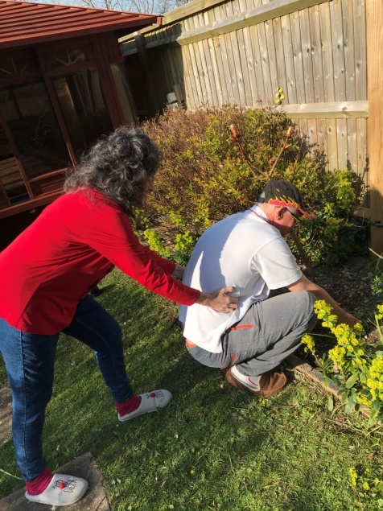
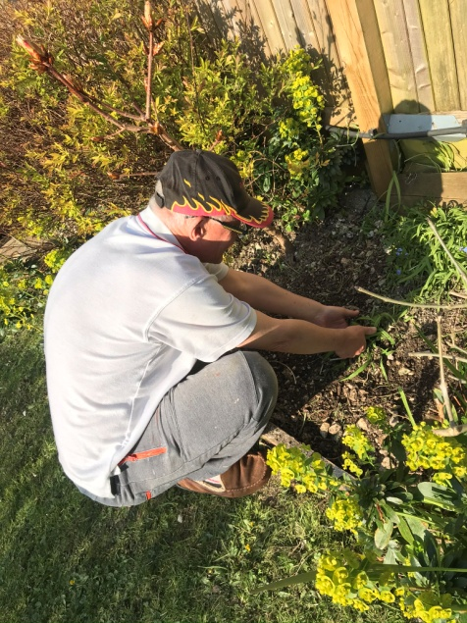

The old man then called on his eldest son to help pull out the enormous carrot. The old man pulled the carrot, the wife pulled the man and the eldest son pulled the wife but the carrot would not ease.
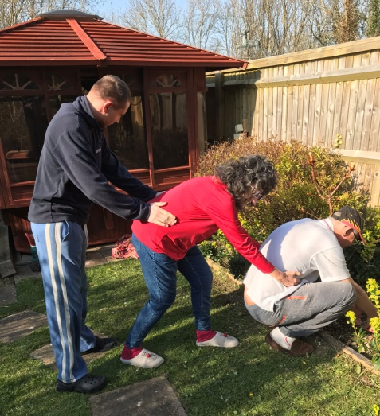

The old man’s daughter saw her family struggle and came out to help. The old man pulled the carrot, the wife pulled the man, the eldest son pulled the wife and the daughter pulled the son. The enormous carrot still remained in the soil.

The old man found his youngest child and pleaded for help. The youngest child pulled the daughter, the daughter pulled the eldest son, the eldest son pulled the wife and the wife pulled the old man. Again the enormous carrot was stuck in the ground.
The old man didn’t know what else to do, until his dog came sniffing by. The dog began to sniff the carrot. This gave the old man an idea...
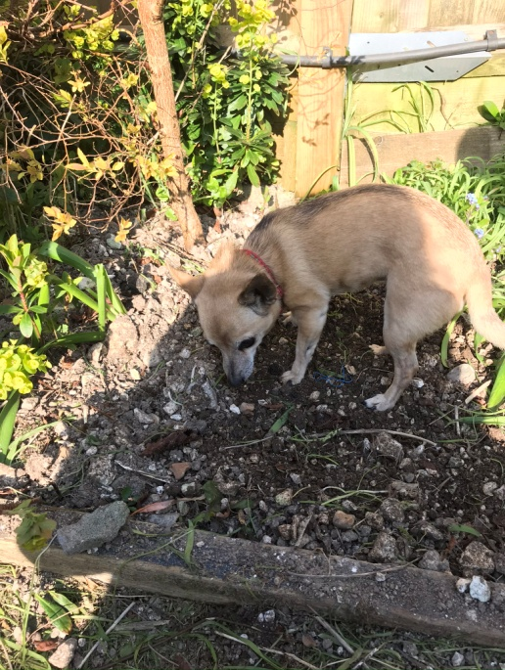
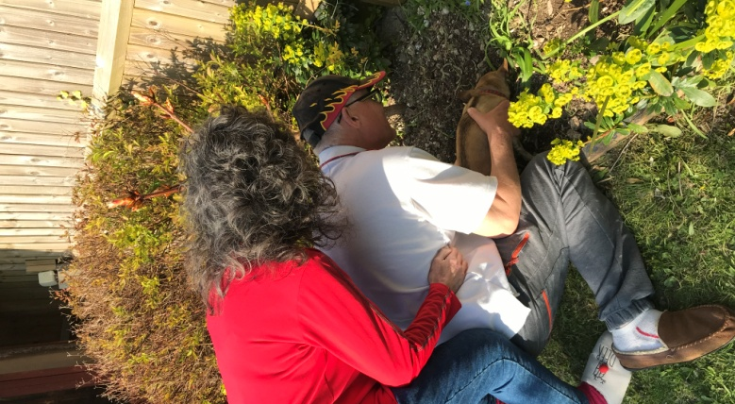

The dog pulled the carrot, the old man pulled the dog, the wife pulled the old man, the eldest son pulled the wife, the daughter pulled the eldest son, the youngest child pulled the daughter and the enormous carrot came out!

The old man was so happy with the enormous carrot. Everyone enjoyed having carrot soup and carrot cake for dinner for the rest of the year.
The end.

