Term __4____- Week____1_____
How many words can you think of that use this spelling pattern?
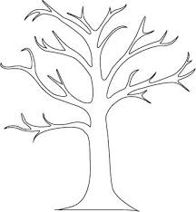
Learn the words listed and add to your spelling tree with leaves showing a different word that use the sound. Write a sentence with those words.
children
jumper

being

The blue spiky clouds are other words the children need to learn. There will be four of these each.
father

swimmer

hopping

mother

beautiful
walker
er

people

Term __4_____- Week____2_____
Learn the words listed and add to your spelling tree with leaves showing a different word that use the sound. Write a sentence with those words.
great
er

bigger
smaller

thinner

The blue spiky clouds are other words the children need to learn. There will be four of these each
break
steak
brother

Term __3_____- Week____3_____

Term 4 week 3
How many words can you think of that use the sound?
Learn the words listed and add to your spelling tree with leaves showing a different word that use the sound. Write a sentence with those words.
move
coldest
tallest
smallest

biggest

The blue spiky clouds are other words the children need to learn. There will be four of these each
prove

est

beautiful
something

Term __4____- Week____4_____
Learn the words listed and add to your spelling tree with leaves showing a different word that use the sound. Write a sentence with those words.
improve
grumpily
sadly
gladly

happily

The blue spiky clouds are other words the children need to learn. There will be four of these each
move
sugar
sure

Adding ly

The last week of term will be a mixture of all the terms words in a spelling bee type contest.
So mix them up and use them in lots of different sentences.

