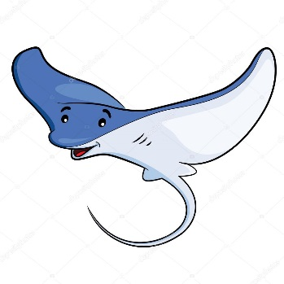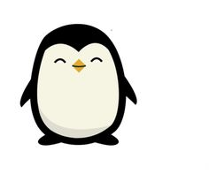 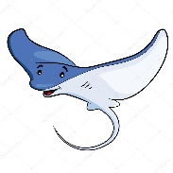

Year 3 Class

Code of Conduct

We will:

* Look after classrooms, make sure rubbish goes in the bin
* Sit quietly
* Listen to all adults
* Put our hand up to speak
* Be kind to everyone
* Do our best work in every lesson

Dates for your diary:

Term 3 begins: Thursday 4th January 2018

Term 3 ends: Friday 9th February 2018

Half Term: Monday 12th February – Friday 16th February 2018

Term 4 begins: Monday 19th February 2018

Class Assemblies: Stingrays: Thursday 1st March, Penguins: Thursday 8th March

Parents Consultations: Tuesday 13th March 3.30 – 5.30pm, Thursday 15th March 4.00 – 6.00pm and Thursday 22nd March 5.30 – 7.30pm.

Term 4 ends: Thursday 29th March 2018

Our school website address is:

<http://www.denton.e-sussex.sch.uk/> and our online blog is there for you to find out information about the class, upcoming events and links to useful websites

Things to Remember:

* P.E. kit for Monday & Friday (Stingrays) and Wednesday & Thursday (Penguins)
* Reading book and home-school link book to be in school every day
* Homework in on Fridays
* Spelling test on Fridays
* School starts at 8:50am with gates open at 8:40am

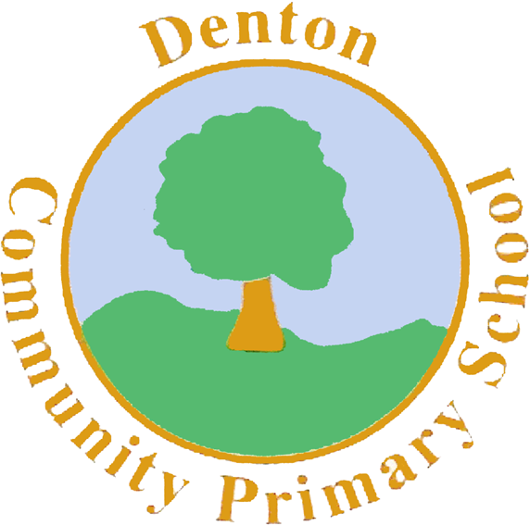

Penguin and Stingray Class

Curriculum Information

Term 3 and 4

2018

If you have concerns or questions please let us know.

We will be in the Key Stage Two playground before school where you can make an appointment to meet at a mutually convenient time.

Thank you,

Miss Blotz and Miss Morgan

P.E.

Our PE days are Monday, Wednesday, Thursday and Friday. Children need to bring their shorts, a t-shirt, trainers and plimsolls on these days. Children need to remove earrings on these days as they cannot do PE with them in.

**Long hair needs to be tied back every day please**.

Our focus in PE is Gymnastics. Children will use the hall equipment to experiment travelling and moving across the beams, apparatus and horses. Children will also take part in a PE session each week with our sports coach.

Spanish

Year 3 will continue exploring their knowledge of the Spanish language, and will be able to ask and answer questions such as ‘How old are you?’ We will also look at numbers between 20 and 40.

Computing

We will be focusing on the skills needed to create a document. Year 3 will be using Microsoft programmes to practise creating information leaflets, combining text and graphics to communicate information.

Science

In Science our focus will be ‘Animals Including Humans’ followed by ‘Living Things’. The children in Year 3 will be looking at different animals and classifying them based on their genetics and diet. We will also be looking at the muscles in our bodies, understanding that they work in pairs, and finding out what the purposes of different muscles are.

Topic

Our topic for this term is ‘Our Wondrous World’. The children in Year 3 will be exploring the geographical aspects of the Earth we live on, and will be exploring what makes it so special. We will be using atlases and globes to locate different countries and cities around the world, and becoming familiar with many of their features.

Music

In our Music lessons throughout Term 3 we will be exploring National Anthems. Relating to our topic, we will look at many different countries and the anthems that they sing- we will even create our own anthems!

P.H.S.E.

We have begun the term looking at ‘Aspirations’ and ‘Dreams’. This has involved setting both short and long term goals, and the children highlighting what they want to do in 2018.

Homework

Homework is set on a Friday for children to return by the following Friday and will relate to previous or future work in class. Later in the term spellings will be stuck into reading records to be practised and learnt for a test the following week.

Literacy

We begin Term 3 by looking at the Northern Lights, and a poem relating to them. We will be using ‘Talk for Writing’ strategies to retell, story map and change the poem to create our very own.

Later on in the term we move on to story writing. We will be looking at popular stories from other cultures and discussing how some of these may be similar or different from tales we have heard. Again, we will be using ‘Talk for Writing’ to develop our own stories.

Art and Design and Technology

In Art and Design we will be looking at the local artist, David Scott Moore, and the many landscape pieces he has created. We will be using different types of media to create our own landscape pictures, and deciding which is suitable for a foreground, middle ground and background of our piece.

Numeracy

Our focus throughout Term 3 and 4 in Numeracy will be on learning the written and mental methods for addition and subtraction, developing a further understanding of ‘carrying’ and ‘borrowing’ to support them.

Year 3 will also be recapping their known times tables, as well as learning their 3, 4 and 8 times tables off by heart.

R.E.

In Term 3 of RE we will be focusing on Marriage in Christianity. We will look at the importance of vows, and what a traditional marital service entails. This will also tie in with our topic, as we will look at how weddings are celebrated around the world.

Geography/History

Our focus this term will be Geography. Children will explore what is Our Wondrous World. We will learn about countries and cities in the United Kingdom and Europe, and will explore the human and physical geographical features of these places. Children will also familiarise themselves with flags and climates.