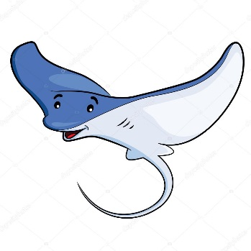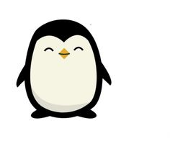 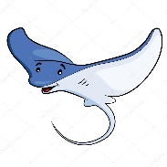

Year 3 Class

Code of Conduct

We will:

* Look after classrooms, make sure rubbish goes in the bin
* Sit quietly
* Listen to all adults
* Put our hand up to speak
* Be kind to everyone
* Do our best work in every lesson

Dates for your diary:

Term 5 begins: Monday 16th April 2018

Term 5 ends: Friday 25th May 2018

Half Term: Monday 28th May – Friday 1st June 2018

Term 6 begins: Monday 4th June 2018

Class Assemblies: Penguins: Thursday 14th June and Stingrays: Wednesday 20th June

Sports Day: Thursday 21st June 2018

Term 6 ends: Wednesday 18th July 2018

Our school website address is:

<http://www.denton.e-sussex.sch.uk/> and our online blog is there for you to find out information about the class, upcoming events and links to useful websites

Things to Remember:

* P.E. kit for Monday & Friday (Stingrays) and Wednesday & Thursday (Penguins)
* Reading book and home-school link book to be in school every day
* Homework in on Fridays
* Spelling test on Fridays
* School starts at 8:50am with gates open at 8:40am

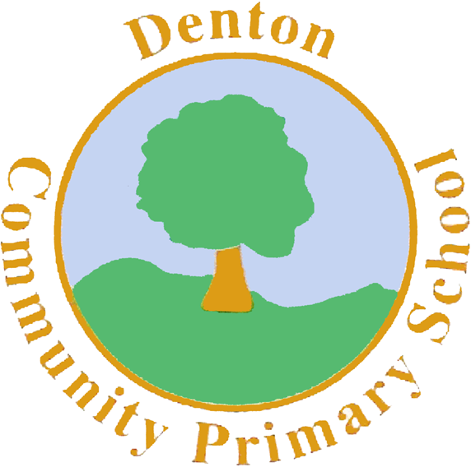

Penguin and Stingray Class

Curriculum Information

Term 5 and 6

2018

If you have concerns or questions please let us know.

We will be in the Key Stage Two playground before school where you can make an appointment to meet at a mutually convenient time.

Thank you,

Miss Blotz and Miss Morgan

P.E.

Our PE days are Monday, Wednesday, Thursday and Friday. Children need to bring their shorts, a t-shirt, trainers and plimsolls on these days. Children need to remove earrings on these days as they cannot do PE with them in.

**Long hair needs to be tied back every day please**.

In PE our topic with Coach will be Football and Athletics. We hope to be getting outside for some of our football sessions so children may bring their AstroTurf football boots. During athletics we will be focusing on sprinting, long jump and throwing. In Term 6 we will also be learning how to play rounders in our sessions with our teachers.

Spanish

In Spanish we will continue our work on numbers, hopefully progressing right through to 100. We will spend some time re-capping the days of the week, months of the year, colours and food.

Computing

During computing we will be collecting different types of data and then learning how to input this data on to an Excel spreadsheet. From there we will learn how to analyse data by creating tables and pie charts. To finish the year we look at coding and programming and how the basic computer works.

Science

Our topic in Science during Term 5 is Forces and Magnets. Children will be investigating how different forces work through a range of experiments and also finding out about magnetic and non – magnetic materials.

Finally our topic for Term 6 is plants and light. We will think about what light is and how shadows are created. When looking at plants we discuss seed dispersal whilst also doing some planting of our own, thinking about optimum growing conditions.

Topic

Our topic over Term 5 and 6 is Ancient Egypt. We will begin the term with a ‘drama for learning’ concept where children will become archaeologists for the week, excavating the tomb of a high priest. We then move on to thinking about Egypt as a country, whilst exploring its history. We will be investigating the music, art and culture of the Egyptians, finally comparing it to our lives in the modern day.

Music

In Music children will continue to think about different musical instruments and the change in sounds they can make. We will focus on some of the instruments played during the Ancient Egyptian era and compare them to modern day instruments.

P.H.S.E.

During Term 5 we will be thinking about British Values and Law. Children will learn about some harmful behaviours and consequences behind them. Term 6 is our Sex and Relationships topic where children continue discussing the differences between boys and girls whilst also looking at personal space and how family units change.

Homework

Homework is set on a Friday for children to return by the following Friday and will relate to previous or future work in class. Later in the term spellings will be stuck into reading records to be practised and learnt for a test the following week.

Literacy

We will begin Term 5 in role as archaeologists, excavating a tomb. We will be keeping a diary of our experiences whilst also creating instructions for traps set in the pyramids and creating a presentation to our archaeology team of our experiences. After this we will be using Talk for Writing to learn a traditional Egyptian story called ‘Muti’s Necklace’. Children will learn the story, then make a change to write their own versions. We will also be learning and performing a piece of poetry by Kenn Nesbitt called ‘Melvin the Mummy’ and creating travel brochures for visiting Egypt.

Art and Design and Technology

We will focus on Design and Technology throughout Term 5 where children will be making canopic jars and Egyptian death masks.

In Art, during Term 6, we will learn about hieroglyphics and children will create their own cartouche. Finally we will look at drawing the Ancient Egyptian gods and goddesses, using techniques such as wax resist and printing to create different textures.

Numeracy

Now that we have covered most of the Year 3 objectives we will spend the rest of the year re-capping over some of the basic numeracy skills, for example, adding and subtraction using the column methods, finding fractions of amounts and basic multiplication and division methods. We will also have a focus on times tables, making sure children can confidently count in 3’s, 4’s and 8’s.

R.E.

Our topic in RE for Term 5 is ‘Moses the Exodus’. We will think about Moses’ journey to the Promise Land. In Term 6 we focus on a range of Artefacts and the religious meaning behind some of them.

Geography/History

In Geography we focus on Egypt as a country. We will discuss landscape, thinking about farming and how the Ancient Egyptians lived. We will also look at modern day Egypt and the country’s tourism.

In History we delve into life as an Ancient Egyptian, looking at the Egyptian timeline, the hierarchy of a community and the Ancient Egyptian Gods and Goddesses.