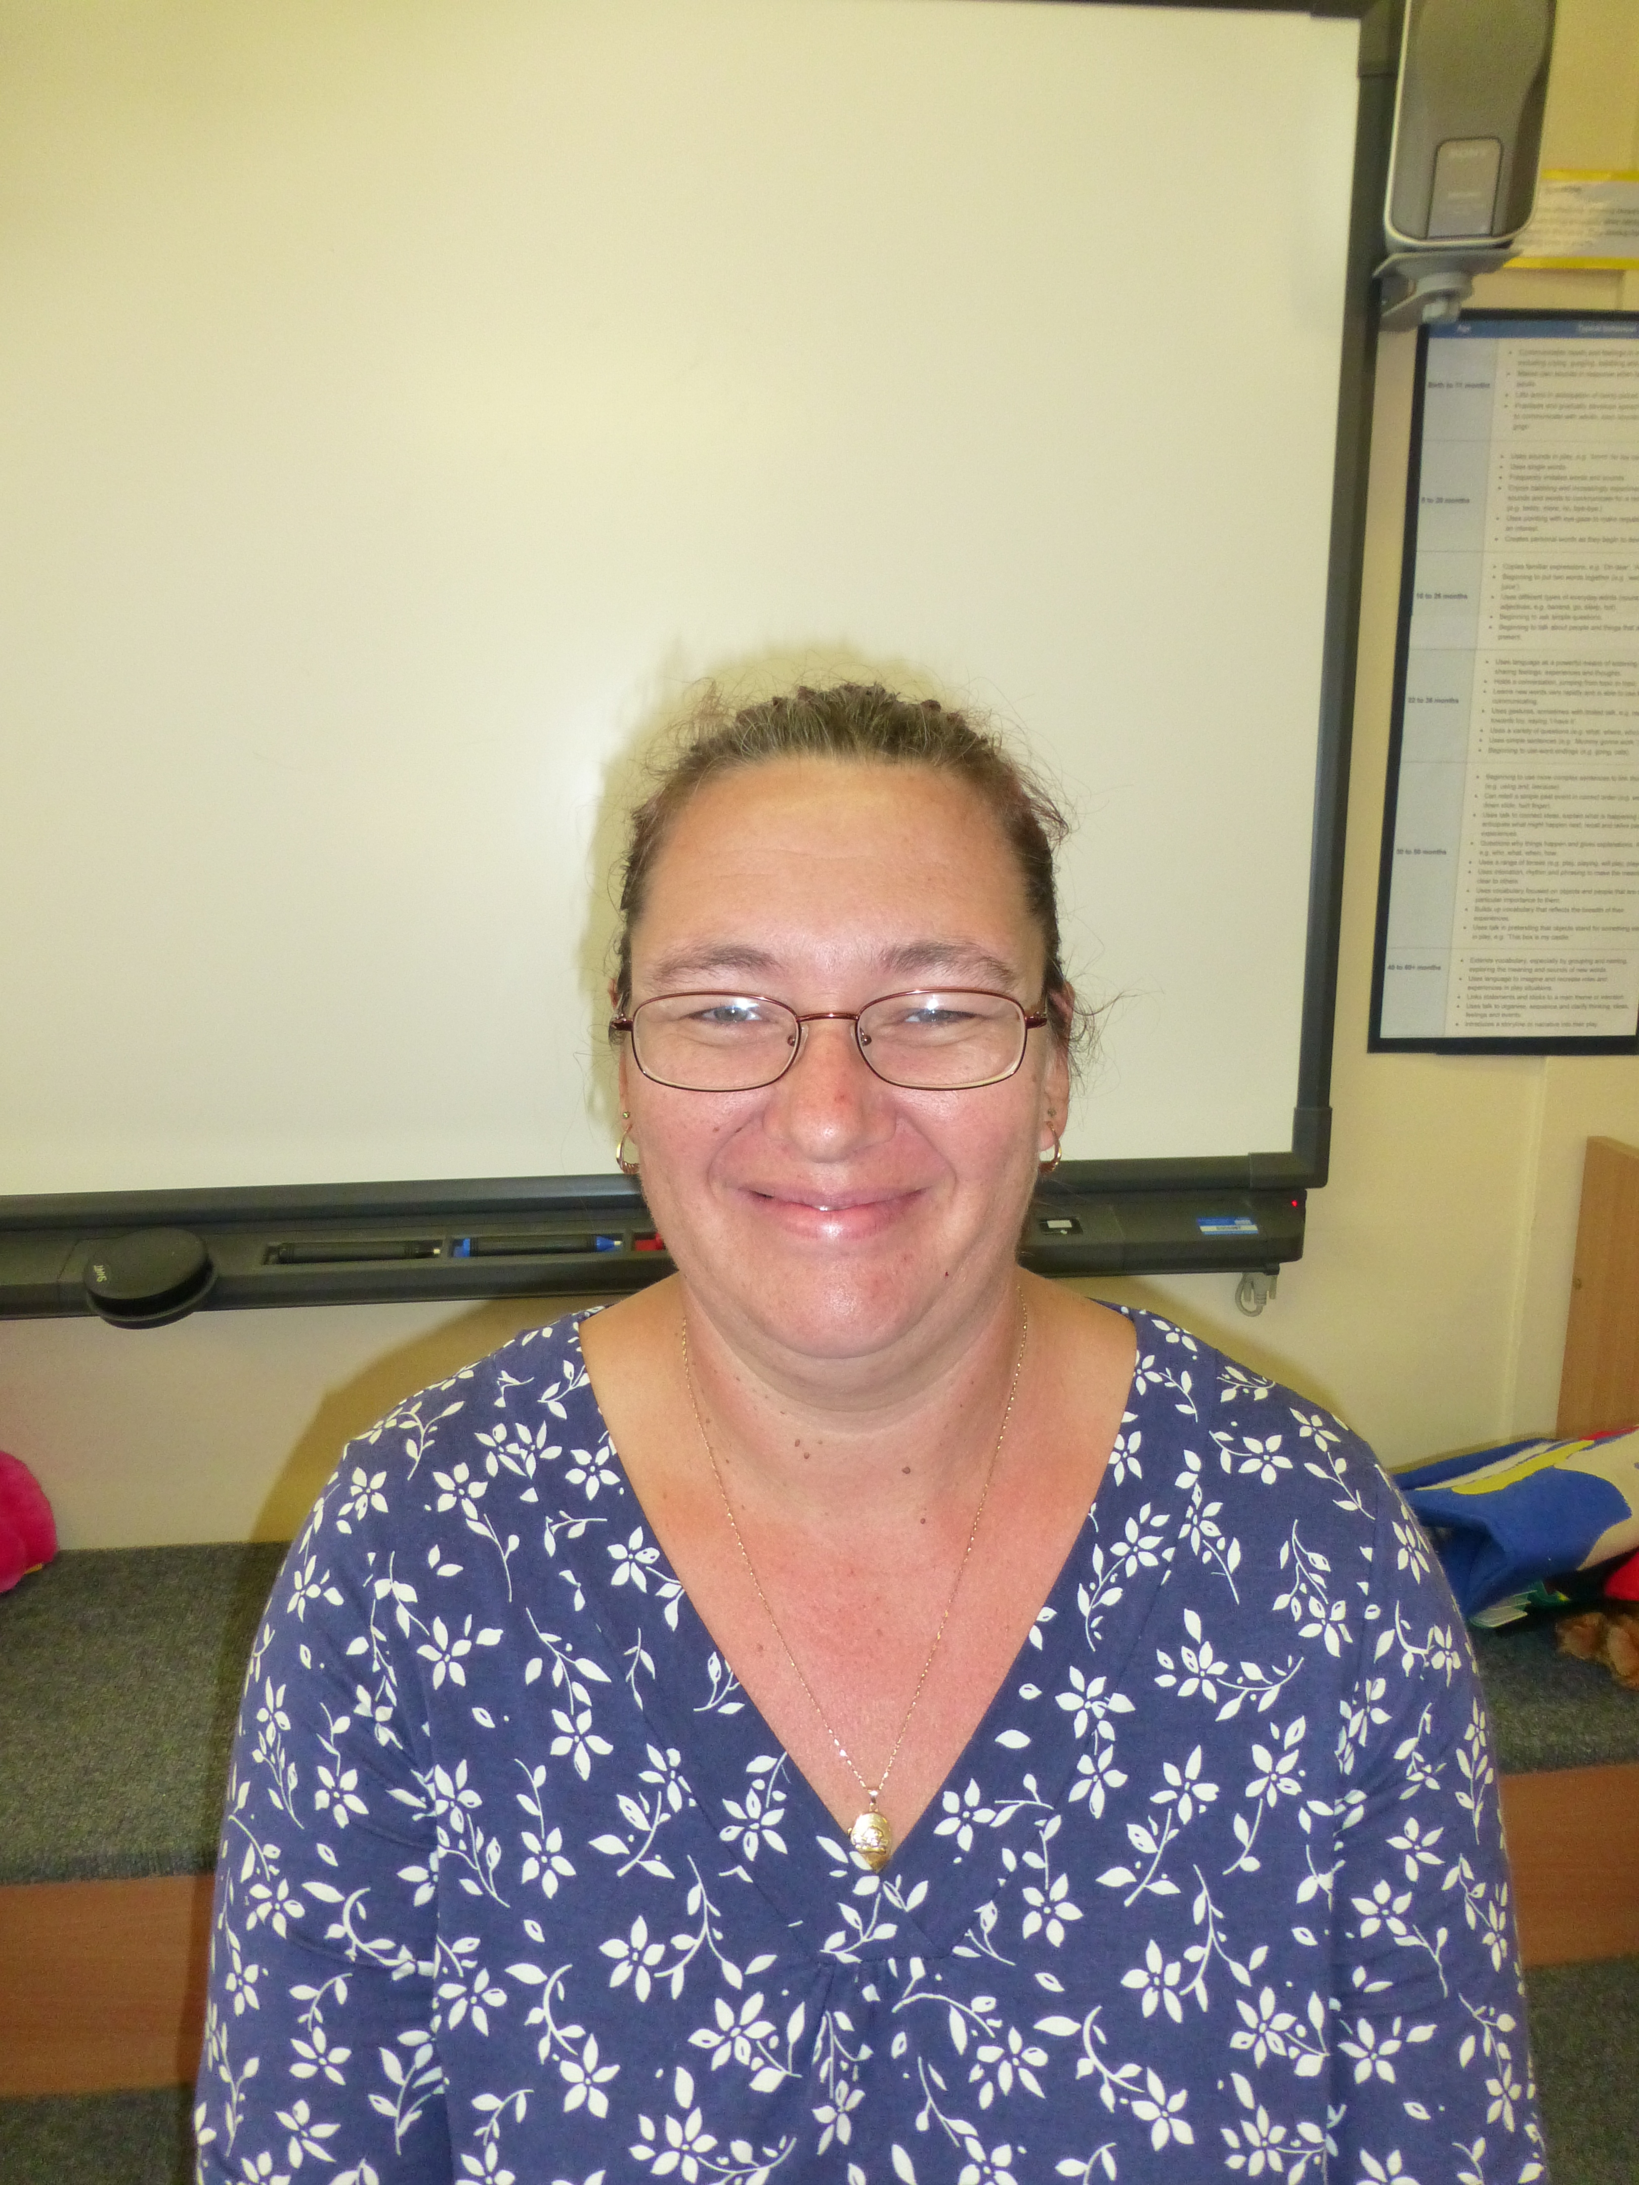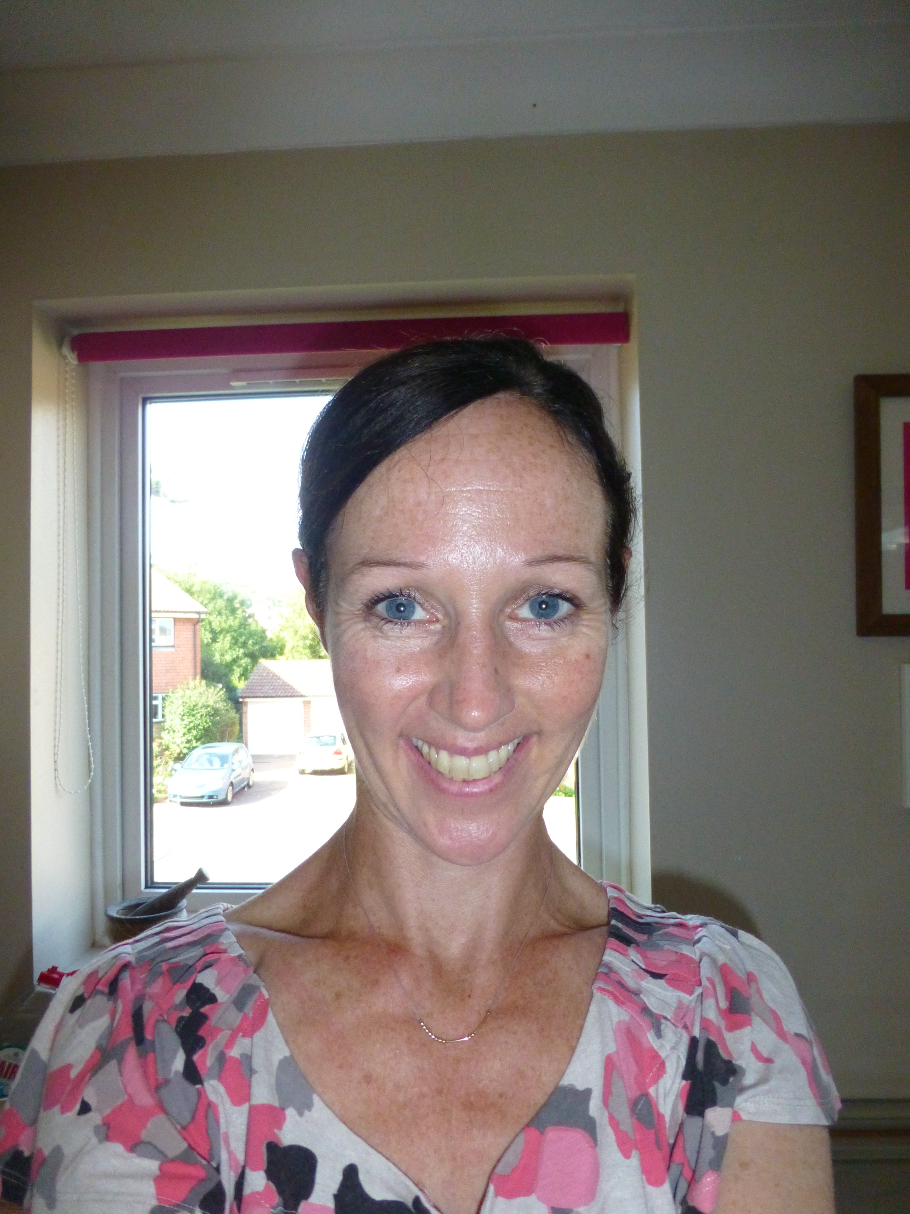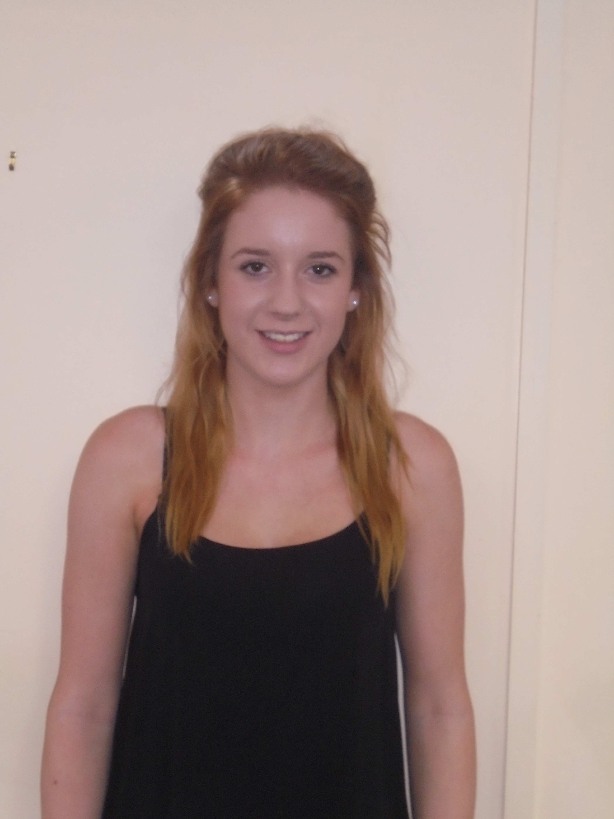
The start of the day

As our older children hear about their Reception places this week, we are moving towards a more independent start to their school day. Our staff will be on hand to help your children come in and put away their things. We will be there to help settle them an activity too. If your child is going to Reception in September we suggest you start to say goodbye at the door and let us help them to become more independent. Thankyou for supporting them.

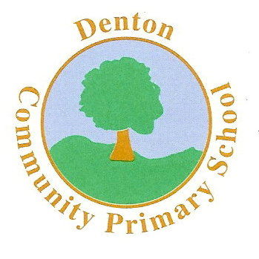 Sea-lions Nursery Class
Term 5

Key dates this term:
Every Monday: P.E- please dress your child in appropriate clothing
Friday 21st April- Mini Marathon

Mrs Ashdown Mrs Dicksee Miss Gilburt

Working together to maximise learning

We recognise the importance of working together to help your child achieve their very best. We love to hear about their successes at home and encourage you to pick up a WOW leaf from the box by the door. We always celebrate the children’s achievements before adding the WOW leaf to our tree.

Please join us on a Friday morning from 8:45- 9:05 for a stay and play session. We will be showing you how we enhance children’s learning in different curriculum areas. This term we will focus on:

Friday 21st April: Reading/sharing stories
Friday 28th April: Numeral recognition
Friday 5th May: Phonics
Friday 12th May: Mark-making
Friday 19th May: Exploring media
Friday 26th May: Learning Journey

Mrs Ashdown
Nursery Assistant
Mrs Dicksee
Nursery Teacher

Miss Gilburt
Nursery Apprentice
Prime Area: Personal, Social and Emotional development (PSED)
Self confidence and self awareness: We are aiming to become more confident in separating from our Parents and Carers. We are trying to say goodbye at the door. We will be reflecting on why we are special and what our special talents are.
Managing feelings and behaviour: We will be talking about right and wrong and the need for rules in the context of our work about pirates. We will be playing lots of games which encourage cooperation and turn-taking.
Making relationships: We will be building relationships through playing in our role play areas and with our small world toys. We will be learning to negotiate and solve problems as we try to build pirate assault courses and think about how we can move boats without touching them.

Prime Area: Communication and Language (CL)
Listening and attention: We will be listening to stories linked to our topic of Pirates. We will be learning texts with actions to help us remember them. We will be playing lots of memory games in our circle time sessions and we’ll be strengthening our recall and retention skills through games such as Pirate Pairs.
Understanding: We will be giving and following instructions in our map work. We will be developing our ability to answer How? and Why? questions in relation to our boat making challanges.
Speaking: We will be developing our vocabulary linked to the sea, the beach and treasure . We will be using language to sequence and organise when we retell stories such as Mr Gumpy’s Outing. When we read Mrs Pirate we will be looking at and collecting, rhyming words. We will be telling our own pirate stories and recording them as MP4 files for you to listen to.
Specific Area: Expressive Arts and Design (EAD)
Exploring and using media/materials: This term we will be busy making treasure maps, pirate flags, hats and clay coins. We will bake jewelled biscuits. Our texture table will have artefacts from the beach and sea for the children to explore. We have a range of new pirate themed songs and rhymes to add to our Nursery favourites.
Being imaginative: We are developing our inside role play area as an underwater cafe and our dark den will become a pirate cave with a secret treasure stash. We have a pirate ship in the Early Years Garden and we’ll be using our playground boat for lots of games. Our small worlds play will focus around boats and people who help us.

Specific Area: Understanding

Shape, Space, Measures: He

Prime Area: Physical Development (PD)
Moving and handling: We are working hard on learning to form recognisable letters. We are developing our tripod grip with lots of creative activities. In P.E we will be working on climbing and jumping skills. Our outdoor challenges will help us to develop our control over equipment such as balls and rackets.
Health and self-care: We will be looking at keeping safe near water and at the beach. We will be focusing on the safe use of equipment such as scissors.

Specific Area: Literacy
Reading: Every week we have a focus text and much of our work is based around this. This term we will be looking at stories with a sea or pirate theme. In addition we will focus on the work of the author John Burningham. We will be learning stories with actions and we’ll retell the stories in our own words.
Writing opportunities: As well as our daily phonics sessions we will have continuous access to our writing area and we will have writing opportunities outside and in our role play areas. We will be writing lists, instructions, messages in bottles and labels. We will also be focussing on writing our names.

Specific Area: Mathematics (M)
Number: This term we will be having a big focus on numeral recognition. We will look at numbers to 5 and then 10. Children who are confident with this will be learning to write numerals and will look at numbers up to 20. We’ll also be sharing equally.
Shape, Space, Measures. We will be looking at money and the value of coins. We will revisit 2D and 3D shapes with our shape sorting treasure boxes, In addition we will follow maps and use positional language to direct our friends around a pirate assault course.

Ship Ahoy!

