Dates

* Open Morning: 28/9/18
* Parent Consultations: 9th, 11th and 16th October
* Inset Day: 29/10/18
* Term 2 Starts: 30/10/18
* Whales Class Assembly: 22/11/18 at 9:10am

Whales Class Rules

Be Kind, Be Polite, Be Honest

Homework

Homework is set on Tuesdays and due in on Mondays. It is important that you support your child with their homework. Any problems, please don’t hesitate to come and speak to me.

Things to remember:

* P.E. kit for **Wednesdays** and **Fridays**
* Reading book every day
* School starts at 8.50am – it is really important that your child is on time.
* Please ensure your child is in correct school uniform every day.
* If your child brings a mobile phone to school it must be left at the school office.

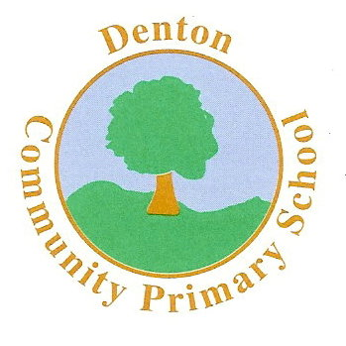 Whales Class

Terms 1 and 2

ENGLISH

We will begin the term by focusing on Nursery Rhymes. We will explore a variety of rhymes, from which, the children will write their own. Our main topic will be World War II. We will explore many wartime stories, and the children will use ‘Talk For Writing’ to enjoy these. By the end of the term the children will have written and enjoyed a variety of text types: stories, letters, reviews, poetry and information texts.

We will also be focusing on grammar, punctuation and spelling (GPS).

Art and D.T.

Much of our Art and DT work will be based on our topic, World War II. The children will be involved in the planning, designing and making of air-raid shelters.

The children will also explore ‘The Blitz’ and will use the colour wheel to create different tones and contrasting colours to compliment their artwork.

Computing

The children will begin by outlining the key features of the World

Wide Web and begin to explain how to use a browser and search engines, including navigation via hyperlinks. Mr Turner will take the lead on these sessions.

MUSIC

The children will take part in a range of singing in assemblies and there will also be the opportunity to sing in the school choir.

In class we will begin learning songs in Spanish!

SCIENCE

The children are going to begin by exploring the topic ‘Evolution.’ We will look at how the world has changed over the years and we will explore Darwin’s theory.

The children will also take part in a range of experiments, from which they will draw conclusions.

MATHS

In Maths the children will cover a range of topics. We will be covering addition, subtraction, multiplication and division. Fractions, decimals and percentages will also be covered in great detail, including adding, subtracting and even multiplying fractions! Times tables will be a regular feature of class work.

We will also begin to look at past SATS papers, which will include lots of problem solving.

HISTORY & GEOGRAPHY

Our History & Geography topic this term will be World War II. We will learn the chronology of events and explore what life was like during the war, for both adults and children.

We will explore terms such as ‘evacuation’ and ‘rationing,’ and begin to explain what these mean.

R.E.

Our RE work will begin by looking at the Five Pillars of Islam and this will form a large part of our PSHE topic. We will then be learning about Christianity and how Christians celebrate events such as Christmas.

Modern Foreign Languages

We will be studying Spanish and developing our basic conversation skills, including meeting and greeting.

P.S.H.E.

In PSHE we will begin by exploring balanced diets and how to stay healthy. We will also discuss social media and how that may impact on how we feel about ourselves. In Term 2, we will explore what constitutes a positive, healthy relationship and develop the skills to form and maintain positive and healthy relationships.

MC900358181[1]

P.E.

The children will be learning how to play a range of sports. We will begin with Football for Term 1 and then focus on Hockey and Tag Rugby for Term 2. Mr Hymers (Coach) will be taking the children for at least one lesson a week.