Dates

* Whales Class Assembly: 30/01/20 at 9:10am
* End of Term 3: 14/02/20
* Inset Day: 24/02/20
* Parents’ Evening in March: 19th at5:30 – 7pm, 24th at 3:30 – 5:30pm and 26th at 4- 6pm.
* End of Term 4: 03/04/20

Homework and Spellings

Homework is set on Tuesdays and due in on Mondays. It is important that you support your child with their homework.

Spellings will be set on a Monday and tested on a Friday. Please look at ClassDojo for these, as the children will not be taking their spelling books home. Any problems, please don’t hesitate to come and speak to me.

Things to remember:

* P.E. kit for **Mondays** and **Wednesdays**
* Reading book every day
* School starts at 8.50am – it is really important that your child is on time.
* Please ensure your child is in correct school uniform every day.
* If your child brings a mobile phone to school it must be left at the school office.

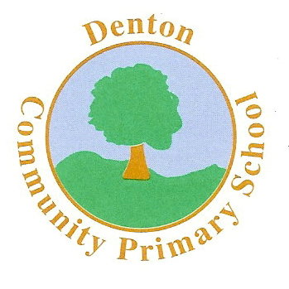 Whales Class

Terms 3 and 4

P.S.H.E.

In PSHE we will begin by exploring the responsible use of mobile phones: safe keeping (looking after it) and safe user habits (time limits, use of passcode, turning it off at night etc.). We will also touch onhow to manage requests for images of themselves or others; what is and is not appropriate to ask for or share. Bullying behaviour will also be covered during both terms.

P.E.

The children will be learning how to play a range of sports. We will begin with Hockey for Term 3 and then the focus will be Tag Rugby. Mr Hymers (Coach) will be taking the children for at least one lesson a week.

HISTORY & GEOGRAPHY

Our History & Geography topic this term will be Natural Disasters. We will learn about the devastating effects that some countries have faced and begin to explore how and why these disasters occur.

The children will be taught to read a map and locate countries. We will also explore the different cultures around the world.

R.E.

Our RE work over the next two terms will be based around learning about Jesus and who he was. We will discuss Jesus’ life and how he died. This will lead us into our Easter topic where we will explore terms such as Lent. We will also visit Denton Church.

ENGLISH

Over the next two terms our focus will be ‘Natural Disasters.’ We will be reading Running Wild by Michael Morpurgo and our writing activities will be based on this. The children will participate in writing letters, stories, news reports and much more! By the end of the two terms, the children will have further improved their writing skills and become confident using the correct grammar and punctuation. Spellings will continue to be a focus and the children will be tested every Friday.

Art and D.T.

Much of our Art and DT work will be based on our topic, Natural Disasters. The children will be involved in the planning, designing and making of volcanos.

The children will also explore countries where volcanoes have erupted and use different media to explore the effects of this.

Computing

The children will use ICT where possible as a cross curricular link. They will use popular search engines to gather information required and use programs such as Word and PowerPoint to present their findings.

MUSIC

The children will take part in a range of singing in assemblies and there will also be the opportunity to sing in the school choir.

In class we will continue to learn songs in Spanish!

SCIENCE

The children are going to begin by exploring different forces and how they act. We will look at different forces around us and look at Isaac Newton’s work.

The children will also take part in a range of experiments, from which they will identify how to keep a test fair and begin to draw conclusions using scientific vocabulary.

MATHS

In Maths the emphasis on addition, subtraction, multiplication and division will continue and the children will be taught to solve a variety of problems involving the four operations. We will regularly tackle word problems which will also involve fractions and percentages. Times tables will continue to be a regular feature of class work, with a times table test every Friday.

Much of Terms 3 and 4 will involve preparing the children for the SATs in May.

Modern Foreign Languages

During Terms 3 and 4 the children will be taught basic conversational skills and begin to speak in Spanish in full sentences.

MC900358181[1]