Dates

* 12/10/17: Whale’s Class Assembly
* 29/9/17: Open Afternoon
* 10/10/17, 11/10/17(instead of 17th as we are at PGL), 12/10/17: Parent Consultations

Whales Class Rules

Be Kind, Be Polite, Be Honest

Homework

Homework is set on Tuesdays and due in on Mondays. It is important that you support your child with their homework. Any problems, please don’t hesitate to come and speak to me.

Things to remember:

* P.E. kit for **Wednesdays** and **Fridays**
* Reading book every day
* School starts at 8.50am – it is really important that your child is on time.
* Please ensure your child is in correct school uniform every day.
* If your child brings a mobile phone to school it must be left at the school office.

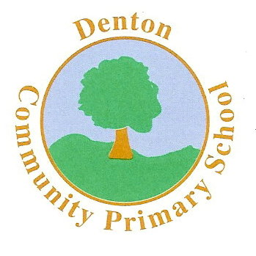 Whales Class

Terms 1 and 2

ENGLISH

We will begin the term by focusing on the poet Michael Rosen. We will explore a variety of poems, from which, the children will write their own. Our main topic will be The Aztecs. We will explore many Aztec stories, and the children will use ‘Talk For Writing’ to enjoy these. By the end of term the children will have written and enjoyed a variety of text types, including stories, letters, reviews, poetry and information texts. We will also be focusing on grammar, punctuation and spelling.

Art and D.T.

Much of our Art and DT work will be based on our topic, The Aztecs. The children will be involved in the planning, designing and making of Aztec mosaic masks and headdresses.

The children will also the colour wheel to create different tones and contrasting colours to compliment their artwork.

Computing

The children will begin by outlining the key features of the World

Wide Web and begin to explain how to use a browser and search engines, including navigation via hyperlinks.

MUSIC

The children will take part in a range of singing in assemblies and there will also be the opportunity to sing in the school choir.

In class we will begin learning songs in Spanish!

SCIENCE

The children are going to begin by exploring the topic ‘Animals Including Humans.’ We will look at the human heart and begin to explain how this works. During the topic, the children will identify and name the main parts of the human circulatory system, and describe the functions of the heart, blood vessels and blood.

MATHS

In Maths the children will cover a range of topics. We will be covering addition, subtraction, multiplication and division. Fractions, decimals and percentages will also be covered in great detail, including adding, subtracting and even multiplying fractions! Times tables will be a regular feature of class work.

We will also look at past SATS papers, which will include lots of problem solving.

HISTORY & GEOGRAPHY

Our History & Geography topic this term will be The Aztecs. We will learn the chronology of events and vocabulary used by The Aztecs. We will also explore their culture and traditions and compare ideas of society in Aztec life, in comparison to other historical periods and today.

R.E.

Our RE work will begin by looking at the Five Pillars of Islam and this will form a large part of our PSHE topic also. We will then be learning about Christianity and the Christmas story.

Modern Foreign Languages

We will be studying Spanish and developing our basic conversation skills, including meeting and greeting.

P.H.S.E.

In PSHE we will be learning from the SEAL materials and covering topics such as ‘Going for Goals’. We will also be working on emotions and relationships.

MC900358181[1]

P.E.

The children will be learning a range of seasonal sports. We begin with Basketball for Term 1 and then focus on Hockey and Tag Rugby for Term 2. Mr Hymers (Coach) will be taking the children for at least one lesson a week.