The Little Red Hen and the Vegetable Patch 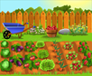
By Mrs Ashdown
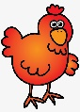
Once upon a time, there was a little red hen that lived on a farm. She was friends with a cow 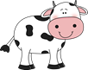 a pig 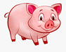 and a sheep.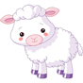
One day the little red hen found some packets of seeds . “Who will help me grow some vegetables?” The little red hen asked the cow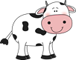 the pig and the sheep. “I will” said the cow“I will” said the pig “I will” said the sheep and they all worked together to make a vegetable patch.
“Now who will help me dig the ground?” asked the little red hen. “I will” said the cow “I will” said the pig“I will” said the sheep. So they all helped the little red hen dig the ground.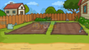

The next day “Who will help me plant the seeds?” the little red hen asked “I will help you” said the cow, “I will help you” said the pig, “I will help you” said the sheep. They all worked together to plant all the seeds.
The next day the little red hen got up to water the plants “Who will help me water the plants?” the little red hen asked. “Yes I will” said the cow “Yes I will” said the pig“Yes I will” said the sheep and they all watered the plants. They all took turns to water the plants over the next few weeks.
A few weeks later the plants had grown and it was time to harvest them. “Who will help me harvest the vegetables?” the little red hen asked. “Me, I will” said the cow. “Me, I will” said the pig. “Me, I will” said the sheep. All the animals helped to harvest the vegetables. 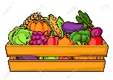
The next day the little red hen asked, “Who wants to help me eat the vegetables?”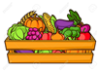 “Me, me, me” said the cow. “Me, me, me” said the pig. “Me, me, me” said the sheep. They all sat down on the picnic blanket and had a great vegetable feast with all of their home grown vegetables.
The End

